|  |  |  |  |  |
| --- | --- | --- | --- | --- |
| ERDC/EL TR-16-DRAFT |  |  | ERDC-CastleLogo1 | |
|  |  | DO NOT DISTRIBUTE BEYOND PSPAP WORKSHOP PARTICIPANTS AT MRNRC  Draft Version 6  Science and Adaptive Management Plan  Extracts from Appendices and Attachments for PSPAP Workshop  Missouri River Recovery Program | |
| Environmental Laboratory |  |  | Draft/Pre-decisional/For Review and Comment | December 2016 |
|  |  |  | |
| Draft Document for Review | |
|  |  |

ERDC/EL TR-XX-DRAFT

December 2016

Draft Version 6

Science and Adaptive Management Plan

Appendices and Attachments

Missouri River Recovery Program

J. Craig Fischenich

Environmental Laboratory  
U.S. Army Engineer Research and Development Center  
3909 Halls Ferry Rd  
Vicksburg, MS 39180

Kate E. Buenau

Marine Science Laboratory

Pacific Northwest National Laboratory

U.S. Department of Energy  
1529 W. Sequim Bay Rd.  
Sequim, WA 98382

Joseph L. Bonneau, and Craig A. Fleming

U.S. Army Corps of Engineers

Omaha District  
Gavins Point Project Office

Yankton, SD 57078

David R. Marmorek

*ESSA*

*600 – 2695 Granville Street  
Vancouver, BC Canada V6H 3H4*

Todd Gemeinhardt

U.S. Army Corps of Engineers

Kansas City District  
Kansas City, MO 64106

Draft Report/Pre-decisional/For Discussion Purposes Only

Submitted as an interim product for review only

Prepared for U.S. Army Corps of Engineers  
Washington, DC 20314-1000

Under Missouri River Recovery Program

Monitored by Environmental Laboratory   
U.S. Army Engineer Research and Development Center  
3909 Halls Ferry Rd, Vicksburg, MS 39180

Abstract

**DISCLAIMER:** The contents of this report are not to be used for advertising, publication, or promotional purposes. Citation of trade names does not constitute an official endorsement or approval of the use of such commercial products. All product names and trademarks cited are the property of their respective owners. The findings of this report are not to be construed as an official Department of the Army position unless so designated by other authorized documents. Subject to revision.

**DESTROY THIS REPORT WHEN NO LONGER NEEDED. DO NOT RETURN IT TO THE ORIGINATOR.**

The Missouri River Recovery Program (MRRP) is undergoing a transformation resulting from 2011 recommendations by an Independent Science Advisory Panel and the Missouri River Recovery Implementation Committee (MRRIC). An Effects Analysis study established the best available scientific information and provided the foundation for an Adaptive Management Plan (AM Plan) that addresses lingering uncertainties and improves management decisions while implementing actions that avoid jeopardizing the three federally listed species in the system. This draft AM Plan includes a process for resolving critical uncertainties using a framework consisting of four implementation levels: 1) research, 2) in-river testing of hypotheses, 3) scaled implementation of select management actions, and 4) full implementation. The decision criteria for moving to higher levels of implementation are included. A NEPA evaluation of alternative management actions identified an initial suite of actions that will be implemented to meet the objectives of the MRRP. This Draft AM Plan accompanies the Draft Missouri River Recovery Management Plan-Environmental Impact Statement and provides the roadmap for the implementation of the selected alternative and for the identification of subsequent management needs should the initial suite of actions fail to meet objectives. The AM Plan will be implemented collaboratively by the U.S. Army Corps of Engineers, the U.S. Fish and Wildlife Service, and MRRIC following the governance process outlined in the AM Plan.

Table of Contents [only highlighted appendices included}

List of Figures and Tables 8

Preface 12

Unit Conversion Factors 14

Appendix A. Attachments 26

Appendix B. Conceptual Ecological Models, Hypotheses, and Key Findings of the Effects Analysis 134

Appendix C. Detailed Description of Level 1 and 2 Science Components for Pallid Sturgeon **Error! Bookmark not defined.**

Appendix D. Population Monitoring and Modeling for Pallid Sturgeon

Appendix E. Listing and Description of Protocols for Sturgeon-Based Process Monitoring and Assessment 357

Appendix F. Cost Estimates and Prioritization of Level 1 and Level 2 Science Components 391

Appendix G. Monitoring and Assessment Protocols for the Birds 419

Appendix H. Monitoring and Assessment Protocols for Human Considerations 503

Appendix I. Quality Assurance Project Plan (QAPP) 504

Appendix J. Integrated Science Program Requirements and Procedures **Error! Bookmark not defined.**

Appendix K. List of Pallid Sturgeon Metrics **Error! Bookmark not defined.**

Appendix L. Reserved **Error! Bookmark not defined.**

Appendix M. Distributed Systems Data Management Requirements **Error! Bookmark not defined.**

1. Appendix D. Population Monitoring and Modeling for Pallid Sturgeon

DRAFT/Pre-Decisional/For Discussion Purposes

Prepared: September 30, 2016

By: Timothy L. Welker, Michael E. Colvin and Daniel James

1. Introduction

The Missouri River Recovery Management Plan (MRRMP) consists of a series of management actions intended to avoid jeopardy to interior least terns, piping plovers, and pallid sturgeon, while achieving acceptable trade-offs with authorized purposes and socio-economic considerations. Management of all three species exists within the context of hydro-climatic uncertainty imposed by the Missouri River basin, and also must accommodate imperfect knowledge of linkages from independent drivers, to habitat conditions, to ecological consequence, and finally to population dynamics. Implementing an appropriate suite of timely management actions to avoid jeopardy of the species in the face of this uncertainty dictates an adaptive management (AM) approach.

* + 1. Background on Effects Analysis and Adaptive Management

The MRRMP has been influenced by the Missouri River Effects Analysis (EA), an effort to compile what is known and unknown about the three species. The results of the pallid sturgeon have been documented in four reports (Jacobson et al. 2015b, Jacobson et al. 2016a, Jacobson et al. 2016b). While the EA documents the wealth of information that has been developed about pallid sturgeon reproductive ecology and the Missouri River over the last 2 decades, it also demonstrates the fundamental uncertainties linking habitats to population processes and rates (Jacobson et al. 2016a). As a result, the AM plan for the pallid sturgeon emphasizes a systematic and strategic science effort to address these uncertainties. The EA compiled and assessed working management hypotheses believed to be relevant to pallid sturgeon population dynamics, resulting in 21 key hypotheses, 10 in the Upper River and 11 in the Lower River. In turn, these hypotheses were organized and grouped according to common physical context and scientific approaches into 12 Big Questions (6 Upper River, 6 Lower River) to focus high priority management decision needs and facilitate effective communication.

The AM plan recognizes the need for long-term population trend assessment to complement the detailed science components that address specific management hypotheses. The AM plan is organized around 4 levels of implementation that progress from an emphasis on learning to full implementation:

1. Foundational, enabling science.
2. Field-scale experiments.
3. Initial implementation of actions at a level intended to elicit a population response.
4. Full implementation of actions.

Level 1 and 2 science components are presented in Appendix C. It should be noted that the population monitoring and the collaborative population modeling described in this appendix also are level 1 science components where additional technical development is needed and ongoing. Therefore, Section D.4 of this appendix will receive significant scrutiny as part of level 1 science to optimize monitoring design, evaluate the consequences of violated assumptions, and how to appropriately estimate population trend and abundance. As information is developed through the science components, we anticipate that hypotheses, management options, and information needs will change, and therefore plans for acquiring that information will change. Information needs for understanding population trends, however, are expected to be fairly stable.

* + 1. Management Objectives

Adaptive management of the pallid sturgeon (*Scaphirhynchus albus*) in the Missouri River is intended to fulfill the fundamental species objective developed by the U.S. Fish and Wildlife Service (USFWS): “Avoid jeopardizing the continued existence of the pallid sturgeon from US Army Corps of Engineers (USACE) actions on the Missouri River.” (USFWS, Draft Species Objectives, 9/12/2013). The USFWS notes that this objective is consistent with species recovery goals (U.S. Fish and Wildlife Service 2014) but is specific to Missouri River management actions. The fundamental species objectives are accompanied by sub-objectives that are measurable and relevant (Table D1).

|  |  |  |  |  |
| --- | --- | --- | --- | --- |
| **Table D1.** Fundamental and sub-objectives for pallid sturgeon provided by the U.S. Fish and Wildlife Service during development of the Missouri River Recovery Management Plan. | | | | |
| **Fundamental Objective** | Avoid jeopardizing the continued existence of the pallid sturgeon from the US Army Corps of Engineers actions on the Missouri River. | | | |
| **Sub-objectives** |  | **Metric** | **Target** | **Time Frame** |
| Sub-objective 1 | Increase pallid sturgeon recruitment to age 1 | Catch rates of age 2 and 3 year-old pallid sturgeon | Short-term: recruitment; long-term: projection from population models of an annual egg to age-1 survival rate > 0.03. | 10 years |
|
| Sub-objective 2 | Maintain or increase numbers of pallid sturgeon until sufficient and sustained natural recruitment occurs | Catch rate of all size classes | Viable population size necessary to successfully overcome recruitment bottleneck. Target: Minimum of 5000 adults in each management unit* | 20 years |
| *From U.S. Fish and Wildlife Service (2014). | | | | |

The emphasis on recruitment reflects the fact that in the Missouri River, no genetically determined, successful recruitment of pallid sturgeon to age-1 has been recorded over the last 20 years (that is, no wild-spawned, naturally produced fish have been collected) (U.S. Fish and Wildlife Service 2014).

The MRRMP is the umbrella planning effort of the USACE under which AM takes place. The geographic scope of the MRRMP is the Upper Missouri River mainstem from Fort Peck Dam to the headwaters of Lake Sakakawea, the Yellowstone River upstream of the confluence with the Upper Missouri River for an unspecified distance, the Lower Missouri River mainstem from Gavins Point Dam to confluence with the Mississippi River at St. Louis, tributaries used by pallid sturgeon, and an unspecified distance downstream in the Mississippi River (Figure D1). The geographic scope is constrained in part by decision-making authority of the USACE and in part by present understanding of the geographic distribution of pallid sturgeon. The reservoirs and inter-reservoir reaches (from Lake Sakakawea to Lewis and Clark Lake) are excluded from the analysis based on the assumption that these habitats are unlikely to sustain reproductive populations of pallid sturgeon. The distance in the Mississippi River is unspecified because presently available information (2015) is ambiguous about the extent to which Missouri and Mississippi river populations mix through migrations and dispersal.

* + 1. Monitoring and Assessment

Adaptive management of the pallid sturgeon in the Missouri River will require multiple sources of information. In addition to the level 1 and level 2 science components (Appendix C), we recognize three types of monitoring and assessment that will accompany implementation of management actions:

1. **Implementation monitoring/assessment** – was the management action implemented as intended. For example, did construction of an interception-rearing complex (IRC) follow and achieve specifications related to size, elevation distribution, and hydroperiod?
2. **Process monitoring/assessment** – did the management action achieve desired changes to ecological processes thought to lead to increased growth and survival? For example, did an IRC achieve an increase in functional food-producing and foraging habitats? Did food abundance actually increase? Were more free embryos advected into and retained in the IRC? Can increases in population growth-rate parameters be inferred confidently from performance of the IRC?
3. **Population monitoring/assessment** – did the effect of the management action propagate to recruitment and population growth? For example, can IRC development be associated or linked by cause and effect with increases in population size or growth rate?

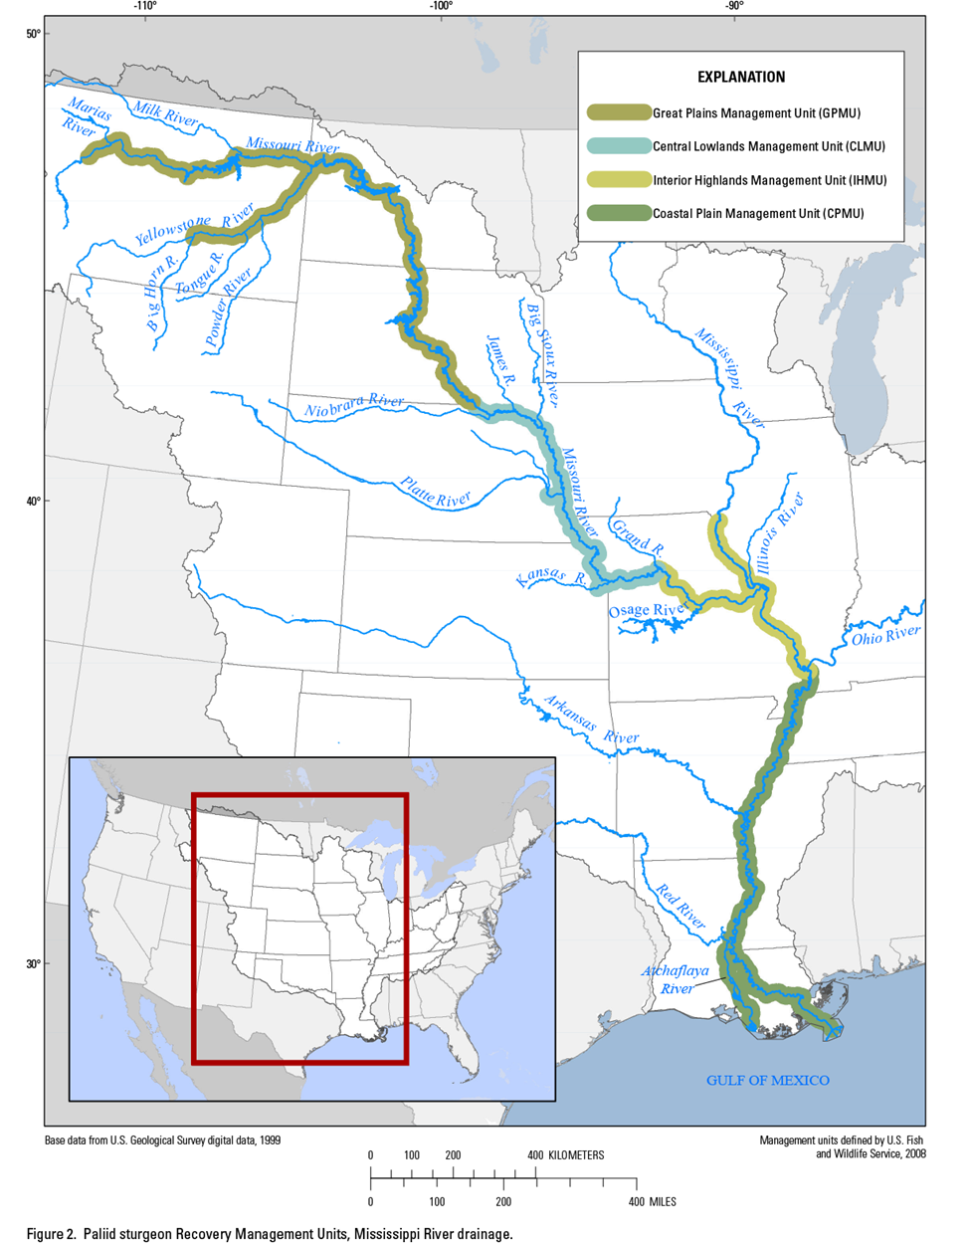

**RPMA 3**

**Figure D1, Pallid sturgeon recovery management units, showing previous recovery priority management areas (RPMA) and contemporary management units (U.S. Fish and Wildlife Service, 2014).**

All three of these types of monitoring and assessment may provide important information for decision making and AM. There is debate, however, about the distribution of resources among the three types and the resulting utility of information to support decisions. Whereas the contributions of implementation and hypothesis-driven process monitoring are fairly clear, the value of population monitoring is less clear. In particular, there are differences of opinion (for pallid sturgeon and many other rare species) about the relative value of enumerating numbers of organisms to document status and trends, compared to modeling population changes based on measured or inferred changes to population growth parameters.

Arguments against investment in population-level monitoring center around high costs (or low information:cost ratio) and the difficulty in testing management hypotheses with population-level data. For example, we would anticipate difficulty assigning cause and effect to changes in estimated pallid sturgeon population as a result of management actions like increased flow naturalization or IRC area. Arguments to include some level of effort in population-level monitoring include:

* Value of population estimates as a reality check on inferences from process monitoring/assessment and (or) population models. Without a population-level assessment, indicators of general population health – positive and negative – may be missed resulting in risk to the species or spending resources where they are not needed.
* Value of population estimates as a metric of success for achieving population targets.
* Value of population estimates to track and predict need for continued investment in population augmentation.
* Value of population estimates and associated survival estimates to continuously update critical parameters in population models, thereby increasing reliability.
* Value of population estimates as a metric for understanding trend compared to performance and cost effectiveness of other metrics such as catch per unit effort (CPUE).
* Value of population estimates in understanding density-dependent processes in population dynamics including potential carrying-capacity limitations or depensation effects.
* Some process-level hypotheses are effectively tested, or testing will be enhanced, by population-level monitoring. This is particularly true about hypotheses related to population augmentation.

The present pallid sturgeon Population Assessment Program (PSPAP) is based on a catch per unit effort that is applied consistently throughout the geographic scope of the Missouri River Recovery Program (MRRP). The PSPAP was developed to support information needs articulated in the USFWS 2003 Amended Biological Opinion (BiOp) (U.S. Fish and Wildlife Service 2000, 2003). It is reasonable to expect that information needs and priorities would shift in 15 years since implementation of the BiOp and that the new management plan would have new information needs.

* + 1. Objective of This Report

The objective of this report is to explore options for refining a population trends monitoring approach so it is effective and efficient in meeting the needs of the adaptive-management program. Effectiveness will be judged based on ability to discern long-term trends and the degree to which the monitoring complements and enhances assessments of specific management actions. Because there are many unknowns about future performance of a population monitoring effort, we do not make specific recommendations about the details of the effort. Instead, we present an assessment of existing efforts and current information needs (Section D.2), design guidance from previous studies (Section D.3), and a general concept for redesign (Section D.4). We provide detail on existing efforts, including sampling protocols and gears, because that information is the foundation from which more effective and efficient methods can be designed. The greatest unknown is level of effort and cost, and the degree to which population-level monitoring can coordinate and leverage resources (staffing, equipment) with process-level monitoring. We therefore recommend investment in a detailed planning and simulation process to refine a population-monitoring effort as a level 1 science effort (included in science components, Appendix C and described in section D4.2.1).

1. Past and Current Monitoring Projects

Several long-term monitoring projects have been implemented on the Missouri River and its tributaries during the last 10 years. Most were specifically designed to meet reasonable and prudent alternatives (RPA) elements in the BiOp for the Missouri River, each with different objectives. The PSPAP was developed to provide an assessment of long-term trends in pallid sturgeon abundance, population structure, and habitat use. Catch-per-unit effort (CPUE) was selected as the metric to evaluate trends in abundance due to the low numbers of sturgeon in the river and the perceived amount of effort that would be required to provide reliable abundance estimates through a mark-recapture effort. A description of the PSPAP and other, past projects is below.

* + 1. Pallid Sturgeon Population Assessment Project

The PSPAP is the primary fish monitoring element for the BiOp (U.S. Fish and Wildlife Service 2000, 2003) and the MRRP. Data collected through the PSPAP are used to evaluate the pallid sturgeon propagation and population-augmentation management action (RPA element IV) and provide long-term assessments of fish metrics (RPA element V; population trends, survival, movement, distribution, and habitat use by pallid sturgeon and other target fishes). The PSPAP also collects pallid sturgeon broodstock each spring for meeting BiOp stocking requirements (RPA element IV) and the stocking levels identified by management biologists for Recovery Priority Management Areas 1-4 (RPMAs, Figure D1).

* + - 1. *Objectives*

The Project objectives, sample design, and protocols were developed by an inter-agency team of Missouri River basin experts and continue to be guided by the Project Delivery Team (PDT) that is comprised of 8 agency offices from the USFWS, Montana Fish, Wildlife, and Parks (MTFWP), South Dakota Game, Fish, and Parks (SDGFP), Nebraska Game and Parks Commission (NGPC), Missouri Department of Conservation (MDC), and USACE. In addition to pallid sturgeon, a representative group of native Missouri River fishes is also monitored to detect improvements in the system as reflected by changes in the warm water benthic fish community. Project monitoring targets the following species: pallid sturgeon (*Scaphirhynchus albus*), sand shiner (*Notropis stramineus*), sicklefin chub (*Macrhybopsis meeki*), sauger (*Sander canadensis*), shovelnose sturgeon (*Scaphirhynchus platorynchus*), plains minnow (*Hybognathus placitus*), western silvery minnow (*Hybognathus argyritis*), shoal chub (*Macrhybopsis hyostoma*; formerly speckled chub, *Macrhybopsis aestivalis*), sturgeon chub (*Macrhybopsis gelida)* and blue sucker (*Cycleptus elongatus*).

Objectives for PSPAP were developed to meet the 2003 BiOp RPA elements IV and V and are as follows:

* Evaluate trends in pallid sturgeon population abundance, distribution and habitat use throughout the Missouri River system.
* Evaluate survival, growth and habitat use of stocked pallid sturgeon in the Missouri River system.
* Document and evaluate pallid sturgeon reproduction and recruitment in the Missouri River system.
* Evaluate current and long-term trends in native Missouri River fish species abundance, distribution and habitat usage, with emphasis on warm water benthic fish community.
  + - 1. *Geographic Scope*

The PSPAP area encompasses the Missouri River from Fort Peck Dam, Montana at rivermile (RM) 1771.5 downstream to the confluence of the Missouri and Mississippi rivers near St. Louis, Missouri (RM 0) and the lower reach of the Kansas River (Figure D1). The BiOp divides the PSPAP area into river and reservoir segments and assigns high, moderate, or low priority management action to these segments for the pallid sturgeon. The focus of the PSPAP is the high-priority management-action segments (Figure D1). The segments identified as moderate or low priority for pallid sturgeon are categorized as reservoirs or transitional zones between rivers and reservoirs (USFWS 2000).

* + - 1. *Sample Design*

Fish and habitat data collections within 13 river segments (Figure D2) began in 2003 with full implementation of standardized sampling in all high-priority segments in 2006. The PSPAP uses a three-tiered hierarchical habitat classification system (macrohabitat, mesohabitat and microhabitat; see Welker and Drobish (2012) for a detailed description of habitat types) that allows for both general and specific categorization for sampling to serve the needs for biological and physical data collection efforts. PSPAP recognizes 14 river segments based on hydrologic criteria. Within each segment, macrohabitats are arranged by bends, which serve as the basic sampling unit (replicate) within each river segment. A bend comprises three continuous macrohabitats, an outside bend (main channel; OSB), an inside bend (main channel; ISB) and a channel crossover (main channel; CHXO). Within a segment, a minimum of 25.2% of all bends are sampled in a sample year. Within a bend, 12 potential discrete macrohabitats could occur beyond the three continuous macrohabitats [that is, large (TRML) and small (TRMS) tributary mouths, confluences (CONF), large (SCCL) and small (SCCS) secondary connected channels, non-connected secondary channels (SCN), deranged (DRNG), braided (BRAD), dendritic (DEND), and island tips (ITIP)]. All available macrohabitats are subsampled within a randomly-selected bend.

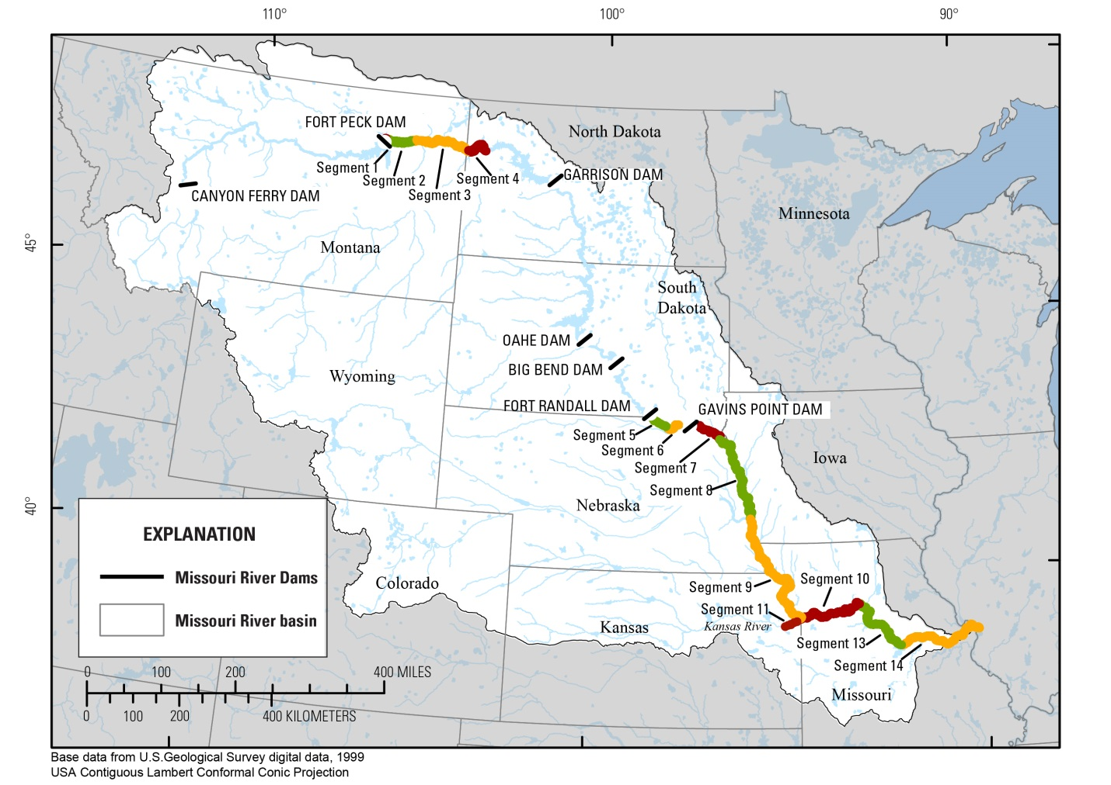

**Figure D2. Segments used by the Pallid Sturgeon Population Assessment Program.**

Sampling occurs from October 31 (or when water temps fall below 12.8 C (55 °F)) of the preceding calendar year to October 30 of the current calendar year. Each year includes two sampling seasons: sturgeon-focused (Sturgeon Season; ST) and native fish community-focused (Fish Community Season; FC) season. Sturgeon season runs from fall when water temperatures are first below the maximum (12.8 °C) set for gill nets to June 30 in attempts to minimize pallid sturgeon stress during collection. Fish community season runs from July 1 to October 31, overlapping ST for water temperatures below 12.8 °C (55 °F) prior to October 31.

A variety of fish and habitat metrics are measured through the PSPAP. For each pallid sturgeon capture, length and weight, morphological (meristics), genetic, marking (PIT tags, elastomer tags, or scute removal), habitat at capture location (depth, velocity, turbidity, and temperature), and location data are collected; some of these data are also collected for the other target fish species. Additional information on PSPAP data is available in Jacobson et al. (2015a).

* + - 1. *PSPAP General Sampling Approach*

Fish-sampling gears and methods were developed by the PSPAP team and are described in detail in Welker and Drobish (2012). A list of the standard-gear types analyzed in this report and the methods used by the PSPAP to deploy the gears are listed below.

* + - * 1. *Sampling Seasons*

Two sampling seasons were established to accomplish sampling objectives for the PSPAP. These sampling seasons are determined by dates and water temperatures to provide flexibility in sampling across the geographic range of the Missouri River Basin. The sturgeon season begins in the fall when the water temperature is < 12.8°C (55°F) and continues through June 30th. The water temperature criteria addresses the issue of the water temperature variations between the upper and lower portions of the Missouri River and the amount of time in the field season to accomplish restrictive sampling (that is, gill netting) prior to ice up. On July 1st, sampling efforts remain the same with an additional emphasis on the associated fish community. The fish community season runs from July 1st through October 31st. The two seasons may overlap in portions of the river when temperatures fall below 12.8°C prior to the conclusion of the fish community season. A variety of fish-sampling gears were used during the sample seasons in both the Upper and Lower Missouri River.

* + - * 1. *Trammel Net*

Trammel nets were used during both sampling seasons within the Upper and Lower Missouri River; however, trammel net sampling was dropped from the sturgeon season in the Lower Missouri River in 2010. The standard trammel net was 125 feet (38.1 m) long by 8 feet (2.4 m) high and had 1-inch (2.5-cm) inner panel bar mesh and 8-inch (20.3-cm) outer panel bar mesh. The top of each trammel net was supported by foam float line; a lead line ran along the bottom. Targeted drift distances for trammel nets were between 75 m and 300 m.

* + - * 1. *Otter Trawl*

Otter trawls were used during both sampling seasons within the Upper and Lower Missouri River. The standard otter trawl was 16 feet (4.9 m) wide at the mouth, 3 feet (0.9 m) high, and 25 feet (7.6 m) long. Otter trawls had ¼-inch (6-mm) inner bar mesh, ¾-inch (19-mm) outer bar mesh, and a cod-end opening of 16 inches (40.6 cm). Trawl doors were 30 inches (76.2 cm) by 15 inches (38.1 cm) and were used to keep the trawl deployed while on the bottom of the river. Otter trawls were fished in a downstream direction with the distance of the tow depending on the size of the macrohabitat and mesohabitat being sampled and presence of snags. Targeted tow distances for otter trawls were between 75 m and 300 m (minimum of 75 m required).

* + - * 1. *Gill Net*

Gill nets were used only during the sturgeon season within the Lower Missouri River. The standard gill net was a 100-foot (30.5-m) long by 8-foot (2.4-m) high experimental gill net that consisted of four 25-foot (7.6-m) long panels. Each net had one panel each of 1.5-inch (3.8-cm), 2-inch (5.1-cm), 3-inch (7.6-cm), and 4-inch (10.2-cm) multifilament square/bar mesh. A 200-foot (61.0-m) experimental gill net was also used and consisted of two 100-foot nets attached together. The first panel deployed from the boat during each set was randomly selected. Gill nets were set over night with a targeted maximum set time of 24 hours.

* + - * 1. *Trotline*

Trotlines were used during both sampling seasons within the Upper and Lower Missouri River. The standard trotline consisted of a 105-foot (32-m) main line with hooks spaced 5 feet (1.5-m) on 18-inch (0.5-m) leaders (20 hooks per 105-foot main line). The level of effort (hooks and lines) could be doubled per deployment (205 ft. main line length with 40 hooks). Hooks were baited with night crawlers. Trotlines were set over night with a targeted maximum deployment of 24 hours.

* + - 1. *Evaluation*

PSPAP data provide useful information for several reasons in addition to trend detection:

1. It allows an evaluation of gear effectiveness and comparison with other fish collecting gears.
2. It provides a way to evaluate the cost of monitoring with a particular gear and to compare that cost to other gears.
3. It can be used to optimize the sampling strategies needed to meet objectives.

Pallid sturgeon objectives for the MRRP include reproduction (<1 year-old pallid sturgeon), recruitment (1-3 year-old pallid sturgeon), and quantifying demographic parameters. It is somewhat difficult to determine ages of pallid sturgeon based on body length; however, it is generally accepted that those <109 mm (Ridenour et al., 2011) are < 1 year old (that is, age-0, young-of-year; hereafter referred to as YOY). For this assessment, we quantified CPUE separately for fish <=109 mm (YOY) and >109 mm (juvenile + adult). Few pallid sturgeon <=109 mm have been captured through MRRP monitoring; therefore, we used shovelnose sturgeon as a surrogate for YOY pallid sturgeon.

The PSPAP uses a variety of standard gears to sample the different ages and sizes of pallid sturgeon. For fish <109 mm, the otter trawl was the gear used to quantify catch (Table D2). The trammel net, gill net, trotline, and otter trawl were used to quantify catch for fish > 109 mm (Table D2). Gear subsamples were averaged across years and segments within a basin to obtain a single CPUE value for each gear type. Catch was reported as number of fish/100 m2 for the trammel net and the otter trawl. Gill net catch was quantified as number of fish/net night and trotline catch as number of fish/20 hooks. The number of sturgeon/gear deployment (subsample) was also reported for all gears (Table D3). For a description of standard gear dimensions, consult Welker and Drobish (2012).

**Table D2.** Sturgeon catch for gears used during standard, random sampling in the Pallid Sturgeon Population Assessment Project (PSPAP; 2006-2015)*, targeted broodstock collection (2006-2015)**, the Habitat Assessment and Monitoring Project (HAMP; 2013-2014), and the Platte River Assessment (Platte River; 2009-2012).

[Standard Error (when available) has been identified in parenthesis below catch data]

|  |  |  |  |  |  |  |  |
| --- | --- | --- | --- | --- | --- | --- | --- |
|  |  | **Gears** | | | | | |
| **Monitoring Effort** | **Size/Age** | **Trawl\***  **(#/100 m2)** | **Trammel Net\***  **(#/100 m2)** | **Trotline*/\*\***  **(#/20 hooks)** | **Gill Net\***  **(#/net night)** | **Trammel Net 48\*\***  **(#/100 m2)** | **Trammel Net 610\*\***  **(#/100 m2)** |
| **Upper Basin** | | | | | | | |
| PSPAP | <109 mm | 0.030 (0.004) |  |  |  |  |  |
|  | >=109 mm | 0.002 (0.0001) | 0.001 (0.0001) | 0.55  (0.030) |  |  |  |
| Broodstock | >=109 mm |  |  |  |  | 0.001 (0.0002) | 0.001 (0.0001) |
| **Lower Basin** | | | | | | | |
| PSPAP | <109 mm | 0.004 (0.003) |  |  |  |  |  |
|  | >=109 mm | 0.004 (0.0002) | 0.0005 (0.00003) | 0.108  (0.005) | 0.035 (0.001) |  |  |
| HAMP | <109 mm | 0.330 (0.027) |  |  |  |  |  |
| Broodstock | >=109 mm |  |  | 0.180  (0.006) |  |  |  |
| Platte River | >=109 mm |  |  | 0.058 |  |  |  |

**Table D3.** Sturgeon catch (number of fish per deployment) for gears used during standard, random sampling in the Pallid Sturgeon Population Assessment Project (PSPAP; 2006-2015)*, targeted broodstock collection (2006-2015)**, the Habitat Assessment and Monitoring Project (HAMP; 2013-2014), and the Platte River Assessment (Platte River; 2009-2012).

[Standard Error (when available) has been identified in parenthesis below catch data]

|  |  |  |  |  |  |  |  |
| --- | --- | --- | --- | --- | --- | --- | --- |
|  |  | **Gears** | | | | | |
| **Monitoring Effort** | **Size/Age** | **Trawl\*** | **Trammel Net\*** | **Trotline*/\*\*** | **Gill Net\*** | **Trammel Net 48\*\*** | **Trammel Net 610\*\*** |
| **Upper Basin** | | | | | | | |
| PSPAP | <109 mm | 0.080 (0.0095) |  |  |  |  |  |
|  | >=109 mm | 0.087  (0.0041) | 0.106 (0.0053) | 0.55  (0.030) |  |  |  |
| Broodstock | >=109 mm |  |  |  |  | 0.062 (0.025) | 0.065 (0.013) |
| **Lower Basin** | | | | | | | |
| PSPAP | <109 mm | 0.129 (0.0073) |  |  |  |  |  |
|  | >=109 mm | 0.011 (0.0010) | 0.019 (0.0014) | 0.180 (0.0071) | 0.0035 (0.001) |  |  |
| HAMP | <109 mm | 0.472 |  |  |  |  |  |
| Broodstock | >=109 mm |  |  | 0.336 (0.010) |  |  |  |

For pallid sturgeon >109 mm, trotlines had the highest CPUE in both the Upper (0.55/20 hooks, 0.55/deployment) and Lower (0.180/20 hooks, 0.180/deployment) basins (Table D2). The gill net had the lowest CPUE for all gears (0.035/net night, 0.0035/deployment). Catch for the trawl and trammel net were similar within their respective basins across the two size classes (Table D2). Catch as quantified by number of fish/deployment followed similar trends across the gears (Table D3).

In addition to the data presented here, several analyses of the PSPAP add understanding of what the project has provided (Sustainable Ecosystems Institute 2004, Wildhaber et al. 2011b, Wildhaber et al. 2015).

* + 1. Habitat Assessment and Monitoring Project

The Habitat Assessment and Monitoring Project (HAMP) was developed in 2004 by an interagency collaboration of representatives from the Iowa Department of Natural Resources, Missouri Department of Conservation (MDC), Nebraska Game and Parks Commission (NGPC), South Dakota Game, Fish and Parks (SDGFP), University of Missouri, USACE, USFWS, and U.S. Geological Survey (USGS). The HAMP was initiated to evaluate habitat modifications designed to increase shallow, slow water habitat within the main channel of the Missouri River. The concept of shallow water habitat (SWH) has been defined operationally as 0-5 ft (0-1.5 m) depth and 0-2 ft/s (0-0.6 m/s) current velocity (U.S. Fish and Wildlife Service 2000a); a recent clarification emphasized dynamics and variability of SWH elaborated on its hypothesized functions: “Shallow water habitat provides locations for increased primary productivity, invertebrate production, and larval/young-of-year nursery habitat” (Olson 2009).

From 2004-2009, pallid sturgeon and other target species were monitored to evaluate changes in relative abundance between habitat-modified and unmodified river bends. A before-after-control-impact (BACI) study design was used to evaluate the potential effects of habitat alteration (dominantly dike notching) on fish communities. The assessment (Schapaugh et al. 2010) cited the HAMP as an excellent design to achieve active AM, yet noted that the assumptions of the underlying BACI designs were not being met under real-world conditions and therefore ability to detect effects of SWH was limited. In particular the authors reported that the actions of dike notching did not result in detectable changes in the fish community. The authors suggested that specific hypotheses addressing mechanisms of change associated with changes in habitat and fish production need to be addressed. . However, Ridenour et al. (2009) used HAMP collected Macryhbopsis spp. chubs to demonstrate ontogenetic shifts in habitat use from age-0 to adulthood, and discussed the role of SWH and the potential for strategic dike notching, in support of pallid sturgeon recovery.

Recently, HAMP efforts have been modified to de-emphasize the previous BACI design and to focus on specific hypotheses relating SWH and life-stage processes of larval and young-of-year pallid sturgeon (Todd Gemeinhardt, USACE, pers. comm.). The purpose of the current HAMP study is to evaluate the efficacy of existing SWH to support early life stages of age-0 *Scaphirhynchus spp.* (undifferentiated age-0 pallid sturgeon and shovelnose sturgeon) to facilitate adaptive decision making for future habitat construction actions.

* + - 1. *Objectives*

The recent, primary objectives of HAMP are to: 1) compare density (numbers per unit area) of age-0 sturgeon between reaches with high acreages of SWH (existing or restored) against reaches with no or minimal SWH; and 2) identify and prioritize the types, or suite of types, of habitats that best promote use by age-0 sturgeon to guide management decisions on future SWH restoration.

* + - 1. *Geographic Scope*

The current HAMP study includes 5 river reaches that are approximately 20 miles in length. The study area begins at RM 327 (approximately 30 miles downriver from Kansas City, MO) and extends to RM 33 near St. Louis, MO.

* + - 1. *Sample Design*

To maximize efficiency and value of the HAMP’s limited sampling resources, a stratified random approach was used in 2014-2015 to guide sampling efforts through the habitat classification hierarchy to avoid oversampling in habitats where age-0 sturgeon (<109 mm) are not likely to occur (based on PSPAP capture data collected from 2003 to 2013 in segments 10, 13, and 14 and existing HAMP data). Sampling units are limited to short (approximately 20 mile) reaches of Missouri River from Kansas City to St. Louis and is implemented to meet the two objectives listed above. Subsampling was distributed with a goal of achieving representativeness (prevent clustering of sampling in any part of reach) and rapid progression through each reach to minimize effects of changing environmental conditions on data interpretation within and among reaches. Additional information related to the sample design can be found in Gosch et al. (2015). Habitats in the 5 reaches are sampled from May through October. Habitats >1.5 m in depth are sampled with an otter trawl similar to that used by the PSPAP (see Welker and Drobish 2012 for description); however, the HAMP trawl has a smaller mesh size (4 mm vs. 6.35 mm for PSPAP). In habitats <1.5 m deep, the HAMP samples with a 4-mm mesh push trawl (Gosch et al. 2015).

* + - 1. *Evaluation*

The catch information reported here is for the 2014 sample season. Catch for age-0 (<109 mm) *Scaphirhynchus* sturgeon through the HAMP project was approximately 5 times greater than the catch rate obtained for PSPAP (Tables D2 and D3). This is likely due to differences in sample design and gear types, in particular the emphasis on targeted, habitat-based sampling rather than completely non-stratified randomizaton.

* + 1. Broodstock Sampling

The pallid sturgeon Propagation and Population Augmentation element (RPA IV) is a direct effort to supplement year-class structure to the pallid sturgeon population due to the lack of spawning and/or recruitment in the Missouri River. It also attempts to provide for survival of the species, retention of the remaining population genetics and structure, provides adults to test management actions and recruitment hypotheses, and provides a reliable source of progeny for addressing uncertainty related to age-0 pallid sturgeon survival.

* + - 1. *Objective*

The objective of broodstock sampling is to provide reproductive adults for the augmentation program. Wild pallid sturgeon are collected each spring and brought into hatcheries for spawning and the eventual stocking of their progeny into the Missouri River; this occurs in the Upper (Fort Peck Reservoir to Lake Sakakawea and the Lower Yellowstone River) and Lower (Lewis and Clark Lake to the Missouri River mouth) Missouri River basins (Figure D1). Currently, pallid sturgeon broodstock collection activities in the upper river are conducted by Montana Fish, Wildlife, and Parks (MTFWP), U.S. Geological Survey (USGS), and the U.S. Fish and Wildlife Service (USFWS), and generally occur in May and June. In the Lower River, broodstock collection occurs primarily in April and is conducted by the USFWS and the states of South Dakota, Missouri, and Nebraska.

The largest broodstock collection effort occurs in the Lower River. For example, in 2015 over a two-week sample period, Nebraska Game and Parks Commission (NGPC) utilized 175 personnel, mostly volunteers, in an intensive effort. A similar, but smaller effort was conducted in the Lower Missouri River by the Missouri Department of Conservation (MDC) where they used a combination of 78 agency and volunteer personnel to collect pallid sturgeon broodstock. In the Upper and Lower rivers, most of the agency personnel that are involved with broodstock collection also conduct fish monitoring through USACE funded projects (e.g., PSPAP, HAMP, and Comprehensive Sturgeon Research Project [CSRP]).

* + - 1. *Geographic Scope*

Pallid sturgeon broodstock collection occurs in the four Recovery Priority Management Areas (RPMA; 1-4) for pallid sturgeon in the Missouri River. RPMA 1 is outside of the geographic scope of the MRRP (that is, upriver of Fort Peck Reservoir); however, the MRRP does include those portions of the Missouri River encompassed by RPMA’s 2-4. The USACE has jeopardy responsibilities for pallid sturgeon under the Endangered Species Act in these three RPMA’s.

* + - 1. *Sample Design*

Broodstock sampling throughout the Missouri River basin is a targeted effort rather than randomized, and is therefore subject to considerable bias in estimating fish density. Sampling is concentrated during spring in areas where adult-sized pallid sturgeon have been found in high concentration in the past (e.g., reaches, bends, habitats, river confluences). A variety of fish sampling gears are used throughout the basin; trammel nets (TN48, 38.1 m long x 2.4 m deep with 4 in and 8 in panel mesh; TN610, 38.1 m long x 2.4 m deep with 6 in and 10 in panel mesh) serve as the primary gear in the upper river with PSPAP standard trotlines the primary gear used in the Lower River (for a description of gear dimensions, consult Welker and Drobish (2012)). Sampling by the various resource agencies is concentrated into a two- to three-week period.

* + - 1. *Evaluation*

For this report, broodstock CPUE was quantified for two types of trammel nets in the Upper Basin and for the standard PSPAP trotline. Gear subsamples were averaged across years and segments within a basin to obtain a single CPUE value for each gear type. Catch was reported as number of fish/100 m2 for the trammel nets and the number of fish/20 hooks for the trotline. The number of sturgeon per gear deployment (subsample) was also reported for all gears (Table D3).

In the Lower River, targeted broodstock sampling with the trotline provided the highest catch per deployment (0.336; Table D3) when compared to the gears used for PSPAP standard, random sampling (Table D2). Targeted broodstock sampling in the upper river provides lower catch rates (Table D3) compared to trotline and trammel net sampling through PSPAP (Table D2). However, the broodstock trammel nets (TN48 and TN610) were selected and are deployed to capture the large and rare upper river legacy broodfish. This likely results in a lower catch rate than if the entire population of pallid sturgeon were also targeted for capture.

* + 1. Platte River Assessment

Sampling for pallid sturgeon began in 2009 as part of a research effort designed to determine the distribution and abundance of pallid sturgeon in the Lower Platte River. Pallid sturgeon were collected annually from 2009-2012 with the research effort renewed in 2014.

* + - 1. *Geographic Scope*

The research area extends up the Platte River from river kilometer (rkm) 0 at the confluence with the Missouri River to rkm 159 near the Loup River Power Canal confluence.

* + - 1. *Sample Design*

Data collection occurred in randomly selected 1-km reaches within two study segments. A stratified-random sampling approach was used to select 20 sample reaches within each segment. Fish were collected with drifting trammel nets (depth=1.8 m; length=38.1 m; outside mesh panel=15.0 cm; inside mesh panels=2.5 cm) and trotlines (30.5 m main line; 20 3/0 O’Shaughnessy hooks). Data provided as a personal communication from M. Hamel (2015).

* + - 1. *Evaluation*

Trammel net catch for pallid sturgeon >=109 mm was 0.058 fish/100 m drifted which is higher than the 0.017/100 m found for the PSPAP in the Lower Missouri River. Trotline CPUE in the Lower Platte River was 0.015/20 hooks which is lower than the 0.108/20 hooks obtained for pallid sturgeon in the Lower Missouri River through the PSPAP. Targeted broodstock sampling with the trotline for the PSPAP yielded 0.180/20 hooks. It should be noted that the Platte River is substantially shallower and has more complex habitats on average than the Missouri River, so gear efficiencies would be expected to vary.

* + 1. Comprehensive Sturgeon Research Project

The CSRP is an interagency collaboration of the USGS, NGPC, MTFWP, USFWS, and the USACE Missouri River Recovery—Integrated Science Program. The goal of CSRP is to improve the fundamental understanding of the reproductive ecology of the pallid sturgeon (*Scaphirhynchus albus*) to better inform river and species management decisions. The CSRP is not intended to be a monitoring project, but it has had aspects of monitoring in its long-term datasets.

* + - 1. *Objectives*

Specific objectives pursued 2005-2014 include:

* Determine movement, habitat use, and reproductive behavior of pallid sturgeon;
* Understand reproductive physiology of pallid sturgeon and relations to environmental conditions;
* Determine origin, transport, and fate of drifting pallid sturgeon larvae and evaluate bottlenecks for recruitment of early life stages;
* Quantify availability and dynamics of aquatic habitats needed by pallid sturgeon for all life stages; and
* Manage databases, integrate understanding, and publish relevant information into the public domain.

CSRP has emphasized understanding of reproductive ecology of adult and early-life-stage sturgeon. For understanding reproductive behaviors of adults, the CSRP approach has been to capture adult shovelnose and pallid sturgeon, evaluate the reproductive status of each individual (Korschgen 2007), and instrument each with a uniquely coded acoustic or acoustic/radio combined telemetry transmitter and archival data storage tag (DST) to record temperature and depth (as pressure) at 15 to 30 minute interval. Telemetry has been used to locate individual sturgeon over long periods to collect information on movement, habitat use, behavior, and response to environmental cues or habitat manipulations.

* + - 1. *Geographic Scope*

CSRP activities range from the Upper Missouri and Yellowstone rivers to the Middle Mississippi River. Some telemetry and supporting abiotic datasets have collected in tributaries like the Osage, Kansas, Platte, and Big Sioux rivers. The inter-reservoir reaches from Lake Sakakawea to Lewis and Clark Lake have not been included.

* + - 1. *Sample Design*

The CSRP telemetry dataset is focused on hypotheses relating to the reproductive ecology of pallid sturgeon adults. The sample design includes comparative studies of migration, aggregation, and spawning in the Upper Missouri-Yellowstone and the Lower Missouri River. In the Lower Missouri River, reproductive behaviors upstream of the Platte River are compared to reproductive behaviors downstream of Kansas City in an attempt to isolate effects of flow management.

Since the CSRP was initiated, 175 pallid sturgeon and 376 shovelnose have been implanted with telemetry tags and telemetry tags in combination with DST devices in the Lower Missouri River. Of these, 172 (98.3%) pallid sturgeon 352 (94.6%) Shovelnose Sturgeon were located at least once after release. More than 80 pallid sturgeon have been in the CSRP study for multiple years and had multiple telemetry and DST devices during that time. From pallid sturgeon implanted with DST devices, CSRP has archived more than 3.3 million depth and temperature records. All locations on the Lower Missouri River are determined through boat-mounted acoustic receivers. On the Upper Missouri and Yellowstone Rivers, most tags have been radio frequency.

CSRP has also carried out some free-embryo sampling to address specific questions about where and when sturgeon spawn. Systematic sampling for free embryo sturgeon and paddlefish was initiated through CSRP in 2012 and is conducted along transects perpendicular to the flow of the river at intervals throughout the spawning and dispersal periods. Systematic sampling was performed in 2012 in the Lower Missouri River near St. Charles, MO from mid-April into October to detect timing, and extent of spawning by sturgeon and paddlefish, and species composition and abundance of Acipensiform free embryos drifting in the Lower Missouri River. Systematic sampling efforts during 2012 and 2013 resulted in a total of 2043 gear deployments at two locations, collecting a total of 665 sturgeon and 412 paddlefish free embryos.

* + - 1. *Evaluation*

CSRP studies have established telemetry methods for implantation, tracking, and data analysis for pallid sturgeon. The experience indicates that boat-based acoustic telemetry tracking is viable on the Lower Missouri River and combined acoustic and radio tags are useful on the Upper Missouri River. The results show the long distances some fish will travel in their reproductive migrations (100’s of km) and, in some case, some spatial fidelity to their reproductive home ranges. This experience with telemetry techniques and data processing is likely to be useful in design and implementation of future population trends monitoring, including the use of telemetry in evaluating emigration and immigration.

* + 1. Summary of Past and Current Projects

Of the projects described above, only the PSPAP was developed and implemented to capture trends in pallid sturgeon population metrics. PSPAP catch information, evaluated within the context of the other projects, documents which gears, habitats, and sampling designs appear to be most efficient and therefore likely to be useful in future population monitoring. In addition to the data presented here, several analyses of the PSPAP add understanding of what the project provides and the reliability of the quantified trends. Early in the development of PSPAP, an independent science review was conducted by Sustainable Ecosystems Institute (2004). A number of recommendations was provided and later implemented to better integrate the project components and meet objectives. Statistical power analyses were performed periodically (Peery 2004, Bryan et al. 2010, Schapaugh and Tyre 2011) to identify investments and trade-offs in the project design and to evaluate the ability to detect changes in abundance. Population trends were quantified through a number of assessments (Oldenburg et al. 2010, Wildhaber et al. 2011, Wildhaber et al. 2015) following standardization of the project design in 2006. Recent work by Wildhaber et al. (2015) provided new models that incorporated covariates (e.g., water temperature, velocity, gear, habitat) that improved the detection of abundance and habitat-use changes over time. Their assessment determined that “….a large-scale, large-river, PSPAP-type monitoring program can be an effective tool for assessing population trends and habitat usage of large-river fish species. Using multiple gears, PSPAP was effective in monitoring shovelnose and pallid sturgeons, sicklefin, shoal and sturgeon chubs, sand shiner, blue sucker and sauger.” However, the question to be answered through this report is: will implementing the current PSPAP monitoring design, or an alternative design, best meet the future needs and objectives identified in the MRRP AM Plan?

* + 1. Design Guidance from Current Monitoring Information

Current and past monitoring projects on the Missouri River can provide valuable insight into important design criteria such as when, where, and at what level of effort to sample; choosing the appropriate level of each criterion will optimize the sample design for meeting MRRP objectives. Review of these projects will lead to development of the most efficient design that provides high quality data, the least-biased estimates, and high precision or certainty. Detailed analysis (e.g., simulations that examine trade-offs) as part of a level 1 science effort will be required to identify the most appropriate design based on the type of information needed, the level of detail, the metrics, and the cost of collecting the data; however, at this preliminary stage, numerous design considerations can be identified. The design considerations are provided below for sub-objectives 1 and 2. Considerations identified for sub-objective 2 would also apply to quantifying or updating population demographics (that is, catch rates for all size classes of pallid sturgeon).

* + - 1. *Temporal Sampling Distribution*

Temporal sampling considerations will depend on the objectives and the metrics selected to assess the Fundamental and Species objectives. The current temporal sampling units vary depending on the project (e.g., PSPAP or HAMP). The PSPAP sampling is separated into two temporal units per year, a sturgeon season (ST) and a fish community season (FC); these generally run from early winter through spring (ST) and summer to late fall (FC). Sampling in the PSPAP has occurred sporadically, representing every month of the year and usually summarized by season or year. Other projects have more specific time periods for sampling such as during the spring/early summer to track reproductive adults or during the late summer to sample for larval sturgeon in the drift, for example.

Temporal sampling units can widely vary (e.g., day, month, season, or year). Depending on the specific objectives of a study, timing of sampling is important especially when directed at certain life stages. Thus, identifying time frames to conduct sampling for specific life stages of interest throughout the year at specific locations will result in the collection of data that can address the objectives of a study. Pallid sturgeon use many locations in the Missouri River and can move extensively throughout the year, thus timing of sampling and location must match to address study objectives.

* + - 1. *Upper River*

Most effort for age 2-3 pallid sturgeon from 2006-2014 was in May (n=3,679 subsamples) and June (n=3,132 subsamples) followed by August and September (n=2,894 and 2,904 subsamples, respectively) (Figure B3). Although the number of subsamples averaged 506 fewer in August/September than in May/June, catch rate (#/subsample) was highest in August/September (mean = 0.04) compared to May/June (mean = 0.025). However, the month of April also had a catch rate of 0.04 when the number of subsamples was only 1,105. The highest catch rate was 0.05 in October where the number of subsamples was 2,081.

The majority of pallid sturgeon < 109 mm were caught in August (Figure B3). Sub-adult pallid sturgeon catch rates were low in the spring/summer and higher from August through October. Few (n=40) large pallid sturgeon (> 1,000 mm) have been caught, however, 31 of those were caught from August through October (Table D5).

The largest amount of subsampling from 2006-2014 has been in May and June, although these two months have generally resulted in a fewer number of pallid sturgeon caught per subsample relative to the other months. The month of April has the largest catch rate relative to number of subsamples for age 2-3 fish and August generally appears to have the greatest catch rates for all sizes of pallid sturgeon.

|  |  |  |  |  |
| --- | --- | --- | --- | --- |
| **Table D5.** PSPAP catch for pallid sturgeon (>=109-1,000 mm; >1,000 mm; age 2-3) and *Scaphirhynchus* species (< 109 mm FL) for each month (March-October) in the upper Missouri River basin for the years 2006-2014. * | | | | |
| [FL: fork length; mm: millimeter.] | | | | |
| Size | Month | Area | Number sturgeon caught | Number per subsample |
| <109 mm | Apr | Segment 4 | 6 | 0.02 |
|  | May |  | 15 | 0.03 |
|  | Jun |  | 3 | 0.01 |
|  | Jul |  | 12 | 0.05 |
|  | Aug |  | 77 | 0.27 |
|  | Sep |  | 28 | 0.07 |
|  | Oct |  | 6 | 0.02 |
| >=109 mm – 1,000 mm | Mar | Segments 2-4 | 0 | 0 |
|  | Apr |  | 188 | 0.17 |
|  | May |  | 515 | 0.14 |
|  | Jun |  | 345 | 0.11 |
|  | Jul |  | 248 | 0.12 |
|  | Aug |  | 695 | 0.24 |
|  | Sep |  | 842 | 0.29 |
|  | Oct |  | 728 | 0.35 |
| Only otter trawl subsamples are reported for *Scaphirhynchus* spp. sturgeon <109 mm; otter trawl, trammel net, and trotline subsamples are reported for the other length/age groups. | | | | |

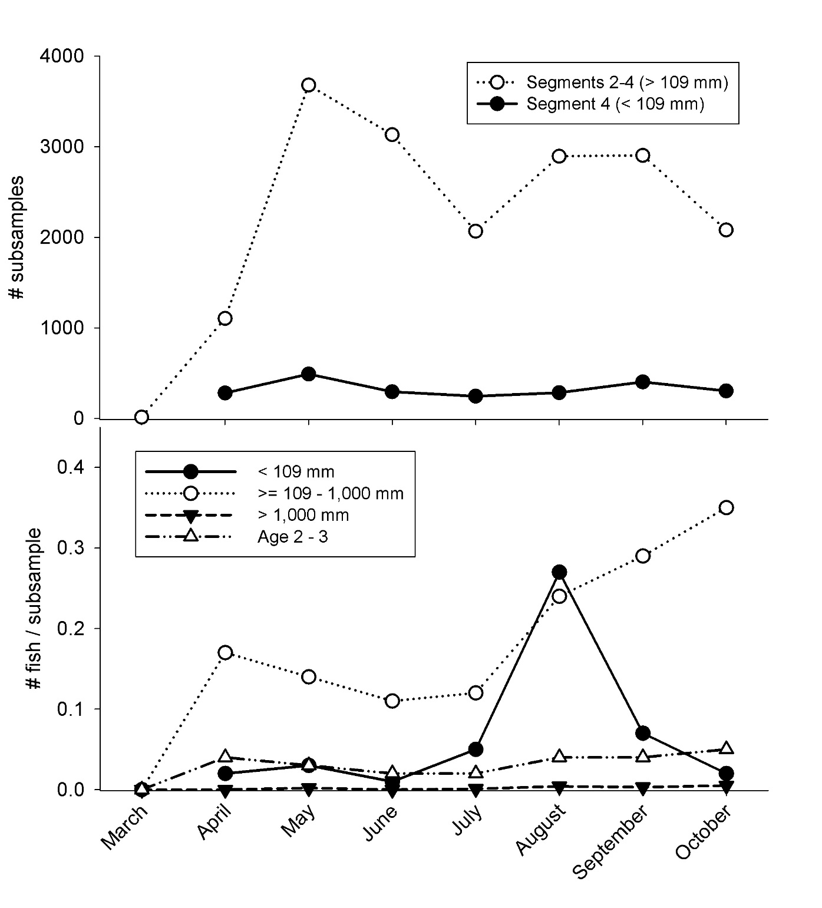

**Figure D3. PSPAP effort (top panel) and catch (bottom panel) for pallid sturgeon (>=109-1,000 mm; >1,000 mm; age 2-3) and *Scaphirhynchus spp.* (< 109 mm FL) for each month (March-October) in the upper Missouri River basin for the years 2006-2014. Only otter trawl subsamples are reported for *Scaphirhynchus spp*. sturgeon <109 mm; otter trawl, trammel net, and trotline subsamples are reported for the other length/age groups.**

* + - 1. *Lower River*

Most effort for age 2-3 pallid sturgeon from 2006-2014 was from May through August (range: 3,946-5,072 subsamples) (Figure B3). The lowest effort was from December through February. Catch rate (#/subsample) was either 0.0 or 0.01. Age 2-3 pallid sturgeon have only been caught from March-May and October-November (Table D6).

Pallid sturgeon < 109 mm were catch rate increased from May to August and peaked in September (Figure D3). Sub-adult pallid sturgeon catch rates were highest in the spring and late fall while low from June through September (Figure D3). The month for the highest catch rate of large pallid sturgeon (> 800 mm) was October.

* + - 1. *Summary*

The largest amount of subsampling from 2006-2014 has been from May through August, although these months have generally resulted in a fewer number of pallid sturgeon caught per subsample relative to the other months. Both spring and fall months have similar catch rates age 2-3 fish, but the months of September and October generally appear to have the greatest catch rates for all sizes of pallid sturgeon. Furthermore, catch rates in September and October are higher with less effort than that observed for the month of May through August.

|  |  |  |  |  |
| --- | --- | --- | --- | --- |
| **Table D6.** PSPAP catch for pallid sturgeon (>=109-1,000 mm; >1,000 mm; age 2-3) and *Scaphirhynchus* species (< 109 mm FL) for each month (March-October) in the lower Missouri River basin for the years 2006-2014. * | | | | |
| [FL: fork length; mm: millimeter.] | | | | |
| Size | Month | Area | # sturgeon caught | #/Subsample |
| <109 mm | May | Segments 10, 13, 14 | 19 | 0.02 |
|  | Jun |  | 65 | 0.08 |
|  | Jul |  | 74 | 0.13 |
|  | Aug |  | 143 | 0.18 |
|  | Sep |  | 201 | 0.31 |
|  | Oct |  | 60 | 0.13 |
| >=109 mm – 800 mm | Jan | Segments 7-14 | 15 | 0.03 |
|  | Feb |  | 44 | 0.05 |
|  | Mar |  | 198 | 0.06 |
|  | Apr |  | 147 | 0.06 |
|  | May |  | 190 | 0.04 |
|  | Jun |  | 39 | 0.01 |
|  | Jul |  | 101 | 0.02 |
|  | Aug |  | 84 | 0.02 |
|  | Sep |  | 71 | 0.02 |
|  | Oct |  | 281 | 0.08 |
|  | Nov |  | 251 | 0.09 |
|  | Dec |  | 48 | 0.06 |
| >800 mm | Jan | Segments 7-14 | 5 | 0.01 |
|  | Feb |  | 26 | 0.03 |
|  | Mar |  | 66 | 0.02 |
|  | Apr |  | 25 | 0.01 |
|  | May |  | 0 | 0 |
|  | Jun |  | 0 | 0 |
|  | Jul |  | 0 | 0 |
|  | Aug |  | 0 | 0 |
|  | Sep |  | 0 | 0 |
|  | Oct |  | 140 | 0.04 |
|  | Nov |  | 56 | 0.02 |
|  | Dec |  | 16 | 0.02 |
| Age 2-3 | Jan | Segments 7-14 | 0 | 0 |
|  | Feb |  | 0 | 0 |
|  | Mar |  | 33 | 0.01 |
|  | Apr |  | 25 | 0.01 |
|  | May |  | 48 | 0.01 |
|  | Jun |  | 0 | 0 |
|  | Jul |  | 0 | 0 |
|  | Aug |  | 0 | 0 |
|  | Sep |  | 0 | 0 |
|  | Oct |  | 35 | 0.01 |
|  | Nov |  | 28 | 0.01 |
|  | Dec |  | 0 | 0 |
| Only otter trawl subsamples are reported for *Scaphirhynchus* spp. sturgeon <109 mm; otter trawl, trammel net, gill net, and trotline subsamples are reported for the other length/age groups. | | | | |

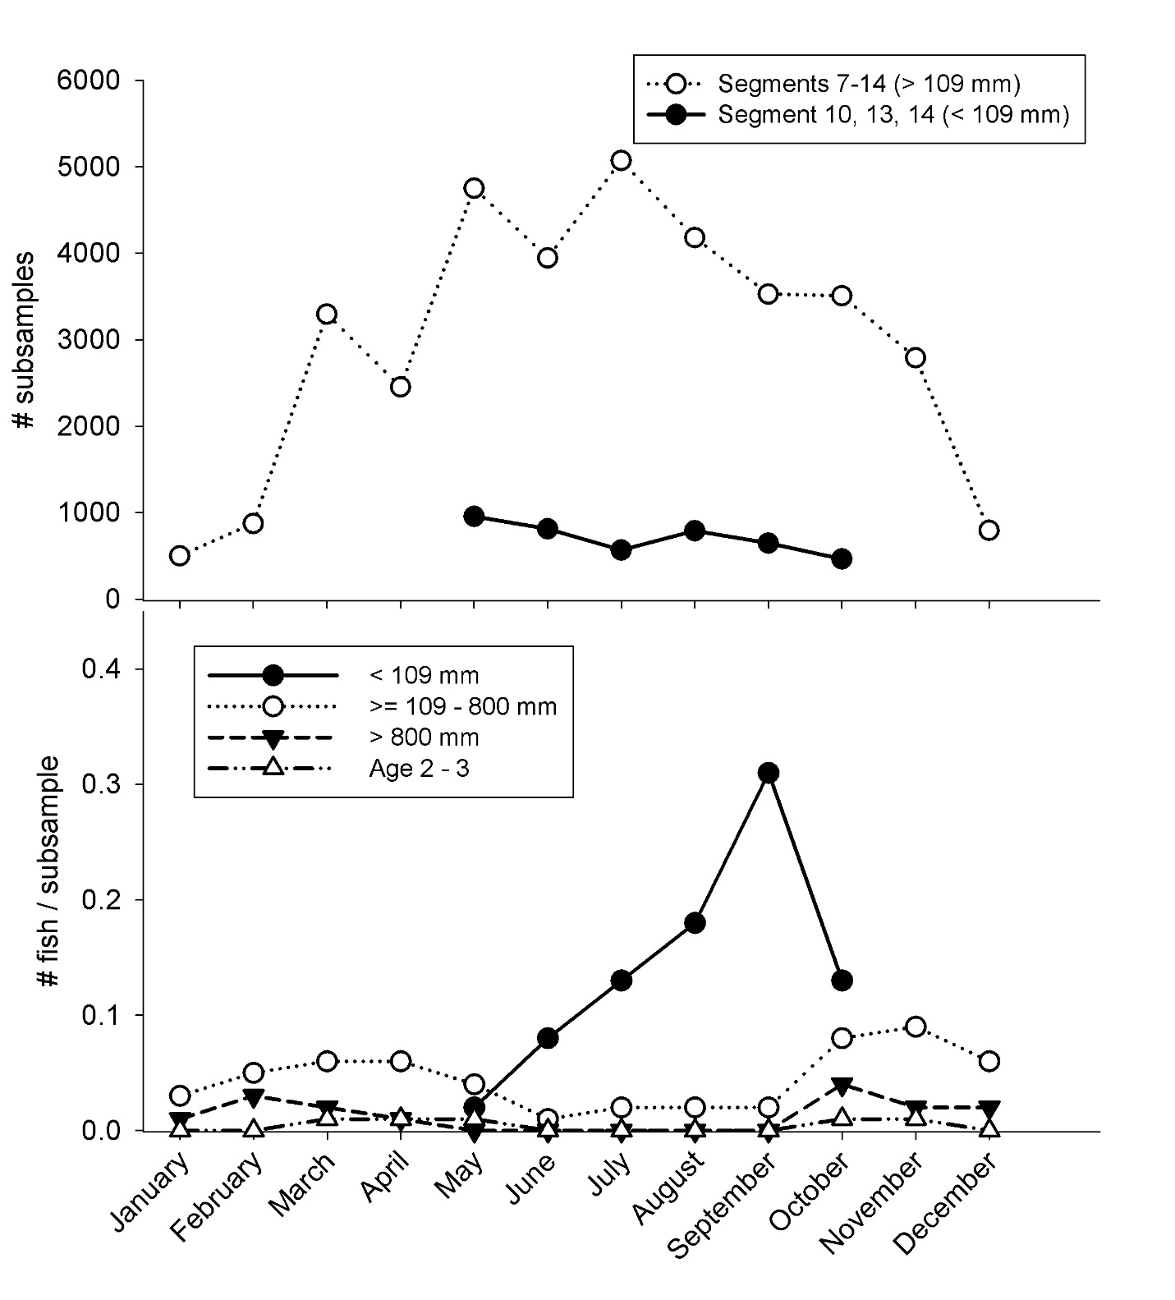

**Figure D4. PSPAP effort (top panel) and catch (bottom panel) for pallid sturgeon (>=109-800 mm; >800 mm; age 2-3) and *Scaphirhynchus spp.* (< 109 mm FL) for each month in the lower Missouri River basin for the years 2006-2014. Only otter trawl subsamples are reported for *Scaphirhynchus spp*. sturgeon <109 mm; otter trawl, trammel net, gill net, and trotline subsamples are reported for the other length/age groups.**

*D.1.1.26 Spatial Sampling Distribution*

Spatial sampling considerations depend upon the objectives under consideration and the metrics selected to assess how actions are meeting these objectives. The largest spatial units of interest for pallid sturgeon monitoring are identified in the EA and MRRMP and are as follows: 1) the Upper Missouri River mainstem from Fort Peck Dam to the headwaters of Lake Sakakawea and 2) the Lower Missouri River mainstem from Gavins Point Dam to confluence with the Mississippi River at St. Louis. These are the largest spatial units that may be considered when developing a monitoring plan for pallid sturgeon through the MRRP for a variety of reasons: 1) these two spatial units reflect biologically significant opportunities for achieving benefit to pallid sturgeon, 2) management actions may be implemented in these areas, 3) the results of management actions may be detected in these spatial units (e.g., successful recruitment), 4) these are the areas where the USACE impacts to pallid sturgeon have been previously identified (e.g., 2003 BiOp), and 5) they encompass the decision-making authority of the USACE. Other spatial units to consider (see reasons 1 and 2 above) are the Yellowstone River upstream of the confluence with the Upper Missouri River for an unspecified distance, an unspecified distance downstream in the Mississippi River, and tributaries used by pallid sturgeon.

The fundamental spatial sampling consideration for any design will be the gear (e.g., trammel net, or gill net) subsample location. Subsample locations can be organized and selected in a variety ways; the most objective approach would be to randomly select points within a larger spatial construct (e.g., river reach). However, such an approach would seem haphazard as much has been learned regarding habitat use by pallid sturgeon in the Missouri River for a variety of life stages. Identifying the habitat types most likely to contain the life stage(s) of interest and incorporating this information into the sample design will likely provide the most efficient path to decision-influencing results. Further, the habitat types that are utilized by pallid sturgeon may also vary longitudinally in the Missouri River. The PSPAP employs a hierarchical sample design that progresses from largest to smallest spatial units as follows: Basin (Upper, Middle, Lower MR), Segment, River Bend, Habitat (Macro, Meso, Micro), and gear subsample. The current HAMP project selected and then targeted those habitat types from PSPAP that provided the highest catch rates for very young (that is, age-0) *Scaphirhynchus* sturgeons. The HAMP project provides an example of what a targeted habitat-sampling effort can provide with regard to detecting a size/age of interest. Tables D5 and D6 provide the number of *Scaphirhynchus spp.* (surrogate for age-0 pallid sturgeon), juvenile/sub-adult pallid sturgeon, and adult pallid sturgeon captured in each habitat type from 2006-2014 within Upper and Lower Missouri River segments. HAMP capture information for the 2014 sample year is provided in Table D7. Body length was used to partition the captures into age-0 (<109 mm; Ridenour et al. 2011), juvenile/sub-adult (>= 109 mm – 800 mm in the LB and 1,000 mm in the UB), and adult (>800 mm LB, >1,000 mm UB) for sub-objective 2. Tables D5 and D6 provide the same information for pallid sturgeon 2-3 years of age (hereafter referred to as 2-3 yr old). The length range for 2-3 yr-old pallid sturgeon was derived from the growth models of known-age hatchery-produced pallid sturgeon in Shuman et al. (2011); the length range between the predicted length for the 2 and the 3-year old age groups was used to select the catch information for this category (that is, 275-400, Upper River; 325-425, Lower River).

**Table D7.** Catch [number/subsample] for *Scaphirhynchus spp.* (less than 109 millimeters fork length) for each Macrohabitat-Mesohabitat combination in the Lower Missouri River below Kansas City, Mo. sampled through the HAMP from 2013-2014.

[See Welker and Drobish 2012 for a description of gears and habitat types.]

|  |  |  |  |
| --- | --- | --- | --- |
| **Macro/Meso** | **Gear** | **Gear Subsample Count** | **Individuals Captured/Subsample** |
| **River miles 327-307; 237-215** | | | |
| CHXO-BARS | Micro-mesh Otter Trawl | 12 | 0.25 |
| CHXO-CHNB | Micro-mesh Otter Trawl | 41 | 0.46 |
| ISB-BARS | Micro-mesh Otter Trawl | 142 | 0.27 |
| ISB-CHNB | Micro-mesh Otter Trawl | 451 | 0.73 |
| OSB-CHNB | Micro-mesh Otter Trawl | 1 | 1.00 |
| OSB-BARS | Micro-mesh Otter Trawl | 9 | 0.22 |
| SCCL-BARS | Micro-mesh Otter Trawl | 136 | 0.11 |
| SCCL-CHNB | Micro-mesh Otter Trawl | 530 | 0.44 |
| SCCL-ITIP | Micro-mesh Otter Trawl | 1 | 0.00 |
| **River miles 180-157; 110-94; 54-33** | | | |
| CHXO-BARS | Micro-mesh Otter Trawl | 59 | 0.05 |
| CHXO-CHNB | Micro-mesh Otter Trawl | 436 | 0.38 |
| CHXO-POOL | Micro-mesh Otter Trawl | 12 | 0.5 |
| ISB-BARS | Micro-mesh Otter Trawl | 257 | 0.20 |
| ISB-CHNB | Micro-mesh Otter Trawl | 2040 | 0.51 |
| ISB-ITIP | Micro-mesh Otter Trawl | 2 | 4.50 |
| ISB-POOL | Micro-mesh Otter Trawl | 7 | 3.14 |
| SCCL-BARS | Micro-mesh Otter Trawl | 21 | 0.05 |
| SCCL-CHNB | Micro-mesh Otter Trawl | 26 | 0.15 |
| SCCL-ITIP | Micro-mesh Otter Trawl | 16 | 0.19 |
| SCCL-TLWG | Micro-mesh Otter Trawl | 6 | 0.00 |
| SCCS-CHNB | Micro-mesh Otter Trawl | 2 | 0.50 |

While Tables D5-D7 provide an average of the annual catch rates for sampling through the PSPAP and HAMP, Tables D8-D11 of pallid sturgeon (or *Scaphirhynchus* spp.) throughout the sample year (by month). Tables D12-D15 (Upper River) and Tables D16-D19 (Lower River) provide the gear-habitat distributions of catch rates over the same monthly time frame for the combined segments in each basin (Upper River and Lower River).



**Table D8.**



**Table D9.**



**Table D10.**



**Table D12.**

**Table D11.**





**Table D14.**

**Table D13.**



**Table D15.**





**Table D16.**



**Table D17.**

**Table D17.**



**Table D18.**

**Table D18.**



**Table D19.**

**Table D19.**

* + - 1. *Upper River*

*Scaphirhynchus* sturgeon <109 mm (that is, age-0) and sub-adult (>=109 mm-1,000 mm) pallid sturgeon were most often captured in three habitat types: ISB-CHNB, OSB-CHNB, and CHXO-CHNB (Tables D12 and D13).

In addition, data indicate that segment 4 (downstream from the Yellowstone River-Missouri River confluence) provides the best opportunity to capture pallid sturgeon < 109 mm (few *Scaphirhynchus* *spp.* <109 mm are captured upstream from the confluence).

* + - 1. *Lower River*

The highest catch rates for *Scaphirhynchus* sturgeon <109 mm occurred in CHXO-BARS and ISB-BARS habitats (Tables D16 and D17); however, only 39 subsamples were taken from these habitat types. Of the remaining habitat types, the ISB-CHNB provided the highest catch rate (Tables D16 and D17). Sub-adult (>=109 mm-800 mm) and adult (>800 mm) pallid sturgeon were captured in a variety of habitat types, but most frequently in the CHNB mesohabitat (CHXO-CHNB, ISB-CHNB, OSB-CHNB, SCCL-CHNB) and macrohabitats associated with tributaries (CONF-CHNB, CONF-POOL) (Tables D16 and D17).

Additional insights can be gained from HAMP samples. The current HAMP implements a design that focuses sampling in habitats where age-0 *Scaphirhynchus* sturgeon were most commonly found through the PSPAP. This approach allows the HAMP to avoid over sampling in habitats that are unlikely to contain young sturgeon. From RM 327-215, ISB-CHNB and SCCL-CHNB provided the highest catch rates for sturgeon <109 mm for habitat types with >100 subsamples (Table D7). CHXO-CHNB and ISB-CHNB exhibited the highest catch rates between RM 180 and RM 33 (Table D7). Catch rates of sturgeon <109 mm for the HAMP were at least 6 times greater than those found for the PSPAP (Tables D16 and D17).

* + - 1. *Summary*

Reviewing capture information for macrohabitat types provides insight into fine-scale spatial elements of a sample design, however, it does not provide insight into larger-scale elements. Murray et al. (2014) conducted a basin-wide analysis of PSPAP capture data to elucidate geographical patterns in pallid sturgeon abundance and found that several small- and large-scale factors were associated with higher probability of pallid sturgeon capture in both the Upper and Lower Missouri River:

1. in the Lower Missouri River, gears used in the pool mesohabitat had significantly higher probability of capturing a pallid sturgeon than any other habitat type;
2. macrohabitats associated with a large tributary mouth or a tributary confluence had a greater probability of catching a pallid sturgeon, as well as having greater abundance in the Upper Missouri River;
3. wider valley floor widths were associated with greater probabilities of pallid sturgeon capture or high pallid sturgeon relative abundances in the Upper and Lower Missouri River;
4. in the Upper Missouri River, the probability of pallid sturgeon capture and the relative abundance increased with increasing distance downstream from Fort Peck Dam;
5. in the Lower Missouri River, the abundance of pallid sturgeon decreased from upstream to downstream.

Murray et al. (2014) did not evaluate spatial distribution patterns according to size or age structure. The possibility of examining differences between juvenile/sub-adult and adult habitat preferences was evaluated early in their study; however, only a small proportion (~6.4%) exceeded the adult-length cutoff used to identify adult pallid sturgeon (>800 mm in the Lower MR and >1,000 mm in the Upper MR). Therefore, both size classes of pallid sturgeon were combined for the analysis (which was comprised mainly of juvenile/subadult-sized pallid sturgeon). The longitudinal distribution of catch summarized in this report indicates that age-0 (<109 mm) *Scaphirhynchus* sturgeon are most likely to be found in the lower segments of the Upper and Lower rivers (Table D8); however, older and larger pallid sturgeon tend to be distributed throughout the segments (Tables D9-D11; it should be noted that stocking location likely influences the distribution of age 2-3 year-old pallid sturgeon catch in Table D10).

* + - 1. *Effective Gears*

To evaluate specific fisheries objectives requires the selection of gears that most effectively sample the species or life history of interest. Researchers must consider the selectivity of the sampling gear during field-study design. Capture efficiency is a complex dynamic that includes the sampling gear, technique, and the availability/vulnerability of the target species. Capture efficiency and size selectivity bias is problematic for researchers because it can lead to under or over estimating a population and it can also affect estimates of various population factors, such as recruitment, size structure, and mortality (Levesque 2013). Thus, selecting the most appropriate fish collecting gears should be at the core of any sample design.

In the Upper Missouri River basin, four gears are used by PSPAP crews to sample the fish community: trotline, trammel net, otter trawl, and mini fyke. PSPAP crews in the Lower Missouri River sample pallid sturgeon with the mini fyke, gill net, trotline, trammel net, and otter trawl. The mini fyke net does not effectively sample pallid sturgeon, so it was not considered during this assessment. The HAMP uses an otter trawl similar to that employed by the PSPAP (see Welker and Drobish 2012 for description) in habitats >1.5 m in depth; however, the HAMP trawl has a smaller mesh size (4 mm vs. 6.35 mm for PSPAP). In habitats <1.5 m deep, the HAMP samples with a 4-mm mesh push trawl (see Gosch et al. (2015) for a description of HAMP gears).

* + - 1. *Upper River*

Pallid sturgeon similar in length to 2-3 year old known-age fish were most effectively captured with the trotline in a variety of habitat types (Table D14). The trammel net was also an effective gear, while capture rates for the otter trawl were similar to, but lower than, the trammel net (Table D14).

For PSPAP, only the otter trawl was effective at sampling pallid sturgeon <109 mm (that is, age-0) (Table D12). Sub-adult (>=109 mm – 1,000 mm) pallid sturgeon were most effectively sampled with the trotline (Table D13); nearly 30% of the subsamples in CHXO-CHNB, ISB-CHNB, OSB-CHNB, and SCCL-CHNB contained sub-adult pallid sturgeon. Capture rates for pallid sturgeon greater than 1,000 mm were low for the trotline and trammel net (Table D15). This is likely due to the low numbers of these larger, older fish and the potential poor capture efficiency for these gears. Larger mesh trammel nets are used to capture these larger, adult fish during broodstock collection, although catch rates are still low (Table D15).

* + - 1. *Lower River*

Catch rates were similar and low for pallid sturgeon in the 2-3 year-old length category for all gear types (Table D18). Better catchability information can likely be obtained by reviewing the catch information for sub-adult pallid sturgeon (Table D17) as the sample size is much higher.

Similar to the Upper River, the otter trawl was the only gear effective at sampling age-0 sturgeon (Table D16). As described previously, the combined catch of <109 mm *Scaphirhynchus* sturgeon for the HAMP trawls exceeded those found for PSPAP, likely due to the smaller mesh size, the use of the push trawl in shallow habitat replicates, and the focus on habitats most likely to contain young sturgeon.

The highest catch rates for sub-adult (>=109 mm – 800 mm) pallid sturgeon were obtained using the trotline (Table D17); 11.8% of the trotline subsamples contained at least 1 pallid sturgeon from this category. Pallid sturgeon >800 mm in length were also most effectively captured with the trotline (Table D19).

* + - 1. *Summary*

Analysis of PSPAP catch data by Murray et al. (2014) identified gear-related patterns for pallid sturgeon that can be considered in developing a monitoring approach that meets the two sub-objectives and provides the demographic data needed to update population models. Their gear-related findings are as follows: 1) the trotline was found to be the most efficient gear for catching pallid sturgeon when sampling in both the Upper and Lower Missouri River; it had a significantly lower proportion of deployments with zero catch than the other trawl, trammel net, and gill net, 2) expanding the trotline sampling effort at the cost of reduced sampling effort among other standard gear types may be beneficial, and 3) the otter trawl and trammel net deployments did not provide much useful information about the abundance and distribution of pallid sturgeon. It should be noted that pallid sturgeon less than 109 mm were not evaluated by Murray et al. (2014) as none were collected through PSPAP; however, shovelnose sturgeon <109 mm are frequently captured with the otter trawl (Tables D12, D16).

* + 1. Summary Guidance

The purpose of this section is to summarize the foregoing analysis of temporal, spatial, and gear influences on catch rates to provide guidance for future sampling. This sampling could be a continuation of a CPUE-centered sampling strategy for documenting trends, or as discussed in Section D.4, the sampling could be integrated into a mark/recapture-centered strategy that promises to provide estimates of population size and survival, as well as trends. The guidance is organized by subobjectives.

* + - 1. *Sub-objective 1 – Increase Pallid Sturgeon Recruitment to Age 1* 
         1. *Upper River*

*Longitudinal Sampling Distribution*

Past sampling through PSPAP indicates that the majority of age-0 *Scaphirhynchus* sturgeon has been captured downstream from the confluence of the Yellowstone and Missouri rivers in Segment 4 (FigureD2, Table D8). Further, predictive flow models developed through the Effects Analysis indicate that the majority of the drifting free-embryo pallid sturgeon would settle into this segment, if they do not drift through it into Lake Sakakawea. Therefore, the most effective and efficient trawling to capture age-0 and age-1 pallid sturgeon and to detect recruitment to age-1 would be in Segment 4.

*Macrohabitats*

Age-0 pallid sturgeon have been captured in a variety of macro-mesohabitats through the PSPAP; however, the highest catch rates were obtained in the CHXO-CHNB, ISB-CHNB, and the OSB-CHNB macro-mesohabitat combinations (Table D12). The highest CPUE in these habitats has been found in the months of July through September (Table D12). In the Upper River, pallid sturgeon (and shovelnose sturgeon) typically spawn in late-April through May. Therefore, age-0 *Scaphirhynchus* should be available for capture in June, July, and August. The lack of catch in the month of June and a low CPUE in July for age-0 *Scaphirhynchus* sturgeon (Figure D4) may be an artifact of the sampling gear used by the PSPAP. The HAMP has recently used a smaller mesh size to collect very young and small sturgeon (that is, < 50 mm total length) in the Lower River. For maximum efficiency, sampling for age-0 pallid sturgeon would begin in June and focus on the three habitat types identified above.

*Gears*

The only gear utilized by PSPAP and HAMP for sampling age-0 sturgeon is the trawl. PSPAP uses an otter trawl (OT16) with an opening 16 ft. (4.9 m) wide by 3 ft. (0.9 m) high and 6-mm inner bar mesh. HAMP uses a trawl (OT04) of similar dimensions; however, the inner bar mesh is 4-mm. The HAMP has implemented a targeted sampling protocol that primarily uses the OT04 trawl in the habitats with the highest CPUE values found during 10 years of sampling through the PSPAP. This resulted in the HAMP sampling over 1,300 *Scaphirhynchus* sturgeon < 50 mm in length in the Lower River during a single season (2014). Comparatively, the PSPAP has sampled less than 200 of these small sturgeon in 10 seasons (2005-2014). It is recommended that age-0 and age-1 sturgeon sampling be conducted with either the OT04 or the OT16 fitted with 4-mm inner bar mesh instead of the standard 6-mm mesh size.

*Summary*

For maximum efficiency in addressing the recruitment objective, sampling for age-0 would begin in June, following the pallid sturgeon spawning period. Sampling with the trawl (OT04 or OT16) for these small sturgeon could continue through the summer and into the fall; however, it is anticipated that much of the effort in the fall will need to be focused on mark-recapture sampling. Therefore, it is recommended that trawling to sample age-0 and age-1 pallid sturgeon occur in the months of June and July. The spatial focus of the sampling should be restricted to Segment 4 in the CHXO-CHNB, ISB-CHNB, and OSB-CHNB habitat types. A complete summary of the information can be found in Table D20.

* + - * 1. *Lower River*

*Longitudinal Sampling Distribution*

Past sampling through PSPAP (Table D6) and HAMP (Table D7) indicates that the majority of age-0 *Scaphirhynchus* sturgeon occur downstream from Kansas City, MO in Segments 10, 13, and 14; the only larval (non-drifting) pallid sturgeon found in the Lower River were captured downstream from Kansas City, although drifting free embryos have been captured upstream of the Platte River (DeLonay et al., 2016). Similar to the Upper River, predictive flow models developed through the Effects Analysis show that the majority of the drifting free-embryo pallid sturgeon would settle into this portion of the Missouri River or downriver in the Mississippi River. These models still need to be calibrated and validated, but to maximize efficiency age-0 and age-1 pallid sturgeon trawling would be restricted to Segments 10, 13, and 14 (Figure D2); this restriction could be removed as more is learned about dispersal of age-0 pallid sturgeon.

*Macrohabitats*

Age-0 pallid sturgeon have been captured in a variety of macro-mesohabitats through the PSPAP; however, the highest catch rates were obtained in the CHXO-CHNB and ISB-CHNB macro-mesohabitat combinations (Table D16). The highest CPUE in these two habitats has been found in the months of June through October (Table D16). Similarly, 95% of the age-0 *Scaphirhynchus* sturgeon sampled through HAMP were collected in these two habitat types in the same time frame. In order to maximize efficiency for the recruitment objective, sampling for age-0 pallid sturgeon would begin in June and focus on the two habitat types identified above.

*Gears*

The only gear utilized by PSPAP and HAMP for sampling age-0 sturgeon is the trawl. As described above, PSPAP uses the OT16 otter trawl with 6-mm inner bar mesh and the HAMP uses the OT04 that possesses a much smaller (4 mm) mesh. The smaller mesh size used through HAMP results in a much higher catch rate for sturgeon < 50 mm (total length). Therefore, it is recommended that age-0 and age-1 sturgeon sampling be conducted with either the OT04 or the OT16 fitted with 4-mm inner bar mesh instead of the standard 6-mm mesh size.

*Summary*

For maximum efficiency of sampling applied to the recruitment objective, sampling for age-0 pallid sturgeon would begin in June, following the spawning period. Sampling with the trawl (OT04 or OT16) for these small sturgeon could continue through the summer and into the fall; however, it is anticipated that much of the effort in the late fall will need to be focused on mark-recapture sampling. Therefore, it is recommended that trawling to sample age-0 and age-1 pallid sturgeon occur in the months of June, July, and August. The spatial focus of the sampling should be restricted to Segments 10, 13, and 14 in the CHXO-CHNB and ISB-CHNB habitat types. A complete summary of the information can be found in Table D20.

* + - 1. *Sub-objective 2 – Population Growth, Abundance, and Stability*
         1. *Upper River*

*Longitudinal Sampling Distribution*

Past sampling through PSPAP and other monitoring projects indicates that pallid sturgeon juvenile and adult (>109 mm in length) have been captured in all Segments (2, 3, 4) on the Missouri River (Tables D9-D11, D13-D15). Therefore, it is recommended that mark-recapture monitoring occur in all Segments (2, 3, 4) of the Missouri River.

*Macrohabitats*

Juvenile and adult pallid sturgeon have been captured in a variety of macro-mesohabitats through the PSPAP; however, catch rates are closely linked to gear-habitat combinations and time of year. Overall, the highest catch rates have been found for the same three habitat types (that is, CHXO-CHNB, OSB-CHNB, ISB-CHNB) as YOY Scaphirhynchus sturgeon (Tables D13-D15) with high catch rates also found for the SCCL-CHNB. Tributary mouths have also provided high catch rates for juvenile and adult pallid sturgeon in the Upper River and could also be included in the sample design. Catch rates are highest in April-May and August-October.

*Gears*

The trammel net and the trotline have been used to effectively sample juvenile and adult pallid sturgeon in the Upper River (Tables D13-D16). Trotline CPUE is generally higher than that of the trammel net. Sampling with the trotline is generally ineffective in the spring due to high debris loads in the river that bury the gear and in the summer/early fall due to loss of bait to non-target fish species. The trammel net is most effective in August-October when river stage and discharge begins to decline.

*Summary*

For maximum efficiency in addressing the population growth, abundance, and stability objective, sampling for juvenile and adult pallid sturgeon would begin in August with the trammel net and continue through October. Trotline sampling can occur in October when this gear is effective at sampling pallid sturgeon (Ryan Wilson, USFWS, pers. comm.). The spatial focus of the sampling should be Segments 2, 3, 4 (Table D14) in the CHXO-CHNB, ISB-CHNB, OSB-CHNB, and SCCL-CHNB habitat types. Tributary mouths (TRML), such as the mouth of the Yellowstone River, may also be incorporated into the sample design. A complete summary of the information can be found in Table D20.

* + - * 1. *Lower River*

*Longitudinal Sampling Distribution*

Past sampling through PSPAP indicates that pallid sturgeon juvenile and adult (>109 mm in length) have been captured in all Segments (7, 8, 9, 10, 13, 14) of the Lower River (Tables D9-D11). Therefore, it is recommended that monitoring for pallid sturgeon >/= 109 mm occur in all segments of the Lower River.

*Macrohabitats*

Past PSPAP sampling indicates catch rates for juvenile and adult pallid sturgeon are closely linked to gear-habitat combinations and time of year. Overall, the highest catch rates have been found for the four habitat types: BRAD-CHNB, CHXO-CHNB, ISB-CHNB, and ISB-POOL (Tables D17-D19). Tributary mouths have also provided high catch rates for juvenile and adult pallid sturgeon in the Lower River and could also be included in the sample design. Catch rates are highest in March-May and October-December (Tables D17-D19).

*Gears*

In the Lower River, the trotline has been the most effective gear for sampling juvenile and adult pallid sturgeon (Tables D17-D19). Sampling with the trotline is generally effective in the spring and late fall. The gear is much less effective during May-September when small, non-target fishes remove much of the bait from hooks (Kirk Steffensen, NGPC, pers. comm.). The other gears exhibit very low catch rates for pallid sturgeon and would require large amounts of effort in a mark-recapture approach (Tables D7, D17-D19); however, fall sampling with the gill net may be considered as catch rates are comparable to the trotline.

*Summary*

For maximum efficiency in addressing the population growth, abundance, and stability objective, sampling for juvenile and adult pallid sturgeon would occur with the trotline during two time periods: 1) in spring beginning in March and continuing through mid-May and 2) in fall beginning in mid-September and continuing through December. The beginning and end of each sample period in a particular segment is closely tied to water temperature. Water temperature greatly influences the capture efficiency of the trotline as the activity of bait-stealing fish increases as water temperature increases. Ice-up can also prevent crews from accessing sample sites in the late fall. The spatial focus of the sampling should be all Lower River segments in the BRAD-CHNB, CHXO-CHNB, ISB-CHNB, and ISB-POOL habitat types. Tributary mouths (TRML), such as the Platte River, have provided high catch rates for the trotline and therefore may also be incorporated into the sample design. A complete summary of the information can be found in Table D20.

|  |  |  |  |  |
| --- | --- | --- | --- | --- |
| **Table D20.** Summary of sampling information from previous pallid sturgeon monitoring projects that identifies the most effective gears, habitats, segments, and sample periods for capturing pallid sturgeon. | | | | |
| **Targeted Size** | **Gear** | **Habitats** | **Segments** | **Effective Periods** |
| **Upper Missouri River** | | | | |
| <109 mm (age-0) | OT04/OT16 | CHXO-CHNB, ISB-CHNB, OSB-CHNB | 4 | June-October |
| >=109 mm | Trammel Net | CHXO-CHNB, ISB-CHNB, OSB-CHNB | 2, 3, 4, lower 48 km of the Yellowstone River | August-October |
|  | Trotline | CHXO-CHNB, ISB-CHNB, OSB-CHNB, SCCL-CHNB | 2, 3, 4, lower 48 km of the Yellowstone River | October |
| **Lower Missouri River** | | | | |
| <109 mm (age-0) | OT04/OT16 | CHXO-CHNB, ISB-CHNB | 10, 13, 14 | June-October |
| >=109 mm | Trotline | BRAD-CHNB, CHXO-CHNB, ISB-CHNB, ISB-POOL | 7, 8, 9, 10, 13, 14 | March-May; October-December |

1. An Integrated Approach to Population-level Monitoring, Assessment, and Modeling

In this section we discuss a potential approach to optimize population-level monitoring, assessment, and modeling to support AM of the pallid sturgeon in the Missouri River. Additional future analysis will be required to develop details of this approach as a level 1 science effort. Our objective in this section is to provide a broad outline of this potential approach.

Our approach has been highly influenced by concerns that many species monitoring programs have been poorly structured to address specific management hypotheses and fit into the category of unfocused and inefficient surveillance monitoring (Nichols and Williams 2006). This same concern was articulated by the Missouri River Independent Science Advisory Panel (ISAP) in its recommendation that “monitoring programs along the Lower Missouri River should be re-designed so as to determine if expected outcomes are attributable to specific management actions” (Doyle et al. 2011). While the approach implemented by the PSPAP has met BiOp RPA requirements, the ISAP described it as surveillance monitoring that has “unfocused monitoring targets, unrelated to specific hypotheses or management actions” that “produce results that are problematic to interpret” (Doyle et al. 2011).

The three types of monitoring and assessment described in the introduction are designed to address these concerns, although optimal distribution of effort among the three hasn’t been determined. According to the draft AM plan, the population trends monitoring and assessment process will track metrics for the fundamental objectives, whereas science components and process-level monitoring/assessment will develop the understanding of how management actions affect population processes. Each of the science components is aimed at understanding relationships between management actions and changes to growth or survival. Inferences for how management actions propagate to the population level will be strengthened through integration in the population model (discussed in Section D4.2).

Based on the assumption that some level of population-level monitoring/assessment will be beneficial to management of the river and the species, we present a broadly defined framework for what a new, more effective population-level assessment would look like. A new approach to assessing population trends in pallid sturgeon in the Missouri River will optimally address multiple objectives, including:

* Provide accurate assessments of population status and trends to evaluate fundamental species management objectives;
* Make maximum use of historical population assessment data;
* Benefit from information developed through science components that focus on specific management hypotheses as well as providing information to those science components;
* Support population modeling and decision making;
* Include relevant ancillary variables that would be useful to explain occupancy, such as physical and chemical habitat;
* Achieve results that are efficient and cost effective.

While the previous population assessment effort provided a means for tracking indicators of population status through CPUE, it was not amenable to providing population or survival estimates needed for population-dynamics models and decision making. The approach described here is a hybrid of methods intended to track population metrics relevant to the fundamental species objectives while also providing mechanisms to estimate population size and survival rates for updating population models. The approach is intended to increase efficiency, cost effectiveness, and utility of monitoring to support AM.

Because the approach is focused narrowly on information needed to understand pallid sturgeon population dynamics related to management actions, the approach sacrifices collection of a broad suite of surveillance data. Using the analysis presented in Section D.3 of this appendix, the gears, habitats, and timing of fish sampling can be optimized for the specific sub-objectives. By neglecting other native fish species (in contrast to the PSPAP), however, the approach would exclude opportunities to use CPUE of multiple species to infer inter-species interactions or multi-species responses to stressors. While efficiencies will be gained in the new approach some additional risk will result from loss of ancillary information that could provide context and explanation. An alternative to a broad monitoring program to establish comparable time series of pallid sturgeon and native or non-native species, would be to address specific hypotheses about interactions with specific, short-term science projects. While the data and analyses presented here are not meant to be a comprehensive evaluation of PSPAP and HAMP data, they are intended to provide context and understanding that has a bearing on potential, future designs for population monitoring.

* + 1. Mark-Recapture Based Alternatives

There are several possible approaches to undertaking a monitoring program for pallid sturgeon in the Missouri River. The current program, PSPAP, uses a CPUE based approach, which is designed to yield trend information, but not demographic parameters. A CPUE sampling design may be thought of as a place-based approach, rather than an individual-based approach. CPUE sampling programs yield valuable life history information in showing spatial and temporal use of varying habitats by life stages of an organism. However, they tend to be extensive in scope, and therefore relatively expensive. Once there is an understanding of an organism’s use of available habitats through its life stages, if the focus of the study is to be the organism itself, it is usually more efficient to switch to an individual based mark-recapture methodology. Mark-recapture analysis tends not to yield extensive habitat information, but instead yields demographic information about the population, in particular, population size, survival, and capture probability.

CPUE programs have some inherent flaws. There are inevitable problems with observer bias, for example. From the analysis standpoint, all equipment sets are treated equally, yet those sets are made by people, who differ greatly in both their experience and fishing ability. The problem of individual variation in fishing “power” (that is, the “skipper effect”) has been acknowledged as a real, if understudied and little acknowledged, effect (Hilborn 1985, Abrahams and Healey 1990). A CPUE approach also tends to treat fish as inert particles, disregarding the ability of fish to learn (that is, trap-happy or trap-shy). CPUE approaches, because of rigid sampling schemes, normally are zero heavy; that is, the sampling design, unless an AM scheme is built in, will continue to sample areas and utilize gears found to have lower probabilities of capture, and thus have high numbers of zero catches.

There are few other approaches toward population estimation of fishes, such as transect sampling or multiple removal methods. Most of these have their intellectual roots in a CPUE framework, and all would be inapplicable to pallid sturgeon, a rare fish in a large, turbid, low-visibility system.

In comparison, mark-recapture programs work by repeatedly sampling a population over a series of defined time periods. The metric of interest is not the gear set, but rather the capture or recapture of individuals. Individuals are marked with unique and lasting identifying marks, and released back into the population. By assessing the proportion of recaptures of these marked individuals to the capture of unmarked individuals over multiple recapture periods, population demographics including survival, recapture probability, and population size are estimated.

* + - 1. *Assumptions of Mark-Recapture*

There are several assumptions that have to be met for a mark-recapture program to generate valid data. They include:

* Marked and unmarked animals have equal probabilities of capture;
* marked animals mix evenly in the population of interest between capture sessions;
* marks are unique, distinguishable over the time of the study, do not adversely affect the survival or behavior of the animals, and are not lost;
* effort is proportional to the size of the study area and the size of the study population (the rate of recapture has to be reasonably high); and
* emigration and immigration can be measured or estimated reliably.

Many violations of these assumptions can be compensated for through model selection, if the effects aren’t severe. If, for example, the act of marking an animal causes it to be trap-shy, or avoid recapture for a time period, the effect can be accommodated for in the population model if the study length exceeds the period of trap-shyness. If, however, the act of capture and marking causes the animal to permanently avoid recapture, then assumptions 1 & 3 are violated, and a mark recapture program may not generate reliable estimates.

The sampling universe has to be well defined, such that marked animals have the ability to mix through the population of interest. If the interval between the marking period and the resampling period is too short for marked animals to have physically spread throughout the defined sampling universe, then assumption 2 may be violated, and the population of interest may have to be redefined in terms of where marked animals may have been able to spread to.

Marks must be unique, and last. If the animal loses its mark, then when it is recaptured it will be mistakenly treated as a new, never-before-seen animal. This has the effect of inflating the population estimate, by creating an invalid capture history. If an animal is recognized as a recapture but has no identifying information (that is, has tag scars, but no readable tag), it creates a limbo state for that animal in terms of the population estimation.

The effort and catch must be proportional to the study area and the estimated size of the population. There are no hard rules for the proportion of the population under study that must be observed in each sampling period. However, there must be recaptures in order for the method to work. Rule of thumb and simulation studies suggest that a study should attempt to observe approximately 10% of the expected population per period if the study is to be short-term (between 2-10 sampling periods), or 5% per period if the study is to be long term (>10 sampling periods, where a sampling period is biologically relevant to the population of interest). The initial population estimate can be an order-of-magnitude estimate, if no prior information is available, and should be revised as information is gathered during sampling. If, for example, the original estimate was that there were 1,000 animals in the population, but the first sampling event captures 200, then the estimate should be revised upwards; if the second sampling event captures another 200, with no recaptures, then the estimate, and the expected sampling intensity, should be revised upwards again. If, on the other hand, 100 of the animals in the second sample are recaptures, then the estimate would be revised downwards, and the estimate of capture efficiency would be revised upwards. Sampling should be distributed across the study universe in order to ensure that all animals have an equal opportunity to be sampled, but should be highly weighted towards the gears, habitats, and seasons with the highest efficiency.

Mark-recapture studies report apparent survival, as emigration and immigration from or into the study population create confounding effects. Over short time frames, the study population can be treated as a closed population, but over long time frames, births, deaths, immigration, and emigration must be accounted for in the modelling. Within a mark-recapture framework, there are multiple model designs available, ranging from the simple to the complex. The choice of models depends on the complexity of the sampling situation and biology of the population under study. Pallid sturgeon populations in the Missouri River are a situation of high complexity. Factors adding complexity include: a long lifespan, stocking of juveniles of different ages, and the inherent complexity of environmental changes along the long latitudinal range of the species.

Telemetry can be merged with mark recapture in several ways. First, telemetry returns can be used as a proxy for actual captures of the telemetered fish; if they were alive and moving during the sampling period, then they can be included as a virtual recapture. Secondly, telemetered fish can serve as an indicator for where sampling should occur (that is, “Judas animals”). Last, if enough animals are telemetered, and the tag life is long enough, then demographic estimates of survival, emigration, and immigration can be derived directly from telemetered animals, and applied to the rest of the population of interest.

* + - 1. *Comparisons: CPUE, Mark-Recapture, Telemetry*

Telemetry, mark-recapture, and CPUE trend analysis each have unique strengths, but also certain weaknesses. Telemetry is limited in that only a small portion of fish can be instrumented, tags have limited life, and it is difficult to maintain continual observation of marked animals. However, telemetry reveals details of fish movements and distributions in a way that no other observation system can. The entry costs for telemetry continue to decline as technology improves, and adoption of the latest technology (e.g., autonomous receivers) can decrease observation costs to entirely reasonable levels. A specific science component in Appendix C addresses a feasibility study of autonomous receivers on the Missouri River. Mark-recapture programs can generate capture histories for individuals that reveal information about population demographic values such as survival, recruitment, population size and composition. However, mark-recapture programs yield very limited information of movements, or the characteristics of other fish stocks. CPUE trend analysis gives an imprecise view of population demographic values, and almost no knowledge of fish movements, but does yield local-level use information, and a larger picture of local fish stock assemblages.

* + - 1. *Benefits and Limits of Mark-Recapture*

The current population of pallid sturgeon in the Missouri River can be best thought of as being several disjunct populations. In the upper river, RPMA 1, (RM 2052-1867) above the headwaters of the Fort Peck reservoir, has a very small (~40) population of old wild fish, which recruited over 60 years ago, and approximately 8,000 surviving hatchery reared fish (2013 estimate; Rotella et al.., 2015), released since 1998. RPMA 2, from the Fort Peck dam to Lake Sakakawea (RM 1764.1 to 1537; PSPAP Segments 1-3), including 147 RM of the Lower Yellowstone River, has a small (~100-200) population of old wild fish, and a hatchery released population of approximately 43,000 fish (2013 estimate; Rotella et al., 2015), released since 1998.

In the Lower River, RPMA 3, between Fort Randall Dam and Lewis and Clark Lake (RM 863-843; PSPAP Segments 5-6), is not thought to have any wild fish, and only approximately 1900 hatchery released fish (2013 estimate; Rotella et al., 2015). RPMA 4, from Gavins Point Dam to the Mississippi River confluence (RM 811-RM 0; PSPAP Segments 7-10, 13-14), has an unknown (but probably in the high hundreds to low thousands) number of wild fish, and approximately 29,000 surviving hatchery released fish (2015 estimate, of 155,316 hatchery fish released through 2014, based on Steffensen et al., 2010). Steffensen et al. (2013) estimated a wild population between 715 and 437, and a hatchery population between 2,304 and 2,600 for a 80.5 km stretch of this RPMA between 2008 and 2010. Extrapolating this to the entire reach yields estimates of a wild population between 7,000 and 11,500 wild fish, and 37,000 and 41,800 hatchery fish. However, this would assume an even distribution along the entire reach, a tenuous assumption; the 80.5 km section sampled by Steffensen is one of the higher quality areas, and probably has a higher population density than other reaches. Limited natural recruitment may occur in this RPMA; however, there is also probably emigration of larvae from this RPMA into the Mississippi River, with only limited return of adults. RPMAs 1 and 3 are outside the scope of the MRRMP; however, downstream emigration (through Gavins Point Dam) has been documented for RPMA 3 and likely occurs for RPMA 1 (through Fort Peck Dam) as well. The Mississippi and Atchafalaya Rivers (RPMA 5 &6) are also outside the scope of the MRRMP, but are known to have adult populations which may migrate into the Missouri, but with an unknown extent.

If the criteria for selection of a sampling approach is that the sampling tests the effectiveness of the system changes proposed to avoid extirpation of pallid sturgeon, then a combination of a long term mark-recapture program and a modest telemetry effort may be an effective prescription. The number of animals in the system (approximately 82,000 hatchery released fish, and a few thousand wild fish), as well as the quantity of information derived from the years of sampling conducted by the PSPAP, HAMP, and CSRP, provides sufficient information for designing a sampling program.

There are several objectives that a mark-recapture/ telemetry program will not address that the current sampling does address. A sampling regime aimed at providing robust mark-recapture data would not sample newly recruiting fish. Thus, there would be a lag of two to three years after a recruitment event before the juveniles would be vulnerable to the sampling gear and be detected. Therefore, fundamental sub-objective 1 – increase recruitment of age-1 fish – may need to be addressed through a separate sampling design. Also, a targeted sampling design would not furnish ecological information on the other fish species present in the system. However, there is an argument to be made that a sampling regime to which fish are vulnerable two to three years after recruitment is valid, as long as there is a commitment for the sampling to extend a sufficient length of time.

* + - 1. *Mark-Recapture Level of Effort*

The level of effort needed to derive high quality estimates of population and demographic rates can be estimated broadly based on the estimated population in each RPMA and the expected catch rates from the current sampling. From the PSPAP, HAMP, and broodstock sampling, catch rates on trotlines in the upper river are expected to be 0.55 fish/ 20 hooks, while the Lower River catch rate is expected to be 0.25 fish/ 40 hooks. If the objective is to capture 5% of the expected population in each segment, and if a field crew can run 10 40-hook lines in a day, then a rough estimate of the required effort would be 218 crew-days in RPMA 2and 344 crew-days in RPMA 4 (Table D21).

|  |  |  |  |  |  |  |  |  |
| --- | --- | --- | --- | --- | --- | --- | --- | --- |
| **Table D21**. Recovery priority management area, population estimate, sample size and estimated effort required for robust population estimation assuming trotline deployment (*RPMA 2 = PSPAP Segments 1-3; RPMA 4 = Segments 7-10, 13-14). | | | | | | | | |
| Recovery priority management area* | Length, kilometers | Number of wild pallid sturgeon | Number of hatchery pallid sturgeon | Number of wild fish per kilometer | Number of hatchery fish per kilometers | Number to sample each year at 5% target | Number of trotline sets at 40 hooks/set at 5% capture | Crew days at 10 sets per day |
| 2 | 598.4 | 150 | 43000 | 0.25 | 71.86 | 2158 | 1961 | 218 |
| 4 | 1297.6 | 2000 | 29000 | 1.54 | 22.35 | 1550 | 6200 | 344 |

* + - 1. *Robust Design Overview*

A variant on the mark-recapture design is what is referred to as a robust design (Pollock 1982, Kendall 1997). As originally described by Pollock (1982), a robust design consists of primary sampling occasions with secondary sampling occasions nested within the primary sampling occasion. Primary occasions are spaced temporally to capture processes such as survival and growth. Secondary occasions occur over a short timeframe, short enough that closure of the population from demographic processes (that is, recruitment, mortality, immigration, emigration) can be assumed. The secondary sampling occasions also provide multiple opportunities for individuals to be captured, allowing for the estimation of capture probability providing an estimate of the population rather than an index of relative abundance. True abundance estimates are important to ongoing AM and recovery because species recovery objectives and sub objectives are specified as abundance and population growth rate () is estimated as  where  is population abundance.

The robust sampling design has been applied across a wide range of taxa to estimate demographic rates and population abundance. The robust design was originally conceived to provide a robust population estimates derived from open capture-recapture models, the Jolly Seber model in particular. Its use has been extended to studies of species occurrence (i.e., occupancy models; MacKenzie et al. 2002 Tyre et al. 2003) and abundance (N-mixture models; Royle 2004b, Royle 2004a) of unmarked individuals. Therefore it provides a rigorous framework that allows for the estimation of relevant demographic rates and abundance, using marked or unmarked individuals. It should be recognized that monitoring pallid sturgeon in a system as large as the Missouri River is inherently challenging and it is likely that any approached used will violate one or more assumptions required to estimate demographic rates or population abundance. Additional modeling calculations will be needed to evaluate whether violations of assumptions would lead to unreliable results as part of a level 1 science effort. The following sections provide a preliminary overview of the robust design as a potential monitoring design for pallid sturgeon populations of the Upper and Lower Missouri River.

1. A Hybrid Population Assessment Approach

The hybrid approach presented here is intended to achieve pallid sturgeon population-level monitoring and assessment objectives. It involves a core of mark-recapture effort based on a robust design, sampling to identify recent recruitment (age-0 and age-1), an integrative population model to serve as the population inventory framework, collection of ancillary data needed to estimate parameters for the population model and to provide explanation, and a CPUE effort to provide a check on population-estimate trends. The population-level monitoring is intended to complement level 1 and 2 science components, and effectiveness and process monitoring of level 3 and 4 implementations of management actions.

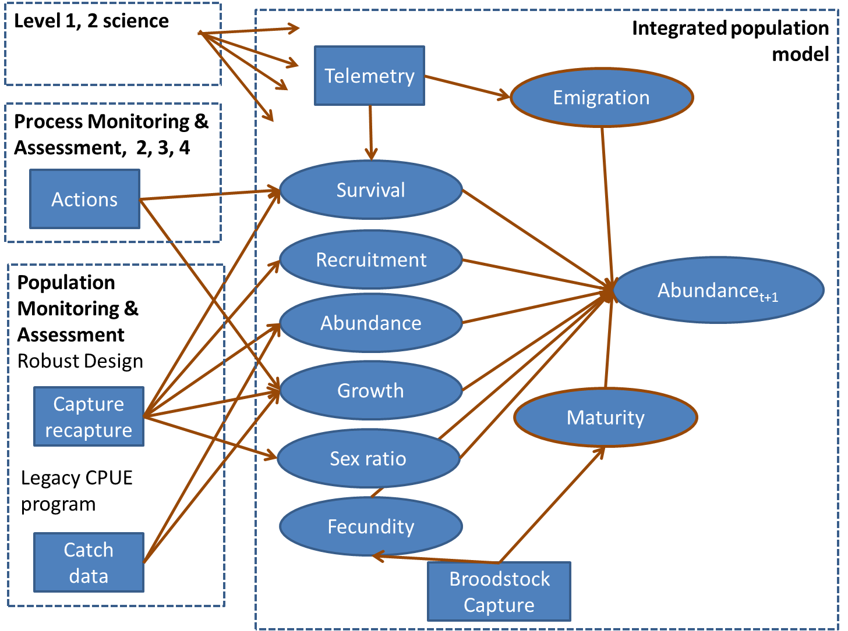

**Figure D5. Concept of interrelations among level 1, 2 science, process monitoring and assessment, population-level monitoring and assessment, and the integrative population model.**

* + 1. Population Monitoring

Population monitoring for the MRRP will be designed to provide the data to meet the USFWS’s species objectives (that is, Fundamental Objective; Sub-objectives 1 and 2) and the demographic data needed to develop the pallid sturgeon population model (e.g., survival, population size). The approach detailed below is a recommended starting point and should be evaluated as part of a level 1 science effort and adjusted periodically to improve the design so that it more effectively meets the monitoring and species objectives. The recommended population monitoring will consist of two components: 1) age-0/age-1 trawling to detect reproduction and recruitment to age 1 (Objective 1) and 2) mark-recapture sampling to evaluate Objective 2 and provide the demographic data needed for predictive population modeling. Both components will be implemented in the Upper and Lower Missouri rivers; however, the sample designs may differ depending on factors like relative gear efficiencies and seasonality. The general design elements (e.g., river bend, macrohabitat, segment) will follow that of USACE’s PSPAP (Welker and Drobish 2012) which includes the river bend functioning as the sample unit. Much has been learned regarding pallid sturgeon distribution, sample gears, and sampling effort through the monitoring programs implemented by the USACE since 2005 (Section D.3). This information along with input from PSPAP and HAMP biologists was used to form the monitoring and sampling recommendations below, including the target levels of effort provided in Tables D22-D24.

* + - 1. *Sampling to Identify Recent Recruitment (age-0 and age-1)*

Monitoring recent reproduction and recruitment can be used to track the effects of management actions. Increases in the occurrence of young pallid sturgeon through time can be used to identify the positive incremental effects on this portion of the population, the portion that is hypothesized as the recruitment bottleneck. Additionally, annual fluxes in the occurrence of these fishes may be used to directly evaluate the effects of individual management actions (e.g., IRC). Trawl sampling will be used to monitor the occurrence of age-0 and age-1 pallid sturgeon in the Upper and Lower Missouri rivers to detect reproduction and recent recruitment of pallid sturgeon. Yearly changes in abundance of young sturgeon will be measured using CPUE or changes in occupancy rates.

* + - * 1. *Upper River*

Under this proposed design, sampling for age-0 and age-1 pallid sturgeon would be restricted to Segment 4 (below the confluence of the Missouri and Yellowstone rivers). Past sampling and Effects Analysis drift models (Fischenich, in review) indicate that the majority of young pallid sturgeon will reside in this portion of the Upper River. At the local scale, sampling will be confined to the CHXO-CHNB, ISB-CHNB, and OSB-CHNB habitat types during the months of June and July. These habitats have provided the highest CPUE values for young *Scaphirhynchus* sturgeon during the previous 10 years of PSPAP sampling. Although these small sturgeon will recruit to the sampling gear from June through September, sampling will be restricted from June (near the time of spawning) through July to accommodate the start of mark-recapture sampling.

*Gears*

To maximize efficiency, only two types of trawls should be considered for sampling age-0 and age-1 pallid sturgeon as they have been used extensively and effectively by USACE monitoring projects: OT16 otter trawl (PSPAP; consult Welker and Drobish 2012 for a detailed description) and the OT04 trawl used by the HAMP (Gosch et al. 2015). Using the OT16 would provide continuity between the monitoring through the AM plan and the historic PSPAP monitoring. However, pallid sturgeon < 50 mm would not be effectively sampled with the OT16. Therefore, we recommend that sampling be conducted with the OT04 or the OT16 fitted with an inner bag made of 4 mm bar mesh.

*Effort*

The level of effort needed to monitor age-0 and age-1 pallid sturgeon is difficult to determine as few have been captured in either the Upper or Lower Missouri rivers through USACE monitoring. The HAMP has been very successful at sampling YOY *Scaphirhynchus* sturgeon and the targeted monitoring approach described here follows that of the HAMP. The HAMP samples at an effort of 4 trawls per mile (approximately 3/km) with repeated sampling at sites where young sturgeon are captured. The average river-bend size in the Upper Missouri River is 2.3 km which would result in an average of 7 trawls per bend (based on the 3 trawls/km sample through the HAMP; Table D22). Twenty-five percent of bends in Segment 4 will be sampled each month (June and July), resulting in 50% of the bends (that is, 24) sampled per year; this was a realistic level of effort (25%) for this type of sampling in the PSPAP (Table D22). Additional trawl subsamples will be taken at sites where young sturgeon are captured and may result in more than 7 trawls per bend and 84 trawls per month (Table D22). Additional bends may be added per sample period as time allows. Sampling designs and levels of effort may be evaluated via simulation to identify tradeoffs in efficiency and precision.



**Table D22.**

* + - * 1. *Lower River*

Sampling for age-0 and age-1 pallid sturgeon will be restricted to Segments 10, 13, and 14 (below Kansas City, MO to the Missouri River mouth). The HAMP has recently sampled larval pallid sturgeon in habitats below Kansas City which represent the only larval (settled) pallid sturgeon captured in the Lower River. Effects Analysis drift models also indicate that the majority of young pallid sturgeon will reside in this portion of the Lower River (and the Middle Mississippi River). At the local scale, sampling will be confined to the CHXO-CHNB and ISB-CHNB habitat types in the months of June, July, and August. These habitats have provided the highest CPUE values for young *Scaphirhynchus* sturgeon during the previous 10 years of PSPAP sampling and recently through the HAMP. Although these small sturgeon will recruit to the sampling gear from June through October, sampling will be restricted from June through August to accommodate the start of mark-recapture sampling.

*Gears*

As with the Upper River, the most effective sampling gears for age-0 and age-1 *Scaphirhynchus* sturgeon are the OT16 and the OT04 trawls. Therefore, the recommendation for sample gears follows that made for the Upper River with either the OT04 or the OT16 (fitted with an inner bag made of 4-mm bar mesh) used to sample age-0 and age-1 pallid sturgeon.

*Effort*

Monitoring in the Lower River will follow that of the HAMP. The average river-bend size in the Lower River is 4 km which would result in an average of 12 trawls per bend (based on the 3 trawls/km sample through the HAMP; Table D22). A target of 25% of the bends in Segments 10, 13, and 14 will be sampled each month (June, July, August), resulting in 75% of the bends (that is, 24) sampled per year (Table D24). Additional trawl subsamples will be taken at sites where young sturgeon are captured and may result in more than 12 trawls per bend and the estimated trawls per month (Table D22). Additional bends may be added per sample period as time allows. Tradeoffs (that is, cost, precision, bias) amongst candidate sample designs may be evaluated through simulation.

* + - 1. *Sampling for Population Characteristics: Mark-Recapture Robust Design*
         1. *Description*

Changes in population size through time are a function of births, deaths, immigration, emigration, and recruitment. Open capture-mark-recapture (CMR) models assume that the population is influenced by natality, mortality, emigration, and immigration and is therefore considered open between sample periods. Closed population models assume that the size of the population remains unchanged between sampling events and require that multiple samples are taken over a short period of time to assume closure. The advantages and disadvantages of each type of model are well documented (Pollock et al. 1990, Nichols 1992) with CMR models used to estimate survival, emigration, and immigration and the closed CMR models used to estimate population size and capture probability. The Robust Design integrates the advantages of both types of models which allows considerable flexibility in estimating a very large number of important demographic parameters, including abundance, survival, and recruitment. The concept behind the Robust Design is to break the mark-recapture sessions into shorter sampling occasions so that capture probabilities can be estimated among encounter occasions within these sessions. The capture sessions are brief enough that we can assume the population is closed (that is, no births, deaths, immigration, or emigration). Therefore, closed models can be used for the estimation of population size and then integrated with open models to estimate true survival, emigration, and immigration over the longer, open primary sampling periods. The basic design is to sample over two temporal scales.

The pallid sturgeon populations in the Upper and Lower Missouri Rivers are unique in many respects (e.g., size and age at maturity, growth rates, life span). The habitats in which they live are also very different. The Lower River is characterized by a narrow, self-scouring channel with higher water velocities, especially in the main channel. In contrast, the Yellowstone and Upper Missouri Rivers are characterized by lower velocities, shallower depths, and a more natural channel form. The nature of the differences between these two portions of the Missouri River has shown that the most effective sampling methodologies and potential strategies also differ significantly and therefore necessitate that the mark-recapture sample designs be tailored to each population.

The accurate estimation of population parameters represents a critical component of assessing the system state for pallid sturgeon in the Missouri River and providing key demographic values for evaluating management actions through predictive population modeling. The estimation of these metrics depends on the quality and quantity of data collected from a well-developed sampling design. The optimal design must be cost-efficient, and provide reliable, accurate data. Implementing an untested design on a large system like the Missouri River could prove costly from the expenditure of time and effort if the selected design performs poorly. For the initial stage of development, we recommend that candidate sampling designs be evaluated by simulation modeling to identify the optimal design (that is, tradeoffs between precision, bias, and cost) and provide proof of concept prior to testing or implementing in the field. This effort is included as a level 1 science component in Appendix C under Technical Development. Once the sample design has been optimized through implementation and adjustment over a number of sample years, only periodic monitoring may be required (e.g., every few years) to estimate and update demographic values.

* + - * 1. *Design Understanding from Simulations*

A preliminary simulation was performed as a proof of concept to evaluate whether a capture-recapture study of individual fish using a robust design would be feasible on a river the size of the Missouri River. First a geographic template was used based on the current PSPAP river bend sampling units, where a river bends are defined as a three continuous habitats (channel cross-over, inside bend, outside bend) and vary in number and size from for the lower and upper basin (Lower: N=317, mean=4 rkm, min=0.2, max=19; Upper: N=157, mean=2.3, min=0.6, max=8). Simulations were performed using the lower basin sampling units as templates. Population dynamics were simulated given known recruitment, survival, and abundance. Given the population dynamics, capture histories were simulated for two levels of capture probability 0.1 and 0.4. These values were selected based on capture probability estimates (Rotella and Hadley 2010, Steffensen et al. 2015b). These simulated capture histories were then used to estimate population abundance, survival, and recruitment. The robust design estimator used was the simplest case, assuming homogenous capture probabilities among secondary sampling units and that capture probability was homogenous among bends. The simulation used 5 primary sampling periods and varying secondary sampling occasions (2 through 10) to evaluate estimator performance, reliability, and effort levels.

Within a primary sampling occasion at least 2 secondary capture occasions are required to estimate the population using capture-recapture of marked individuals and more are likely needed if heterogeneous capture probabilities are present. Over a spatial extent, sampling at least 20% of the river bends was necessary in preliminary simulations. While this preliminary simulation does not address specific gears, selecting gears and sampling occasions that maximize catch will likely result in reduced effort (Section D.3). Based on preliminary analyses, the population abundance could be estimated (Figure D6). With the exception of a capture probability of 0.1 reasonable abundance estimates were achieve by sampling 20% of the bends if capture probability was 0.4 (Figure D6). If capture probability was 0.1 either more bends needed to be sampled or 6 or greater sampling occasions. There was no appreciable effect of increased secondary occasions to estimate population abundance if capture probability was 0.4. It should be recognized these simulations were conducted under the best case scenario (that is, homogenous survival and capture probability) and therefore may not reflect the challenges to sampling a large turbid river like the Missouri River and additional study is required to evaluate ‘worst case’ scenarios.

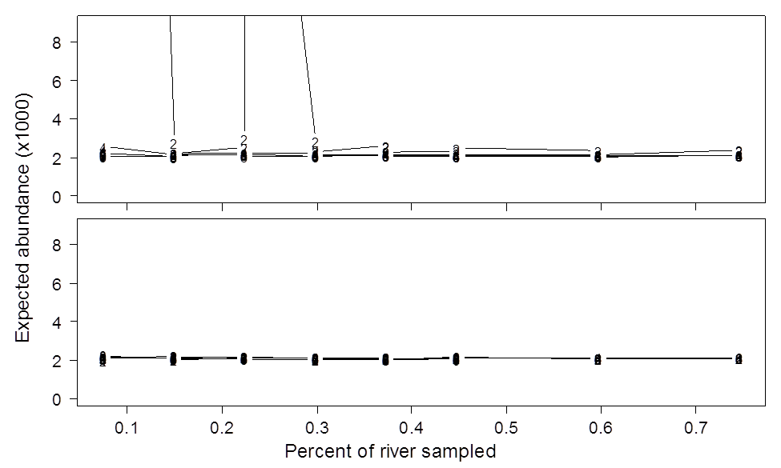

**Figure D6. Effect of number of secondary samples and amount of river bends sampled on population abundance estimates. The upper graph assumes a capture probability of 0.1; the lower graph assumes a capture probability of 0.4. The number in the graphs represent the number of secondary sampling occasions.**

* + - * 1. *Additional Information to Complete Design*

This simulation study is preliminary and suggests that a robust design mark-recapture approach may be a useful monitoring approach. To fully complete the robust design, a level 1 study should be implemented to evaluate spatial and temporal configurations required to achieve acceptable population and demographic rate estimates (Appendix C). Additionally, if the monitoring program will be used to detect the effect of management actions, a power analysis must be completed. The amount of effort required to provide reasonable estimates should be considered. Lastly, including auxiliary information such as data from telemetry tracking in an integrated population model is intended to provide a unifying framework incorporating system level monitoring and providing estimates and feedback necessary to parameterize and calibrate the population model.

* + - * 1. *Caveats and considerations*

There are many assumptions required to estimate population abundance and demographic rates. For example, in this preliminary analysis, survival and detection probability were constant among primary and secondary occasions, which is likely a poor assumption. Additionally, factors affecting pallid sturgeon survival, such as age, growth, condition were not evaluated and should be accounted for to improve estimates and also capture the effect of these variables on survival such that they can then be potentially linked to management actions. Additional research will be required to evaluate the tradeoffs of efforts with estimate bias and precision as part of a level 1 science effort. Also, evaluation of how sensitive estimates are to violation of assumption will be necessary prior to implementation of monitoring programs. Lastly, the monitoring design will have to be optimized within the constraints of the finite resources available to monitor pallid sturgeon on an annual basis, which is not a trivial task in a large turbid system like the Missouri River.

* + - * 1. *Upper River*

If mark-recapture is to be implemented as part of the population-level monitoring, we would recommend that sampling occur in Segments 2, 3, 4, and the lower 48 km of the Yellowstone River. Past sampling (2000 to present) indicates that the majority of the pallid sturgeon reside in these areas during fall. Gear subsample deployments should occur primarily in the four habitat types that have provided the highest catch rates for pallid sturgeon >/= 109 mm in length: CHXO-CHNB, OSB-CHNB, ISB-CHNB, and SCCL-CHNB. As identified previously, tributary mouths have also provided high catch rates of pallid sturgeon and may be included as a focus habitat. Sampling should occur in August through October dependent upon flows and water temperature.

*Gears*

The trotline and the trammel net have been effective gears for sampling pallid sturgeon in the Upper River (Tables D13, D14, and D15). However, the trotline is only (generally) effective at sampling pallid sturgeon during October when the water temperatures are low enough to reduce the level of bait stealing by small-bodied fishes (Ryan Wilson, USFWS, pers. comm.). In contrast, the trammel net can be fished effectively from August through October and provides the flexibility to repeatedly sample areas (that is, bends, habitats) within the same day that contain high concentrations of pallid sturgeon. Therefore, we recommend using the trammel net for mark-recapture sampling in the Upper River. The trotline could serve as a replacement gear when low river flows reduce the capture efficiency of the trammel net.

*Effort*

The proposed sample season for the Upper River would occur in the months of August, September, and October. Approximately 2,150 pallid sturgeon juveniles and adults need to be sampled per year (August, September, October) to achieve a 5% capture rate for the population (Table D21). A capture rate of 0.6 pallids/subsample would require 3,596 trammel net subsamples (1,200 drifts/month) to reach the target of 2,158 pallid sturgeon (Table D23). Closed population estimates of abundance will be obtained at the bend level through repeated sampling of an individual bend over a 3-day period. Simulation will be used to identify the sample design that optimizes the level of effort and precision and that minimizes bias. The estimated number of drifts, bends, and effort needed per segment is included in Table D23.



**Table D23.**

* + - * 1. *Lower River*

If mark-recapture is to be implemented as part of the population-level monitoring, we would recommend that mark-recapture monitoring occur throughout the Lower River (Gavins Point Dam to the Missouri River mouth) as past PSPAP monitoring has collected numerous pallid sturgeon in all Segments (7, 8, 9, 10, 13, and 14). Gear subsample deployments should occur primarily in the four habitat types that have provided the highest catch rates for pallid sturgeon >= 109 mm in length: BRAD-CHNB, CHXO-CHNB, ISB-CHNB, and ISB-POOL. Tributary mouths have also provided high catch rates of pallid sturgeon and may be included as a focus habitat. Sampling should occur in March-May and October-December with the timing of sampling dependent upon water temperature.

*Gears*

The trotline has been the most effective sampling gear for pallid sturgeon >/= 109 mm; therefore, it is recommended that the trotline be used for mark-recapture sampling in the Lower River. The effectiveness of this gear is restricted to spring and late fall due to the activity of bait-stealing fishes.

*Effort*

The proposed split-sample season for the Lower River contains approximately two sample months in the spring and two months in the fall. Approximately 1,550 pallid sturgeon juveniles and adults need to be sampled per year to achieve a 5% capture rate for the population (Table D21). A capture rate of 0.25 pallids/subsample would require 6,200 trotline (40 hooks/set) subsamples (1,550 sets/month or 3,100 per season) to reach the target of 1,550 pallid sturgeon (Table D24). Selected bends will be sampled for 3 consecutive days to obtain the closed population estimate. Table D24 provides the estimated number of sets, bends, and effort needed per segment. As with the Upper River, simulation will be used to compare designs and optimize the level of sampling effort.

**Table D24.**



* + - 1. *Integrative Pallid Sturgeon Population Model*
         1. *Model overview and spatial organization*

The collaborative population model structure was developed to meet three objectives:

1. provide a quantitative framework to forecast pallid sturgeon population dynamics given inputs from the CEMs;
2. provide a flexible model structure template that can be used to model upper and lower basin populations, and;
3. account for whether a pallid sturgeon was produced in the Missouri River System or the hatchery system.

A secondary consideration in the development of the integrative model structure was the availability of biological data commonly collected during population assessments (e.g., size, weight, age, sex, origin), which will be necessary to parameterize the model and allow the model to provide decision support and inform monitoring efforts. We provide a brief overview of the model structure as it has documented in detail in the EA integrative report (Jacobson et al. 2016a). Current versions have expanded the temporal and spatial resolution of the model which does not change to stage and age structure in previous versions.

Stages were used to organize pallid sturgeon life history and as a framework to model population dynamics. Seven stages were used in the model to capture biologically important pallid sturgeon stage transitions similar to those identified in Wildhaber et al. (2011a) and correspond to life stage-specific CEMs. Pallid sturgeon life history in the Missouri River System was organized into the following stages:

* 1. **Embryo** (5-8 days): period from fertilization to hatching.
  2. **Free embryo** (8-12 days post hatch (dph)): period from hatching until the larval fish initiates feeding.
  3. **Exogenously feeding larvae** and age-0 (8-12 dph - June 1): period from full development of fin rays over the winter period until June 1 of the following year.
  4. **Juvenile** (age-1 to age-9): period of pallid sturgeon sexual immaturity, a fish can remain in this stage until age-9.
  5. **Spawning adult** (age-7 to age-41): this stage includes juvenile fish that have become sexually mature and are read to spawn and adult fish that have already spawned and are ready to spawn again.
  6. **Post-spawn adult**: a pallid sturgeon that has released its gametes, model assumes fish remain in this state until June the following year.
  7. **Recrudescent adult**: a post-spawn pallid sturgeon, replenishing gametes, may remain in this state for up to 4 years post-spawn.

Each stage represents an important portion of pallid sturgeon life history in the Missouri River System that varies in duration from days to years. The effect of hatchery operations on the population was accounted for with the addition of stages specific to the hatchery system, including:

1. **Broodstock**: sexually mature fish ready to spawn that are removed from the Missouri River System and used as a source of gametes to fertilize and produce offspring in a controlled hatchery environment.
2. **Fingerlings**: pallid sturgeon hatched in a hatchery setting and reared for 3–4 months and released back into the Missouri River System.
3. **Yearlings**: pallid sturgeon hatched in a hatchery setting and reared for 10–12 months and released back into the Missouri River System.

The current implementation of the model has a geographic extent limited to the Lower and Upper Missouri River segments, denoted as RPMA 2 and 4 (Figure D1). These two river segments are subdivided into bends representing the spatial grain of the population model. River bends are defined as a three continuous habitats (channel cross-over, inside bend, outside bend) and vary in number and size from for the lower and upper basins (lower: N=317, mean=4 rkm, min=0.2, max=19; upper: N=157, mean=2.3, min=0.6, max=8). As currently implemented, fish move among bends. We use bends as a spatial organization because they are the sampling units for the PSPAP and are likely to be retained as the spatial organization for future monitoring. Current temporal extent is user defined and can be up to 50 years with a monthly time step.

* + - * 1. *Integrating the population model with monitoring and research*

The integrated population model (IPM) can be used to evaluate scenarios of interest, but to be a useful as a decision support or scenario planning tool it needs be able to accept information from ongoing monitoring and research. These monitoring and research efforts can be thought of as ‘plugins’ into the model. A preliminary view of this is illustrated in figure B5. Specifically, various monitoring programs and research efforts will provide data for demographic rates and abundances. This approach assimilates monitoring and science programs to inform population simulations. Within this framework we have identified 3 major programs (Level 1 and 2 Science, Process monitoring and assessment, and Population monitoring and assessment) that can inform demographic rates and 2 ancillary programs (Telemetry, Broodstock capture) that can further inform demographic rates.

How specific science and monitoring programs will plug in to the IPM will vary among the programs. Level 1 and 2 science should provide at least baseline or best-case estimates of what parameters might be that cannot be estimated in the system (e.g., embryo survival). Process monitoring and assessment should be able to inform the effect of management actions on demographic rates. For example, IRC habitat is hypothesized to increase survival, so monitoring data from in-river experiments may be assimilated into the model. Lastly the population-level monitoring and assessment can potentially inform survival, recruitment, abundance, growth, and sex ratio of the population. The robust design capture-recapture program proposed can also potentially be used to calibrate CPUE data using a Bayesian framework.

Ancillary programs like telemetry and broodstock capture can further be used to refine relationships and demographic rates. For example, within the broodstock program, information on fish size and fecundity can be used to refine fecundity maturity relationships, which will likely be important to link growth. Telemetry can inform survival and emigration. Periodic detections, if designed correctly, provide information regarding whether a fish is in the system and alive. The use of strategically located autonomous telemetry receiver arrays may be useful inform migration rates (Appendix C).

* + - * 1. *Caveats and considerations*

The IPM described here is a work in progress and specific methodological and analytical details will be presented as they are developed. Some additional effort is needed to be made to develop the framework and evaluate whether or not it will work given system constraints. The additional effort is planned as a level 1 science effort. However these efforts primarily require computer simulation and therefore could be evaluated early in the process. Another caveat to consider is that with the addition of information streams, computation time may become a limiting factor, however once parameters are estimated population simulation should go relatively quickly. Lastly, in order for science and monitoring programs to plug in to the integrated population model, studies and data need to be conducted in a manner that allows for integration. For example, if all studies estimating survival use a logit-linear model these results can be integrated, however if a study is set up differently, the study may need to be reanalyzed to be integrated. The refinement and maintenance of the IPM is considered to be an ongoing Technical Development in Appendix C.

* + - 1. *Ancillary Data for Population Assessment*
         1. *Data for Parameter Estimation*

A population monitoring and modeling intended to provide useful estimates of population size and growth will require several types of information in addition to population size and survival estimates from the mark-recapture robust design. These include:

* Tag loss estimates
* Sex ratios
* Reproductive ratios
* Fish condition, health
* Fecundity estimates
* Age at first reproduction
* Age at senescence
* Growth rates
* Emigration and immigration

Estimates of these parameters values will require additional effort in the monitoring program but required data can be gathered with minimal extra effort.

* + - * 1. *Links from Action Hypotheses to Population Assessment*

The level 1 and 2 science components outlined in Appendix C are structured to determine whether each hypothesized action will be effective in increasing the population of pallid sturgeon, and if so, how survival at specific life stages will be affected by the action. Changes in survival estimated from laboratory, mesocosm, or field experiments will provide new estimates to update the population model and thereby indicate whether the population is likely to increase. The likelihoods projected from implemented actions will be compared to population sizes estimated from the robust design, documented survival, and CPUE.

In this framework, the level 1 and 2 science components and population assessment are mutually supportive. The population assessment and IPM will serve as the over-arching accounting process to document population trends whereas the science components provide the causal linkages from management actions to changes in survival. Importantly, survival from age-0 to age-1 or age-2 will probably not be measurable in the field or in mark-recapture because of gear limitations in capturing/recapturing small fish. Therefore, science component estimates may be the only information available to address survival at these important life stages.

In addition, we recommend that some ancillary abiotic data be collected during the robust design. These data are not intended to provide habitat selection or resource-use data; instead, they are intended to provide indicators that may be related to survival, or to catchability. We recommend that water temperature, conductivity, and turbidity should be collected with each gear deployment.

* + - 1. *Catch per Unit Effort Continuity and Check*

A limited CPUE effort would serve to provide continuity with previous population trend data developed through the PSPAP and to serve as a check on population estimates obtained from the robust design. The original goal from the PSPAP was to provide information to detect changes in pallid sturgeon populations and the first objective of the PSPAP was to evaluate annual and long-term trends in pallid sturgeon population abundance and geographic distribution throughout the Missouri River System (Welker and Drobish 2012). Although CPUE does not estimate true abundance of the population, it does theoretically detect changes (increases or decreases) in relative population abundance (Hubert and Chamberlain 1996). Because the PSPAP has collected CPUE data for 10+ years and because the pallid sturgeon is a long-lived species, continuing to collect such data would be useful to track relative changes in population abundance in the future.

As previously mentioned, CPUE is not capable of estimating population abundance, but it is assumed to be proportional to estimates of abundance, which will be derived from the robust design. The two measures of abundance (CPUE and population estimates) should serve as abundance measure checks to one another. For example, if population estimates show an increase, it follows that CPUE values should increase as well. In this situation, the combination of both abundance measures would suggest that the population increased. This level of confirmation may provide confidence in a system characterized by great variability.

Measures of CPUE are sometimes prone to large measures of error due to variation in fish behavior and other factors. One way to reduce variability in CPUE is to standardize sampling methods, which the PSPAP has done with their sampling regime and use of gears (Drobish 2008) to a certain degree. The PSPAP currently has large sampling time periods for each of its sampling seasons (sturgeon season = ~8 months, less when constrained by ice in northern segments; fish community season = ~4 months). A further reduction in variability might be obtained by decreasing the length of sampling time periods to narrower time frames, such as spring or fall (2-3 month time periods). Optimizing gear use for each river location (Upper and Lower) might also reduce variability of CPUE estimates. Gears in the Lower River are not necessarily as effective when used in the Upper River. Based on evaluations of the effectiveness of gears (see Section D.3), it seems using trammel nets and otter trawls in the Upper River and trotlines and the otter trawl in the Lower River would most effectively estimate CPUE of pallid sturgeon. The use of trotlines, otter trawls, and trammel nets to estimate CPUE would provide continuity to the 10+ previous years of sampling during the PSPAP.

1. Assimilation and Interpretation of Data: Application to Decision Making
   * 1. Assimilation of Data in Population Model

Adaptive management of the pallid sturgeon in the Missouri River will require multiple sources of information, at varying spatial and implementation scales. Hypothesis driven monitoring and research also will be required to assess specific management actions. Population-level monitoring data provide three inputs to the decision making process and AM. First, monitoring data provides information which in turn reduces uncertainty of the current state of the system (that is, abundance of pallid sturgeon). This is important as management decisions likely depend on the current state of the system. For example, the annual to multiple-year level of population augmentation (that is, stocking) required to meet sub-objectives will likely depend on knowing population abundance and trend with some confidence. Second, population-level monitoring data provide feedback necessary to evaluate implemented system-level management decisions (level 3) as part of the AM process, albeit it may take many years to realize a system level effect in monitoring data. In this case, the effect a management action on the population is predicted and monitoring data provide the necessary feedback to evaluate whether the predicted population response was realized. Population-level monitoring needs to be coordinated with process monitoring in order to evaluate management actions that may not be detectable at the system level (e.g., effect of IRC on free embryo and exogenously feeding larval pallid sturgeon survival). Lastly population-level monitoring is necessary to determine whether population objectives and sub-objectives have been met.

Challenges exist to using monitoring data that provide a relative index of the population for AM and decision making. Specifically, previous PSPAP monitoring indexed population abundance by CPUE, which assumes that CPUE is proportional to abundance and catchability is constant over time and space (Harley et al. 2001). Catch effort data can exhibit patterns of hyper-stability where catch suggests population abundance is higher than it actually is or hyper-depletion where catch suggests population abundance is lower than it actually is. The use of CPUE data is also in apparent conflict with population objectives stated in the present pallid sturgeon recovery plan of 5,000 individual pallid sturgeon in each management unit (U.S. Fish and Wildlife Service 2014). Calibration of CPUE to pallid sturgeon abundance would be necessary to determine whether this population objective has been met. The value of uncalibrated CPUE data can be of limited value in a decision making context if fundamental objectives focus on population abundance rather than relative abundance, especially if relative indexes are biases. The use of varying sources of information (Level 1 and 2 science, process and implementation monitoring, and system level monitoring) in a decision making context presents a final challenge to the AM process.

The model developed to simulate population dynamics and evaluate management actions provides a flexible framework to evaluate the consequences of management actions on population dynamics and growth (; defined as ). The effects of management actions are propagated to the population through effects to demographic rates, survival in this case. In many cases baseline survival is unknown with a high degree of uncertainty and the effect of a management action on survival is an additional unknown. These unknowns may be parameterized by expert elicitation, existing values, new science, or by model calibration. As the adaptive-management process moves forward additional information will become available that will refine and ideally improve the survival rates and associated uncertainties. These values may become available as a result of controlled experiments or field studies and this information should be assimilated and incorporated in a manner that results in a useable input such that the population model can be used as a decision support tool.

* + 1. Assimilation and Integrating Monitoring, Research, and Management

Integrating monitoring with the AM plan will pose challenges in a decision making context. In particular, the AM plan utilizes multiple sources of information at varying scales of implementation (Level 1 and 2, Process and implementation). Level 1 study consists of small scale experiments and information learned from these studies may not adequately scale to the population level. For example, scientific studies conducted in ponds, flumes, or under controlled laboratory conditions may not generalize to the population level. However this information is important to synthesize and incorporate into decision making and AM as these values may be the only source of that can inform demographic rates used in the population model. A formal framework to integrate information acquired from studies at the varying levels has not been developed and represents a challenge to integrate information across study levels.

The exact nature of a framework to integrate what is learned from levels of studies in the AM plan is uncertain. One approach that has been used to combine sources of information is Bayes Theorem, which can assimilate prior and current information into a posterior distribution of values. This approach is potentially useful because it can be used in either a scenario planning approach (that is, evaluating scenarios through a model) or in a decision model such as a Bayesian Decision Network (BDN) (Nyberg et al. 2006). This section provides an example of how Bayes Theorem may be used to update a distribution of survivals for embryos and some potentially useful applications of BDNs to assimilate and incorporate information learned from studies at varying levels in a decision making context. It should be recognized that this is one approach that shows promise and is commonly used in a decision making context, but there may be other approaches that are more suitable, albeit not yet unidentified.

* + 1. Example: assimilating and incorporating information on embryo survival

Suppose that prior to any level of study, survival of embryos to free embryos () was believed to be some value with some measure of uncertainty. This value and associated uncertainty can be derived by literature review or expert elicitation. In this hypothetical example, suppose the initial value and associated uncertainty for embryo survival () was determined by expert elicitation. An approach to perform the elicitation would be to have experts adjust the parameters of the equation, where  is the expected survival on logit scale and  is a normally distributed error term controlling the uncertainty around . If the results of this hypothetical elicitation were  and , the resulting distribution of  is illustrated in figure B7. This distribution of  values can then be used in stochastic population simulations to evaluate population dynamics and viability over the long term.

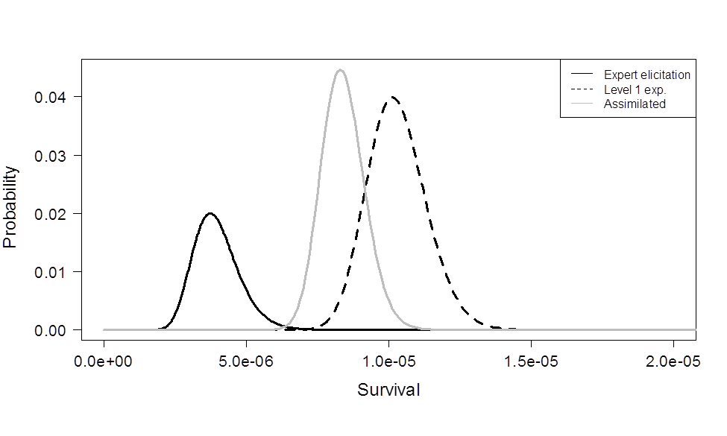

**Figure D7. Hypothetical Pallid Sturgeon embryo survival based on expert elicitation (black line), level 1 study (dotted line), and the assimilation of the two using Bayesian updating (grey line).**

Model parameterization by expert elicitation provides a rapid framework to evaluate the effect of management actions on an objective that otherwise may take months to years or may be impossible to estimate. Sensitivity analysis provides a method to evaluate how dependent model outcomes are on these inputs and potentially guide research and monitoring. As the AM plan moves forward, studies at varying levels will further inform demographic parameters like . For example, suppose a study is implemented that provides estimates of embryo survival based on a flume study and survival was estimated from the same logit linear model where  and  (Figure B7). This study, while not at the scale of the entire system, provides additional information on embryo survival and can be incorporated and assimilated using Bayes theorem to update the distribution of survival values resulting from expert elicitation (Hilborn and Mangel 1997, Clemen and Reilly 2001, Conroy and Peterson 2013). Incorporating and assimilation the information results in a posterior distribution representing the assimilation of the two information sources (gray line in Figure B7). Population model simulations can then be conducted using the new distribution of survivals assimilating expert elicitation and monitoring results.

* + 1. Power of Population-Level Monitoring Data to Detect Management Effect

If population-level changes are to be related to management actions, the population-level monitoring program should be designed to provide sufficient power to detect the effect of the action. In most research studies, power is typically set such that the sampling program detects an *a priori* effect size 80% of the time. In the case of pallid sturgeon, management actions are believed to effect population demographic rates, which are illustrated in the CEMs. Many of these responses are on survival which is bound by 0 and 1. Given the bounds on survivals, effects are likely asymmetrical which can complicate simple power analyses. For example, a 10% increase or decrease in an adult survival () of 0.92 is 1.012 and 0.828 respectively. The 10% increase results in survival exceeding 100%, highlighting the challenge of power analysis to reliably detect biologically meaningful effects due to constrained parameter space. Lastly, suitable effect size should be determined *a priori*, however the practical realities of finite sampling resources will likely limit the reliable detection of an effect, unless the effect is large (that is, it is easier to detect large effects with less effort). Simulation studies as part of ongoing application of the IPM promise to provide information to evaluate whether detecting effects of varying magnitudes is feasible.

* + 1. Value of Monitoring Data

A challenge facing monitoring programs is how much data is sufficient to make a decision and in the context of finite sampling resources. The value of information can be meaningful in decision contexts where multiple sources of information are assembled to reduce uncertainty around current system state or functional relationships (Conroy and Peterson 2013, Canessa et al. 2015). If a BDN is developed, the network contains a utility that corresponds to an objective, the value of various sources of information, perfect or imperfect (that is, population-level monitoring data), can be calculated (Moore and Runge 2012, Conroy and Peterson 2013, Canessa et al. 2015). Additionally, in cases where there are multiple metrics that require monitoring but resources preclude monitoring all desired metrics, a value-of-information analysis can facilitate prioritization of monitoring efforts in the context of making a decision. For example, the number of pallid sturgeon 50 years in the future depends on the current number of pallid sturgeon. However, there is uncertainty in current pallid sturgeon abundance estimates that could be reduced by monitoring. Similarly, there also is uncertainty in survival rates that could be reduced by monitoring or additional research. How finite monitoring and research resources are allocated (e.g., does an agency target abundance or survival) to reduce uncertainty can be informed by a value of information analysis. This type of analysis when performed in conjunction with a sensitivity analysis can provide a framework to determine how valuable information acquired from monitoring and research is, but it requires BDN which in turn requires a set of decision alternatives and a utility.

* + 1. Caveats and Considerations

The approach illustrated in the two hypothetical examples is one approach that may be used to assimilate and incorporate information from varying monitoring designs and levels of study in the AM process. This approach is easily used in a BDN framework as well as in scenario modeling, providing support to using the population model for scenario planning or decision support. As demonstrated in the example, attention needs to be applied to studies such that analyses can be assimilated. Specifically one needs to be able to combine information based off a distribution or predictive model. Additional consideration should be given to how much belief or weight is given each information source, if this approach is applied. For example, should data from mesocosm experiments receive similar or twice the weight of expert elicitations? What about in relation to field level studies and implementations? Assimilating and incorporating varying information sources that will arise from the AM plan will be a challenge requiring careful consideration as to how results will fit together with the population model to support for decision analysis and scenario planning.

1. Summary and Conclusions

This report explored options for refining a population trends monitoring approach so it is effective and efficient in meeting the needs of the adaptive-management program. Analysis of previously collected data indicates how age-0 through adult age pallid sturgeon can be sampled with increased efficiency and initial exploration of robust design mark-recapture indicates that reliable monitoring of the pallid sturgeon population may be cost effective. Population-level monitoring promises to provide an important complement to level 1 and 2 science, and monitoring for implementation and process, to contribute to information for decision making. We develop an approach that would combine CPUE trawling for age-0 and age-1 (to address the objective of assessing recruitment) with a robust design mark-recapture effort (to address the objective of assessing increases to population size).

The results of level 1 and 2 science components, level 3 monitoring and assessment, and population-level monitoring can be effectively integrated in a population-dynamics modeling framework, the integrated population model (IPM). Under the approach developed in this report, the IPM becomes the central mechanism to assimilate data from diverse sources and provide information for decision making. Importantly, confidence in the IPM will be highly dependent on data from population-level monitoring which will provide key parameter estimates and validation.

In the context of limited resources, simulation modeling of robust design sampling can provide increased detail in how to optimize the contribution of population-level monitoring at least cost. We also discuss how a Bayesian Decision Network may be used to assimilate new information into the integrative population model and to evaluate the value of investments in various forms of monitoring.

Appendix E. Listing and Description of Protocols for Sturgeon-Based Process Monitoring and Assessment

Monitoring and assessment will be components of many level 1 and level 2 science components as well as level 3 and level 4 implementations. Multiple agencies and projects have contributed to more than a decade of experience on the Missouri sampling for pallid sturgeon and characterizing their habitats. This collective experience will be the foundation for design of monitoring and assessment protocols that are optimized for projects. Notwithstanding this broad experience, we also anticipate that some field projects may require development of new measurement and sampling protocols, and sample designs. The purpose of this appendix is to describe an approach to developing specific protocols and to document existing protocols.

For many, if not most, level 1-4 actions, monitoring and assessment protocols will need to be refined from existing protocols, or in rare cases, developed anew. Therefore, we anticipate that at the beginning of each component or implementation, there would be a step in which the experimental design, and sampling, measurement, and assessment protocols are developed and documented. This step would include a power analysis to determine whether the experimental design will be able to discriminate among alternative hypotheses. It may also require pilot studies in the laboratory or field to refine existing techniques or to develop new ones. Some adaptation of designs and protocols may occur also during the course of the project, but care will need to be applied to assure that adaptation does not impart bias. An example of the piloting approach is documented in Appendix A in the Technical Development section wherein a specific level 1 science effort is proposed to optimize population-level monitoring.

A large number of existing protocols exists. The following is not intended to be an exhaustive list; rather it is intended to illustrate the depth and breadth of existing sampling and measurement protocols. Some protocols have been documented in published reports specifically about the protocol, some have been documented in other reports or published articles, and some are documented in unpublished agency documents. The quality and detail of information varies considerably among these formats. The protocols are listed by major project.

* All handling of the endangered pallid sturgeon must conform to U.S. Fish and Wildlife handling protocols (U.S. Fish and Wildlife Service, 2012).
* Pallid Sturgeon Population Assessment Project (PSPAP) protocols are documented in multiple reports, notably (Welker and Drobish, 2012a, b, 2016).
* Habitat Assessment and Monitoring Project (HAMP). Early HAMP projects used PSPAP protocols whereas protocols for later HAMP projects are documented in (Dzialowski and others, 2013; Morris and others, 2013; Gosch and others, 2014; Gemeinhardt and others, 2015; Gosch and others, 2015).
* Comprehensive Sturgeon Research Project (CSRP). This US Geological Survey research project includes integrated abiotic and biotic studies of the reproductive ecology of pallid sturgeon, including extensive research using telemetry, laboratory studies, and physical habitat assessments. The USGS maintains unpublished, very detailed standard operating practices (SOPs) for all aspects of the research. In addition, methods are documented in a variety of documents including (Jacobson and others, 2004; Wildhaber and others, 2005; Bryan and others, 2007; Papoulias and others, 2007; Wildhaber and others, 2007; Reuter and others, 2008; DeLonay and others, 2009; Elliott and others, 2009; Papoulias and others, 2009; Reuter and others, 2009; Papoulias and others, 2011; McElroy and others, 2012; Albers and others, 2013; DeLonay and others, 2016).
* In addition, CSRP scientists have contributed assessments of existing monitoring data and power analyses (Bryan and others, 2010; Wildhaber and others, 2011b)

The following section is an example of a draft monitoring plan for a major MRRP action, creation of interception-rearing complexes (IRCs) for age-0 pallid sturgeon. Attachment 2 presents a monitoring plan for adjustments to existing shallow water habitat projects with an emphasis on chutes. Similar monitoring plans and protocols will be developed for other management actions as the adaptive management process proceeds.

* 1. IRC Construction and Monitoring

DRAFT/Pre-Decisional/For Discussion Purposes Prepared: April 15, 2016  
By: Todd Gemeinhardt, Nathan J. Gosch, Brian O. Ma, Carl Schwarz

* + 1. Introduction

An Effects Analysis proposed functional definitions of Age-0 sturgeon habitat as interception, food producing, and foraging habitat types (Jacobson and others, 2016a). Collectively these habitat types are referred to as Interception and Rearing Complexes (IRCs) when they are co-located within geographic proximity to benefit age-0 pallid sturgeon. The physical components of these habitat types are defined as follows: 1) food-producing habitat occurs where velocity is less than 0.08 m/s, 2) foraging habitat are areas with 0.5 – 0.7 m/s velocity and 1-3 m depth, and 3) interception habitat is qualitatively described as zones of the river where hydraulic conditions allow free embryos to exit the channel thalweg.

For interception habitat, the hypothesis posed by Jacobson and others (2016a) is that recruitment failure occurs because newly hatched free embryos are not able to exit the thalweg (navigation channel) before they starve because the river lacks hydraulic conditions that would transport them into supportive channel-margin habitats with food and protection. Therefore, construction of IRC restoration sites is planned to enhance interception of age-0 sturgeon as they transition from the drift stage to benthic feeding and provide increased amounts of foraging and food producing habitats.

* + 1. Management Hypotheses

The IRC Monitoring Plan was developed to monitor the success of the construction of IRC restoration sites on increasing age-0 pallid sturgeon recruitment. To measure the success of restoration activities, monitoring will focus on exogenously feeding age-0 sturgeon with the primary response metric being catch per unit effort (CPUE) of age-0 *Scaphirhynchus* *sp*. sturgeon given the low numbers of age-0 pallid sturgeon present in the lower Missouri River. This monitoring plan focuses on interception, while the rearing portion of the EA hypothesis (food and protection) is currently being addressed in an ongoing HAMP study. Specifically, this study will test the following hypothesis for the biological response of sturgeon to IRC restoration sites:

H0,1: Catches of age-0 sturgeon within river bends that include IRC habitat restoration sites are similar to control sites before and after habitat restoration actions.

HA,1: Catches of age-0 sturgeon within river bends that include IRC habitat restoration sites increase relative to control sites after habitat restoration actions.

Coupled with the measurement of the biological response (CPUE of age-0 sturgeon), physical monitoring will characterize the hydrodynamics of interception habitat treatment and control bends. The measure of hydrodynamics will include depth and velocity magnitude and direction. Specifically, this study will test the following hypothesis on the physical response to the construction of IRC restoration sites:

H0,2: The hydrodynamics of the river bends that include IRC habitat restoration sites are similar to control sites before and after habitat restoration actions.

HA,2: The hydrodynamics of the river bends that include IRC habitat restoration sites are different than control sites before and after habitat restoration actions and allow free embryos to exit the channel thalweg.

* + 1. Approach
       1. Sampling Design

Key uncertainties in the IRC Monitoring Plan were (1) the selection of IRC habitat restoration sites (bends) and corresponding control sites, and (2) the timing of construction of IRC habitat restoration sites. To assist the development of a sampling design, analyses were conducted on existing baseline data from the Habitat Assessment and Monitoring Program (HAMP) on age-0 sturgeon catch data (Sub-Attachment 1A). Only the HAMP data (2005-2009, 2014-2015) were used to estimate the various components of variance in CPUE and conduct the analysis. Data from the MDC program (2014-2015) were also considered but were not used because the CPUE from this program was significantly higher than what is regarded as normal CPUE (~10× the typical CPUE for the Missouri River).

A hierarchical staircase study design was proposed to evaluate the response of age-0 sturgeon catch to IRC habitat restoration activities. A staircase design is a series of staggered before-after-control-impact (BACI) designs (Walters et al. 1988), and therefore requires paired control and treatment bends for the duration of the study. Each IRC habitat restoration site (i.e., treatment site) should also have a corresponding control site. Each IRC and control site should be sampled annually and at least one year prior to initiation of construction.

The decision to use this design was because of (1) logistical constraints, and (2) statistical considerations. Logistical constraints included the speed at which IRC habitat restoration sites could be constructed. It was estimated that up to two sites could be constructed per year. Statistical considerations consisted of power analyses conducted on several candidate configurations to determine a sampling design that would have the most power to detect a significant difference when such a difference actually exists (Brown and Guy 2007) given the existing logistical constraints (see Sub-Attachment 1A).

Generally, power increases with the number of IRC sites implemented, the magnitude of change in CPUE and the total number of years of monitoring. After some exploration of alternative sampling designs, the AM team, Management Team, and Oversight Team converged on a sampling design with 12 IRC-control site pairs implemented over 7 years (i.e., baseline monitoring for the first IRC-control site pair, followed by six years of building and monitoring 2 IRC-control site pairs per year; Figure E4; Table E 1). This sampling led to approximately 80% power to detect an 80% increase in CPUE within 7 years, at an alpha=0.05 and beta=0.2 at the river bend scale based on estimates of variance.

The benefit of a faster rate of construction of IRCs is in providing accelerated learning about action effectiveness. If 10 or more years of monitoring were intended, there was little increase in power for constructing IRC habitats at a rate faster than one per year; however, the rate of two IRC-control sites per year yielded a relatively large increase in power when planning for less than 10 years of monitoring (Figure E 5). To obtain adequate statistical power within the first half of the 15-year time frame of the MRRP, the 12 IRC sites built over 7 years need to create an average increase in CPUE of at least 75% (Figure E 5). The construction of habitat can be delayed (e.g., every second year) without affecting the analysis, but delaying the implementation of an IRC will result in some reduction in power. The power analysis does not consider cost of construction or monitoring, which may add further constraints to the sampling design.

Table E 1:: Biological data collections at IRC and control bends. ‘X’ represents site-years where monitoring occurs. Shaded boxes indicate the year in which construction will be initiated; CT refers to the control site.

|  |  |  |  |  |  |  |  |  |
| --- | --- | --- | --- | --- | --- | --- | --- | --- |
| **Site/Year** | **1** | **2** | **3** | **4** | **5** | **6** | **7** | **8** |
| **01** | X | X | X | X | X | X | X | X |
| **01 CT** | X | X | X | X | X | X | X | X |
| **02** | X | X | X | X | X | X | X | X |
| **02 CT** | X | X | X | X | X | X | X | X |
| **03** |  | X | X | X | X | X | X | X |
| **03 CT** |  | X | X | X | X | X | X | X |
| **04** |  | X | X | X | X | X | X | X |
| **04 CT** |  | X | X | X | X | X | X | X |
| **05** |  |  | X | X | X | X | X | X |
| **05 CT** |  |  | X | X | X | X | X | X |
| **06** |  |  | X | X | X | X | X | X |
| **06 CT** |  |  | X | X | X | X | X | X |
| **07** |  |  |  | X | X | X | X | X |
| **07 CT** |  |  |  | X | X | X | X | X |
| **08** |  |  |  | X | X | X | X | X |
| **08 CT** |  |  |  | X | X | X | X | X |
| **09** |  |  |  |  | X | X | X | X |
| **09 CT** |  |  |  |  | X | X | X | X |
| **10** |  |  |  |  | X | X | X | X |
| **10 CT** |  |  |  |  | X | X | X | X |
| **11** |  |  |  |  |  | X | X | X |
| **11 CT** |  |  |  |  |  | X | X | X |
| **12** |  |  |  |  |  | X | X | X |
| **12 CT** |  |  |  |  |  | X | X | X |

* + - 1. Site Selection
         1. Treatment Bends

The selection of sites for treatment of IRC habitat designs is based on understanding of typical drift rates of pallid sturgeon free embryos, likely maximum upstream spawning locations, the limitations associated with habitat restoration actions on the river, judgment about the engineering feasibility of constructing an IRC habitat at a specific site, and relevancy of the location of the specific purpose of the IRC characteristic being designed and tested. Sites for IRC habitat implementation are limited to areas adjacent to or owned by public entities. Although not a requirement, chosen sites are generally not in the vicinity of major or federal levee projects or near known navigation channel trouble areas. Once sites are screened out due to common restrictions or limitations, engineering judgment and experience are used to determine which sites are the most amenable to geomorphic or physical habitat change within areas that are most relevant for the specific habitat characteristic being tested. Site history is taken into consideration to determine what kind, if any, habitat restoration work was previously completed and if the site has undergone any previous biological monitoring. The culmination in the above factors will result in the reduction in the pool of potential sites to draw from based on preferential characteristics such as location, size, and accessibility.

* + - * 1. Control Bends

Multiple factors may contribute to the selection of treatment bends (see above); however, increased flexibility in selection of control bends is available because modifications will not be made to those locations for the purposes of creating IRC habitat. In the analysis (Sub-Attachment 1A), we assume that control bends are randomly selected; however, power could be increased if control bends were selected to be as similar as possible to treatment bends, a form of blockingThe Lower Missouri River has been classified into six distinct geomorphic categories (robert Jacobson, unpublished data). For this study, control bends should be selected from the same geomorphic classification as paired treatment bends to minimize geomorphic variability between paired control and treatment bends. Ideally, control bends should be selected upstream of the paired treatment bends to avoid treatment actions from influencing control bends. If this cannot be achieved, the control bends should be selected from a sufficient distance downstream of the treatment bends to reduce treatment effects.

* + - 1. Data Collection Tasks
         1. Biological Monitoring

The sampling protocol at each site (trawl location, site selection, frequency, etc.) of this study follows the sampling standard operating procedures (SOP) for 2014-2015 HAMP efforts, except when noted here. The SOP relied heavily on the SOP developed for monitoring and sampling Missouri River fishes between 2003 and 2013 by Welker and Drobish (2016), and includes protocol with collecting information on length, frequency, distribution, and catch per unit effort (CPUE) for all sturgeon species (Appendix I, Attachment 1). To address the unique sampling objectives of this study, highlights and modifications to the Welker and Drobish (2016) SOP are detailed below. Therefore, if not specified below, refer to Welker and Drobish (2016).

Field Measurements and Data Collection Procedures

To maximize efficiency of limited sampling resources, a stratified random approach will be used to guide sampling efforts through the habitat classification hierarchy (Welker and Drobish 2012) to avoid oversampling in habitats where age-0 sturgeon (<110 mm) are not likely to occur (based on Pallid Sturgeon Population Assessment Program [PSPAP] capture data collected from 2003 to 2013 in segments 10, 13, and 14 and existing HAMP data). Sampling will occur at the following Macro, Meso, and Micro habitats (during situations of extreme low or high water stages additional habitats may be sampled but only after agreement with all sampling crews and project manager to ensure sampling consistency):

Macro Habitats: ISB and CHXO

Meso Habitats: CHNB, ITIP, and BARS

Micro Habitats: Based on known age-0 sturgeon captures and available habitat types within each bend, sampling will focus on the first digit of the of the six-digit micro code. Proportional sampling of each microhabitat if available (first digit), will follow the percent of habitat type counts within each bend. The second and third digit will be recorded based on site specifics, and the last three digits of the micro code will be randomly selected in the field based on the available habitat.

First Digit: (micro habitats selected based on previous age-0 sturgeon capture data)

**1** L-Dike

**2** Wing Dike

**4** Rootless Dike

**6** Channel Sand Bar (1 Sampling Unit = 0.25 miles of bar length)

*Example:*

Bend 1: 4 miles * Sampling effort, 4 trawls/gear/mile. = 32 minimum total trawls each sampling period.

Habitat (Sampling Unit) Counts % of total # trawls

L-Dike 3 17.6% 6

Wing Dike 12 70.6% 23

Rootless Dike 1 5.8% 2

Sand Bar 1 5.8% 2

Fishing gears will follow the original HAMP schedule with two variations on a small-mesh trawl; one to sample in deeper water habitats (OT04) and one in shallow water habitats (PT02/OT02). Based on results from Ridenour and Hill (2010), a target sampling intensity of 4 sites per mile should be completed for each bend per sampling period. A minimum of 4 trawls per mile for each bend will be deployed in depths ranging from 1.5 to 4 meters. Trawl depths should not exceed 6m, if depths exceed this, an alternate site should be selected by the crew leader. An additional 4 trawls per mile for each bend will be deployed at 0.5 to 1.5 m of average depth. If depths do not meet these requirements, it will be considered unavailable and a sample will not be taken at the site. When bow trawling depths less than 1.5m, a bridal rope length of 12.2 to 15.2m may be used to maximize trawl effectiveness. Each control and treatment bend will be sampled during a period with similar environmental conditions (e.g., non-flood) (each bend will be sampled in its entirety within two weeks). Re-sampling of bends will occur monthly from May through September. Crew leader judgment will be important to determine if more sampling is required to adequately represent the fishes in any single bend during any sampling period.

Data collection and handling procedures will follow in accordance with the Missouri River Standard Operating Procedures for Fish Sampling and Data Collection (Welker and Drobish 2012) unless otherwise stated.

Age-0 sturgeon > 50mm will be measured and recorded by fork length to the nearest millimeter when a defined fork is present. Total length to the nearest millimeter, minus the filament, will be measured and recorded for all age-0 sturgeon < 50mm.

Each age-0 sturgeon genetics sample will include a completed genetics card which must contain the following information: Genetics vial #, Datasheet #, Fish ID #, Study Bend, River Mile, Date of Capture, and Length (denoting total length or fork length). Each age-0 sturgeon genetics sample should be in its own individual packaging (zip top bag), which includes the completed genetics card and 2ml genetics vial.

Physical monitoring will also occur, and some physical measures are noted here because they pertain to the modified trawl protocol (for more details, see Section E.3.3.2.1). Water depth, in meters will be measured at the beginning, middle, and end of each trawl run with a depth finder. Water current velocity will be measured near bed (also commonly called bottom velocity) at the middle of trawl run during the following situations:

* on at least 25% of trawl runs, distributed among trawl runs to be representative of and reflect habitat types (1st digit of micro code) sampled.
* on all deployments when age-0 sturgeon are collected

Water turbidity (NTU) measurements and substrate composition estimates are not required.

* + - * 1. Physical Monitoring

Characterizing the geomorphic and hydraulic changes resulting from design features and understanding how changes relate to the capture of young-of-year sturgeon is crucial to the assessment of IRC habitats. Use of hydroacoustic tools to develop high-precision models of depth and velocity magnitude and direction will allow quantification of habitat conditions within both treatment and control bends with the intent of relating those conditions to the biological sampling.

The objective of the physical habitat data collections is to adequately characterize the hydrodynamics of interception habitat treatment and control bends through field surveys of depth and velocity to allow incorporation into 2D hydrodynamic models. This physical habitat data will then be compared with biological sampling data to increase our understanding of where and why age-0 sturgeon are captured and thought to successfully transition from the free-drifting embryo stage to the benthic exogenously feeding stage.

Data Collection Procedures

Hydroacoustic instruments will be used to measure and characterize the hydraulic conditions at IRC treatment bends, both pre- and post-construction, and Missouri River mainstem control bends. Instruments to be used will consist of survey-grade single beam echosounders (single-beam) and acoustic Doppler current profilers (ADCP) georeferenced using real-time kinematic global positioning systems (RTK GPS) or differential global positioning systems (DGPS). The most recently approved USACE digital survey maps will be used to plan transects at survey locations. Sampling transects will be generated between a 20-40-m spacing and oriented perpendicular to the recommended navigation sailing line of the Missouri River. Transect spacing will depend upon the particular site and should provide sufficient spatial coverage for creating continuous surface maps of depth, elevation, and velocity given the expected amount of spatial variation due to site specific features as well as variation expected under variable discharges. Repeat surveys will be conducted at each site utilizing the same transect design for subsequent surveys. Figure E 1 illustrates an example reach with transects spaced at 20-m intervals perpendicular along the recommended sailing line. Additional longitudinal survey lines along the banks and in the thalweg may be used to improve accuracy of continuous surface maps.

The frequency and timing of surveys will largely depend upon flow and water levels. At a minimum, one survey per site per year will take place between May-August, as close to assumed or known times of larval drift as possible. However, since it is likely that at “ideal” flow conditions, or flow conditions at which larval drift is believed to be occurring, areas of shallow depth will occur and hinder the ability of a survey vessel to measure depth and velocity, it would be advantageous to conduct multiple surveys per year per site. At least one survey should take place at flow high enough to adequately capture the elevations of areas too shallow to measure during typical larval drift flows. Additional surveys during assumed or known times of larval drift should focus on ADCP collection to characterize the hydrodynamics that occur during these critical time periods.

The data collected at multiple flows will be beneficial during the construction and development of hydrodynamic models of the surveyed reaches. Surveys during high flow will promote the development of accurate terrain models which serve as the basis for the hydrodynamic model, while measured water surface profiles and velocities at more relevant flows will allow for meaningful calibration and validation of the models. A shift in the timing and frequency of surveys may occur as lessons are learned about the time it takes for sites to develop. Data collection will proceed at least one year in advance of design implementation for IRC sites to allow for development and analysis of the pre-construction site model. This timing is consistent with the biological monitoring effort associated with the staircase design (Table E 1).

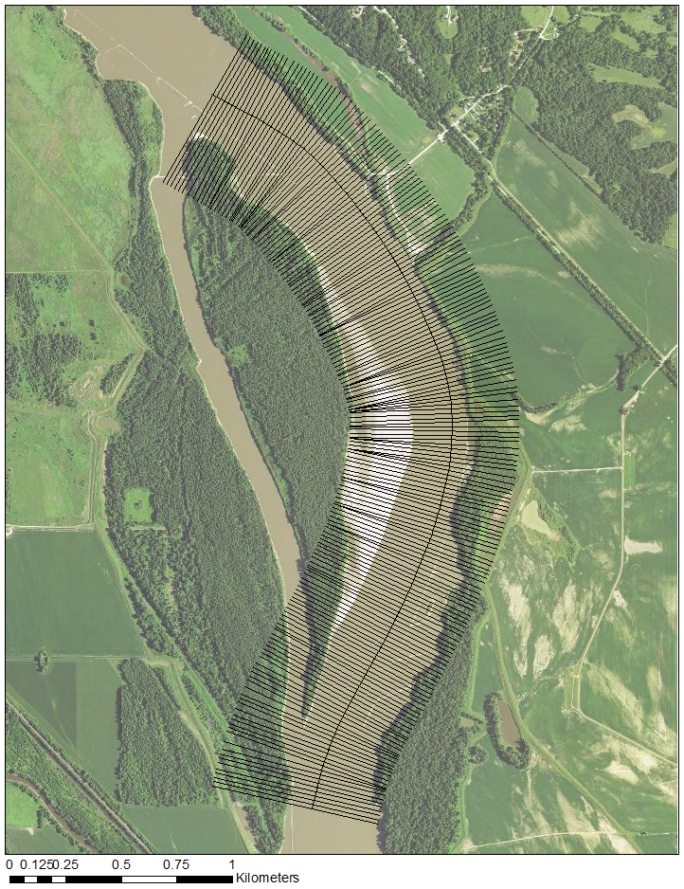

Figure E 1: Example survey reach showing 20-m spaced transects perpendicular to the recommended sailing line.

* + - 1. Data Analysis Tasks
         1. Biological Data Analysis

The analysis of the IRC experiments starts with a data summary to obtain the CPUE at the site level each year because the site is the unit of analysis. The CPUE at the site level was computed as



where (*i*, *j*) refer to site *i* in year *j*.

The statistical model for the staircase design (also known as the stepped-wedge design in clinical trials) is discussed in Walter (2008) and Hussey et al (2007). A general linear model can be fit:

 (1)

where  is the catch per unit area in site *i* in year *j*; ** is the overall grand mean; *si* is the effect of site *i*; *tj* is the common year effect; (*st*)*ij* is the interaction term; *I*(*ij*)*T* represents the treatment effect – the *I*() term is 1/0 if the treatment is active/not active in site *i* in year *j*, the estimate of *T* represents the treatment effect; and  represents measurement error and other sources of random noise. This model can be fit with most statistical packages (such as R) and sample code is available in Sub-Attachment 1A.

This analysis can be performed each year after the first IRC restoration habitat is constructed and monitored.

* + - * 1. Physical Data Analysis

Physical Model Development

Data collection will support the development of 2-dimensional hydrodynamic models which will serve as the primary mode for processing, quantifying, and analyzing the physical habitat data at treatment and control sites. The benefits of analyzing physical habitat data through the development of computational hydrodynamic models versus observation of the collected data with a static terrain model using a geographical information system (GIS) is the flexibility afforded by the computational model in predicting and observing the fluctuations of depth and velocity at environmental conditions beyond those during the time of the survey. Analyses are not limited to the flows at which the surveys took place. However, a considerable more amount of time is spent in model development.

Models will be developed using the Surface-Water Modeling System (SMS; Aquaveo, LLC) or comparable graphical interface. A numerical model such as Adaptive Hydraulics (AdH), or comparably advanced model (e.g. SRH-2D, TUFLOW, etc.), will be used to run simulations of 2-dimensional flow through the bends to quantify depth and velocity at flows most relevant to larval drift.

Analysis - Pre-Construction Assessment and Design

Pre-construction surveys will be used to develop models of the sites at “existing conditions”. The existing conditions model will serve as the baseline for each site against which the change in habitat is measured and serve as the foundation for the interception habitat design to be built from. A calibrated model can then use specific metrics, under certain assumptions, to approximate how effective interception currently is at a site and evaluate the amount of beneficial habitat that exists. Various engineering design alternatives should be incorporated into the existing conditions model by adjusting the model geometry and/or model input controls to represent the geomorphic or hydraulic transformations expected to occur as a result of the design features. These design alternatives can then be evaluated using the previously defined interception and habitat metrics and compared to the existing conditions model in an attempt to identify designs that improve those metrics.

The particle tracking model (PTM), a module within SMS, is a tool that should be used to provide a metric for conceptualizing and estimating larval interception within a model. PTM can be used to simulate the transport of drifting larval fish by using particles with simplified characteristics in conjunction with the hydrodynamic outputs from AdH or other hydrodynamic model code. Interception can be estimated by quantifying the number of particles entering into the area of interest and comparing to the total number of particles in the simulation to obtain a proportion of particles intercepted. This metric is useful for comparing various design alternatives under the same environmental conditions to evaluate which designs will potentially increase the portion of particles intercepted into the desired area. Additionally, design alternatives can be compared through the amount of beneficial habitat that is created based on specific depth and velocity criteria.

Analysis - Post-Construction Assessment and Design

Monitoring will be conducted following habitat construction and continue through the end of the study. The time required for full development of an IRC habitat will vary between habitats and designs and will be estimated during the design phase of the project. The timing of the post-construction evaluation will depend upon the time it takes the IRC habitat to develop to the desired state. Terrain models developed from survey data of depth and velocity using GIS are useful tools for tracking the progress of site development and should be used as an initial measure when assessing the state of the IRC habitat.

Once it is identified that the IRC habitat has substantially developed to either the design state, or a state of geomorphic quasi-equilibrium, the monitoring data should be re-incorporated back into the existing conditions models to develop post-construction models of depth and velocity. The post-construction model will be useful for direct comparisons to the existing conditions model and will provide a detailed representation of changes in depth and velocity direction and magnitude that occur at critical flows. Metrics used during the design phase can be re-evaluated using the post-construction models to assess the effectiveness of the design to function as intended and evaluate whether assumptions used in the design should be adjusted for ensuing habitats.

* + - * 1. Predictive models of CPUE using physical data

Physical metrics of interception habitat should be compared with biological sampling data (e.g. CPUE) to evaluate any physical metrics are factors that can be used to predict larval interception on the Missouri River. General linear models comparing CPUE of age-0 sturgeon to physical metrics could be compared using an information theoretic approach to model selection like Akaike Information Criterion (AIC) to determine which physical metrics, if any, are useful predictors of larval interception on the Missouri River.

* + 1. Schedule

The schedule is expected to follow the coarse schedule shown in Table E 2. Noteworthy is the ramping level of effort associated with the staircase design. When considering construction and monitoring activities, the highest levels of effort are in years 6 and 7 of the monitoring plan.

Table E 2: Schedule for IRC Restoration Habitat Construction and Monitoring

|  |  |  |  |  |  |  |  |  |
| --- | --- | --- | --- | --- | --- | --- | --- | --- |
|  |  |  |  |  | Year |  |  |  |
|  | 1 | 2 | 3 | 4 | 5 | 6 | 7 | 8 |
| Construction of IRC Habitat |  | 2 | 2 | 2 | 2 | 2 | 2 |  |
|  |  |  |  |  |  |  |  |  |
| Biological Monitoring (Bend) | 4 | 8 | 12 | 16 | 20 | 24 | 24 | 24 |
| Physical Monitoring (Bend) | 4 | 8 | 12 | 16 | 20 | 24 | 24 | 24 |

* + 1. Literature Cited

Brown, M. L., and C. S. Guy. 2007. Science and statistics in fisheries research. Pages 1-29 *in* C. S. Guy and M. L. Brown, editors. Analysis and interpretation of freshwater fisheries data. American Fisheries Society, Bethesda, Maryland.

Jacobson, R.B., Annis, M.L., Colvin, M.E., James, D., Welker, T.L., and Parsley, M.J., 2016, Missouri River *Scaphirhynchus albus* (Pallid Sturgeon) Effects Analysis—Integrative Report 2016: U.S. Geological Survey, Scientific Investigations Report 2016-5064, 154 p. 10.3133/sir20165064.

Ridenour, C.J. and T.D. Hill. 2010. Dalbey Bottoms Pallid Sturgeon habitat rehabilitation monitoring project 2009 field season: pre-construction phase annual report. U.S. Fish and Wildlife Service, Columbia Fish and Wildlife Conservation Office, Columbia, MO. 12p.

Walters, C.J., J.S. Collie and T. Webb. 1988. Experimental Designs for Estimating Transient Responses to Management Disturbances. Can. J. Fish. Aquat. Sci. 45: 530-538.

Welker, T. L., and M. R. Drobish (editors). 2016. Missouri River Standard Operating Procedures for Fish Sampling and Data Collection, Volume 1.8. U.S. Army Corps of Engineers, Omaha District, Yankton, SD.

* + 1. Sub-Attachment 1A – IRC Power Analysis Technical Memorandum

April 15, 2016

Authors: Carl Schwarz and Brian O. Ma

* + - 1. Introduction

The Before-After-Control-Impact (BACI) design is the standard design for investigating the effect of a treatment but controlling for temporal effects and site effects. In BACI designs, treatment sites are measured before and after the actual treatment occurs and control sites are also measured in each year. The control sites provide information on temporal trends, so that changes in the treatment site between pre- and post-treatment can be distinguished from the temporal trends.

BACI designs are quite flexible because the number of years measured pre- and post-treatment do not have to be the same, and it is also possible to have multiple sites in both the treatment and control groups. However, BACI designs usually assume that the treatment is applied to all the sites in the treatment group at the same time.

In some cases, it is not logistically possible to apply the treatment simultaneously to multiple sites, and often it is not feasible to do many years of pre-treatment monitoring. Walter et al. (1998) and Hussey et al. (2007) discuss a variant called the staircase (or stepped treatment) design. The staircase design relies on a series of staggered BACI designs where each new treatment (typically) starts one year later. The staircase design implicitly assumes that treatment effects are permanent and persist once the treatment has been applied to a site. Control sites serve as control for all of the treatment sites.

For example, Figure E 2 presents a schematic of one such design involving 6 IRC and their associated control sites. For the construction of IRC habitats, logistical constraints make it difficult to construct more than 1 or 2 habitats in a single year. While there is only one year of pre-treatment monitoring for the first treatment site, successive treatment sites have more than one-year of control monitoring.

The staircase design shown in Figure E 2 can be modified in various ways. For example, it is possible to implement the treatment at more than one site in a year; the number of years monitored before any treatment applied can be increased; control sites can be “paired” with particular treatment sites; treatments can be implemented on a more irregular schedule rather than in successive years.

The statistical model for the analysis of data from a staircase design is discussed in Walter (2008) and Hussey et al (2007) and is shown in model 1:

 (model 1)

where  is the response in site *i* in year *j; * is the overall grand mean; *si* is the effect of site *i*; *tj* is the common year effect; (*st)ij* is the interaction term;  represents the treatment effect; the *I*() term is 1/0 if the treatment is active/not active in site *i* in year *j*; and  represents measurement error and other source of random noise. This model is easily fit using most linear model routines in common statistical packages (Annex 1). No modification is needed to deal with the different variants of the staircase design discussed earlier except if control sites are explicitly paired with treatment sites. In this case, an additional term corresponding to the pairing (a blocking term) needs to be introduced as is commonly done for blocked designs.

The staircase design can be considered as a combination of small BACI designs, with each BACI components starting in a new year. Consider the mini BACI design consisting of sites 1 and 2 in years 1 and 2 in Figure E 2. The BACI contrast (which is used to see if there is evidence of a treatment effect) would be computed as (*Y11*-*Y12*) - (*Y21*-*Y22*), i.e., the differential response from year 1 to year 2 between the treatment and control sites. If we expand each of the *Y*’s in that expression by the model in (1), you see that the *si* terms cancel (the same site is measured in multiple years so a within-site contrast is free of site effects); the *tj* terms disappear (the difference between the impact and control site in each year is free of time effects), but the *(st)ij* and terms do not cancel. If you are willing to assume that the *(st)ij* and terms have mean = 0 then the expected value of the BACI contrast is simply the effect of treatment. The actual computations using all of the cells in the design are more complex but the same analogies hold. Notice that the *(st)ij* and are completely confounded with each other and represent the noise that reduces the ability to detect the treatment effect.

The power of the staircase design to detect the treatment effect depends on a number of factors:

* the size of the effect – Larger effects are easier to detect than smaller effects
* the noise in the response – Higher amounts of noise make it harder (reduce the power) to detect effects,
* the alpha level – usually set to 0.05; and beta level – usually set to 0.2
* the sample size – larger sample sizes lead to higher power to detect effects.

More specifically in the case of the IRC experiments, the power is a function of the number of IRCs proposed; how quickly the IRCs come on line; the number of control sites; and the length of time these sites are monitored.

The noise in a staircase design consists of three sub-components, some of which have no impact on the power.

First is the year-to-year variation in the response that acts in common on all sites. For example, a particular year may experience river conditions for successful spawning and so the number of young fish seen in the sampling trawls tends to be higher in all bends. Because both treatment and control sites are measured on all years, the year-to-year variation has no impact on the power because in the analysis this term “cancels” as shown earlier.

Second is the site-to-site variation. A particular bend may have some local characteristics that cause it to have higher catches than other bends in a consistent fashion over time. Because both treatment and control sites are repeatedly measured over time, pre- vs. post-treatment-year comparisons will again be “free” of site-effects, and again the site-to-site variation has no impact on the power.

Third is the site-year interaction variation, which represents the non-parallelism of response over time among the sites. For example, we assume that temporal effects have the same effect on all sites (parallel responses), but there may be some site-specific factors that inhibit or amplify temporal trends and so a non-parallel response is observed. The site-year interaction (the residual error in model 1) is the determining factor for the power of a staircase design.

A power analysis will require information on these noise components – in particular the site-year interaction variation.

* + - 1. Estimation of Variance Components

In order to estimate the power of a proposed IRC design we need estimates of the site-year interaction term. A site in the IRC experiments is the bend, which then becomes the unit of analysis; i.e., trawl data must be summarized to the bend-level. In order to estimate this term, we need a sample of bends that have been measured in multiple years. It is not necessary for all bends to be measured in all years.

We received data on trawls conducted as part of the HAMP and MDC programs from 2005 to 2009 and 2014 to 2015. Each trawl has information on the bend in which it was measured, the area of the trawl and the number of fish captured in the trawl (Table E 3), and macro/meso habitat of the trawl. Because the bend will be the unit of analysis, the data was summarized to the bend level and the CPUE at the bend level was computed as



This gives one number per bend in each year that it was measured.

We begin by pooling all trawls over all habitat types.

Some bends were measured in both the HAMP and MDC program and a summary of their results are shown in Table E 4. The CPUE from the MDC program is much higher than that from the HAMP. Based on discussions with the working group, it was decided that the MDC data does not represent realistic values for CPUE going forward. Consequently, it was decided to only use the HAMP data to estimate the variance components.

Many environmental effects operate multiplicatively rather than additively. For example, a year effect may double the CPUE in all sites raising a CPUE from .001 to .002 fish/m2 and from .004 to .008 fish/m2. Consequently, a log-transformation will convert the multiplicative year effect to additive effects on the log-scale (e.g., a doubling will simply add log(2)4F[1]=.7 to all values). A timeplot of the log(CPUE) from the HAMP data is shown in Figure E 3. Following the standard convention, all CPUE values were adjusted by ½ of the smallest non-zero CPUE value to prevent taking log(0). Both site and time effects are evident but there is a large amount of non-parallelism in the response.

A linear mixed model was used to estimate the associated variance components. In a short hand (*R* type) syntax, the model was



Estimated variance components are shown in Table E5. . We see that the Site-Year interaction variance component is quite large relative to the effects of site or that of year. This can be seen in Figure E 3 in the generally weak parallel effects of site or year.

* + - 1. Power Analysis

These variance components were used to estimate power based on the results of Hussey et al (2007) but using the methods of Stroup (1999)5F[2]. The basic idea of Stroup (1999) is that the expected values (i.e., incorporating the treatment effects but no random noise) are analyzed as data using the variance components estimated from a pilot study. The resulting F-statistic in the ANOVA table provides information to estimate the power.

We computed the power for the IRC experiments under a number of scenarios involving:

* between 5 and 15 years of monitoring;
* between 6 and 12 IRC sites (plus the same number of control sites)
* between 1 or 2 IRC sites constructed per year
* effect sizes from a 10% to a 100% increase in mean CPUE in IRC sites.

Because the analysis took place on the log-scale, treatment effects can be easily specified using the relationship that a 10% increase in response corresponds very closely to a 0.1 increase on the log-scale.

The specific results for one such power analysis are shown in Table E 6. We see that this proposed design has an approximate 80% power to detect an 80% increase in CPUE at alpha=0.05. Figure E 4 illustrates the relationship between the number of IRC sites, the number of years monitoring, and the power for various effect sizes. Generally, effect sizes less than a 50% increase cannot be detected even with 15 years of monitoring and 12 IRC sites. However, acceptable power (around 80% power) is generally achievable for an effect size of 75% and at least 10 years of monitoring at a construction rate of one IRC site per year.

Over longer periods of monitoring, there is a negligible benefit of implementing 2 IRC-control pairs/year rather than 1 IRC-control pair/year (while keeping the total length of monitoring and total number of sites the same), as shown in Figure E 5. However, the benefit of doubling the rate of IRC construction increases in sampling designs where the number of monitoring years is small. If only one IRC-control pair is implemented per year, it may not be possible to implement all of the proposed IRC sites. For example, it is not possible to fully implement 6 IRC-control pairs with only 5 years of monitoring unless 2 IRC/year are implemented. However, once there are 10 or more years of monitoring planned, there is no particular advantage to implementing the IRC at a faster rate.

The limiting factor to the power of the design is often the Site-Year interaction variance component. One potential reason why the responses are not-parallel over time is perhaps that the different habitat types respond differently over time and so the overall response at the bend level has extra noise. We investigated this by fitting the linear mixed model to only the trawls at BARS or CHNB meso habitat types (these two meso habitat types account for the majority of the habitat). The variance components from these separate habitat types are shown in Table E 7, but there is no evidence that partitioning by habitat type will lead to improvements as the Site-Year variance components are larger than when pooled together! A power analysis (not shown) indeed shows a reduced power.

Because we summarized CPUE to the bend level, we could not separate the (Site-Year) interaction variance component from measurement error. We can fit a more complex linear mixed effects model to separate out the two components (Table E 8). The two sets of variance components are not directly comparable because the logarithm of the CPUE computed by summing the number of fish and area does not separate into the individual CPUEs in the same fashion as would a regular mean, but this does seem to suggest that trawl-to-trawl variation is large. However, because the average number of trawls per bend is around 42, computing the average CPUE at the bend level reduces the impact of the trawl-to-trawl standard deviation by a factor of around 6F[3]. Consequently, the total variation at the bend-year level is mainly due to the Site-Year interaction. Additional sampling (i.e., more trawls) would only lead to minor reductions in the Site-Year variance component and negligible impact on power.

This power analysis assumes that control bends are selected at random from all possible bends. However, power could be increased if control bends were selected to be more similar to treatment bends. This should result in more parallel responses. Unfortunately, we currently lack any information to investigate this alternative.

* + - 1. Summary

This report estimated the variance components from the HAMP trawl data and used it to estimate the power of a potential IRC design. This is only an estimate of the power and the uncertainty in the variance components has not been incorporated. Consequently, the actual power may be different than forecasted.

Discussions of the analysis with biologists and managers suggested two options, both of which generate 80% statistical power with an effect size of 80% increase in CPUE:

1. 12 IRC-control site pairs implemented over 7 years at the rate of 2 sites / year, with 7 years of total monitoring;
2. 6 IRC-control site pairs implemented over 7 years at the rate of 1 site / year, with 12 years of total monitoring

Generally, power increases with the number of IRC sites and the number of years of monitoring. The benefit of option A is that it provides both a more rapid rate of learning (7 years vs 12 years), and potentially greater cumulative biological benefits (if the IRC sites are indeed effective). The tradeoff between the number of IRC sites and the number of years of monitoring will depend on the relative costs of both activities and was not pursued here. Adding more trawls to the bends is unlikely to lead to useful improvements in power because there is already substantial effort in each bend (mean of ~42 trawls per bend) so that the trawl-to-trawl variation has been “reduced” averaging over all trawls.

* + - 1. Literature Cited

Hussey, M.A. and Hughes. J. P. (2007). Design and analysis of stepped wedge cluster randomized trials. Contemporary Clinical Trials, 28, 182-191.

Stroup, W. W. (1999).  Mixed model procedures to assess power, precision, and sample size in the design of experiments. Pages 15-24 in Proc. Biopharmaceutical Section. Am. Stat. Assoc., Baltimore, MD.

Walters, C.J., J.S. Collie and T. Webb. 1988. Experimental Designs for Estimating Transient Responses to Management Disturbances. Can. J. Fish. Aquat. Sci. 45: 530-538.

Table E 3: Summary of trawls by bend and year. HAMP and MDC data pooled.

Bend_ID 2005 2006 2007 2008 2009 2014 2015

375 0 0 40 30 40 0 0

379 0 0 0 0 0 801 514

381 0 1 37 33 38 0 0

390 0 0 44 35 39 0 0

391 0 0 0 0 0 8 3

392 0 0 0 0 0 57 37

393 0 0 0 0 0 43 38

394 0 0 0 0 0 170 101

395 0 0 0 0 0 35 19

396 0 4 57 34 28 45 34

397 0 0 0 0 0 70 36

398 0 2 95 74 82 88 48

399 0 0 0 0 0 14 0

403 0 0 0 0 0 1 0

423 0 0 0 0 0 60 62

424 4 9 43 26 45 94 98

425 0 0 0 0 6 107 610

426 0 0 0 0 8 131 128

427 0 0 0 0 0 66 76

428 0 0 0 0 0 32 35

429 0 0 0 2 1 92 88

430 5 20 43 28 46 76 59

432 0 17 48 28 31 0 0

433 0 0 0 0 1 0 0

434 0 0 0 0 2 0 0

442 0 14 42 22 31 0 0

443 0 0 0 0 3 0 0

444 0 11 40 21 40 0 0

445 0 0 0 0 3 0 0

446 0 0 0 2 10 0 0

447 0 0 0 9 24 71 42

448 0 0 0 0 7 77 60

449 0 0 0 0 0 65 37

450 0 0 0 0 0 138 83

451 0 0 0 0 0 97 74

452 0 12 52 24 33 46 42

453 0 0 0 0 0 76 63

454 0 0 0 0 0 4 0

461 0 0 0 0 1 0 0

465 0 0 0 0 0 180 340

466 0 0 41 20 28 0 0

467 0 0 0 0 0 379 525

468 0 0 0 0 0 110 62

469 0 0 0 0 0 39 27

470 0 0 0 0 0 63 32

471 0 0 0 0 0 116 73

472 0 0 0 0 0 60 40

473 0 0 38 14 20 57 50

474 0 0 0 0 0 45 24

475 0 0 0 0 0 61 26

476 0 0 0 0 0 120 73

482 0 0 39 20 25 0 0

489 0 0 43 18 33 0 0

494 0 0 0 0 0 4 0

495 0 0 0 0 0 38 24

496 0 0 0 0 0 40 25

497 0 0 0 0 0 43 28

498 0 0 0 0 0 44 28

499 0 0 0 0 0 70 38

500 0 0 0 0 0 55 47

501 0 0 0 0 0 23 15

502 0 0 0 0 0 29 16

503 0 0 0 0 0 48 34

506 0 0 48 15 25 0 0

510 0 0 44 17 43 0 0

Table E 4: Comparison of CPUE from bends simultaneously measured from HAMP and from the MDC programs.

Bend_ID Year Source total.Effort total.numfish CPUE

48 425 2009 2005-2009 HAMP 8277.0 0 0.0000000000

49 425 2014 2014 HAMP 41792.2 32 0.0007656931

50 425 2015 2015 HAMP 40336.1 40 0.0009916675

51 425 2015 2015 MDC 34507.8 139 0.0040280748

116 467 2014 2014 HAMP 14348.6 5 0.0003484661

117 467 2014 2014 MDC 21232.8 175 0.0082419653

118 467 2015 2015 HAMP 7070.2 0 0.0000000000

119 467 2015 2015 MDC 35330.4 191 0.0054061092

Table E 5: Estimated variance components from fitting a linear mixed model to log(CPUE)

**Component Std.Dev.**

Site 0.373

Year 0.508

Site-Year 1.311

Table E 6: Estimated power from two sampling designs: A) 12 IRC-control pairs implemented over 7 years (i.e., two new IRC-control site pairs per year) and 7 years of total monitoring and B) 6 IRC-control site pairs implemented over 7 years (i.e., one new IRC site per year) and 12 years of total monitoring. See Figure E 1. Variance components from Table 3 were used to estimate the power using the method of Stroup (1999). An increase of .1 on the log-scale corresponds to a 10% increase in CPUE as the result of treatment. The power was found for one-sided tests (i.e., to look for an increase in CPUE) at alpha=0.05. If there is no treatment effect (i.e., effect 0.0) the experiment will still detect an effect 5% of the time – these are false positives.

|  |  |  |
| --- | --- | --- |
| Effect Size  (∆ CPUE) | Power with Sampling Design A | Power with Sampling Design B |
| 0.0 | 0.050 | 0.050 |
| 0.1 | 0.094 | 0.091 |
| 0.2 | 0.162 | 0.154 |
| 0.3 | 0.256 | 0.239 |
| 0.4 | 0.372 | 0.346 |
| 0.5 | 0.502 | 0.467 |
| 0.6 | 0.631 | 0.590 |
| 0.7 | 0.747 | 0.705 |
| 0.8 | 0.840 | 0.803 |
| 0.9 | 0.907 | 0.878 |
| 1.0 | 0.950 | 0.930 |

Table E 7: Estimated variance components when a separate analysis is done on each habitat type.

BARS habitats

**Component Std.Dev.**

Site 0.58

Year 0.65

Site-Year 1.54

CHNB habitat

**Component Std.Dev.**

Bend_ID 0.64

Year 0.72

Site-Year 1.42

Table E 8: Estimated variance components when trawl measurements are used directly in the linear mixed model (eq. 1). The average number of trawls/bend-year combination is around 42. This implies that the total variation when summarized at the bend-year level would be computed as:  which is not much larger than the Site-Year interaction term. Sampling more trawls/site will result in negligible improvements in the power.

**Component Std.Dev.**

Site-Year 0.242

Site 0.115

Year 0.129

Trawl 1.061

**Sampling Design A**

Year

Site 01 02 03 04 05 06 07

01 C T T T T T T

02 C C C C C C C

03 C T T T T T T

04 C C C C C C C

05 C C T T T T T

06 C C C C C C C

07 C C T T T T T

08 C C C C C C C

09 C C C T T T T

10 C C C C C C C

11 C C C T T T T

12 C C C C C C C

13 C C C C T T T

14 C C C C C C C

15 C C C C T T T

16 C C C C C C C

17 C C C C C T T

18 C C C C C C C

19 C C C C C T T

20 C C C C C C C

21 C C C C C C T

22 C C C C C C C

23 C C C C C C T

24 C C C C C C C

**Sampling Design B**

Year

Site 01 02 03 04 05 06 07 08 09 10 11 12

01 C T T T T T T T T T T T

02 C C C C C C C C C C C C

03 C C T T T T T T T T T T

04 C C C C C C C C C C C C

05 C C C T T T T T T T T T

06 C C C C C C C C C C C C

07 C C C C T T T T T T T T

08 C C C C C C C C C C C C

09 C C C C C T T T T T T T

10 C C C C C C C C C C C C

11 C C C C C C T T T T T T

12 C C C C C C C C C C C C

Figure E 2: Staircase designs A and B. Staircase design A has 12 treatment sites and 12 control sites all measured for 7 years. The treatment (T) is applied to sites 1&3, 5&7, 9&11, 13&15, 17&19, 21&23 starting in years 2, 3, 4, 5, 6, and 7 respectively. Measurement continues in all sites until year 7. Control sites (even numbered sites) are left untreated (C) and measured in all years. Staircase design B has 6 treatment sites, 6 control sites all measured for 12 years. The treatment (T) is applied to sites 1, 3, 5, 7, 9 and 11 starting in years 2, 3, 4, 5, 6, and 7 respectively. Measurement continues in all sites until year 12. Control sites (even numbered sites) are left untreated (C) and measured in all years.

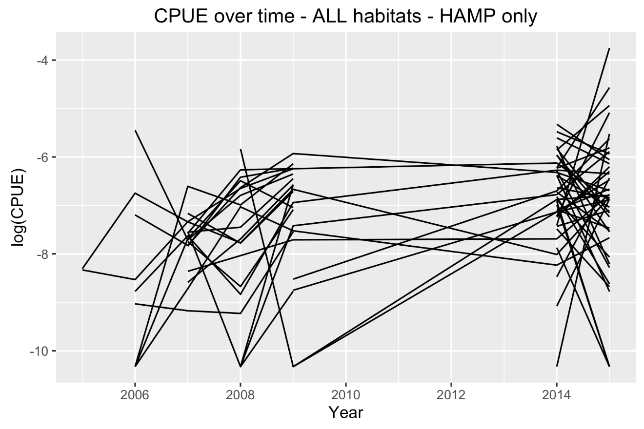

Figure E 3: Time plot of log(CPUE) for each bend from the HAMP data only. ½ of the smallest non-zero CPUE was added to all points to prevent taking log(0).

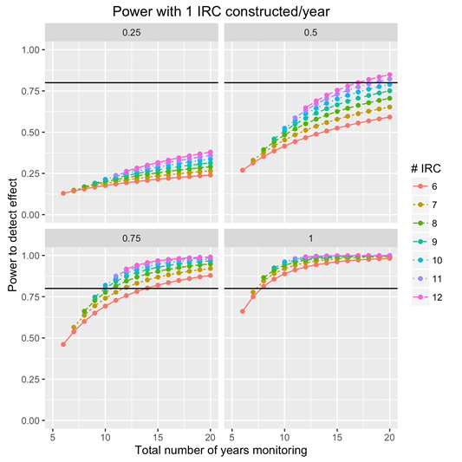

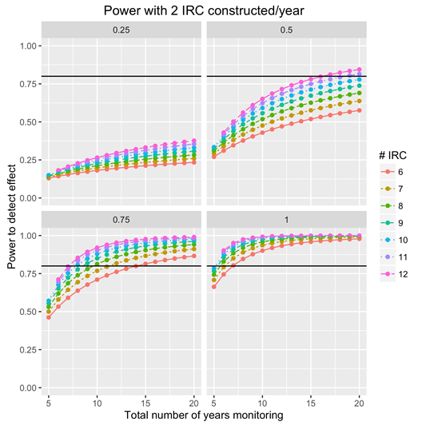

Figure E 4: Comparisons of power for different sampling designs. Top panel of four graphs shows statistical power when the number of IRC sites is varied from 6 to 12 with 5 to 20 years of monitoring and one IRC added per year. The four panels correspond to a 25%, 50%, 75%, or 100% increase in mean CPUE in the IRC sites. Lower panel of four graphs shows the same information with two IRC sites constructed per year.

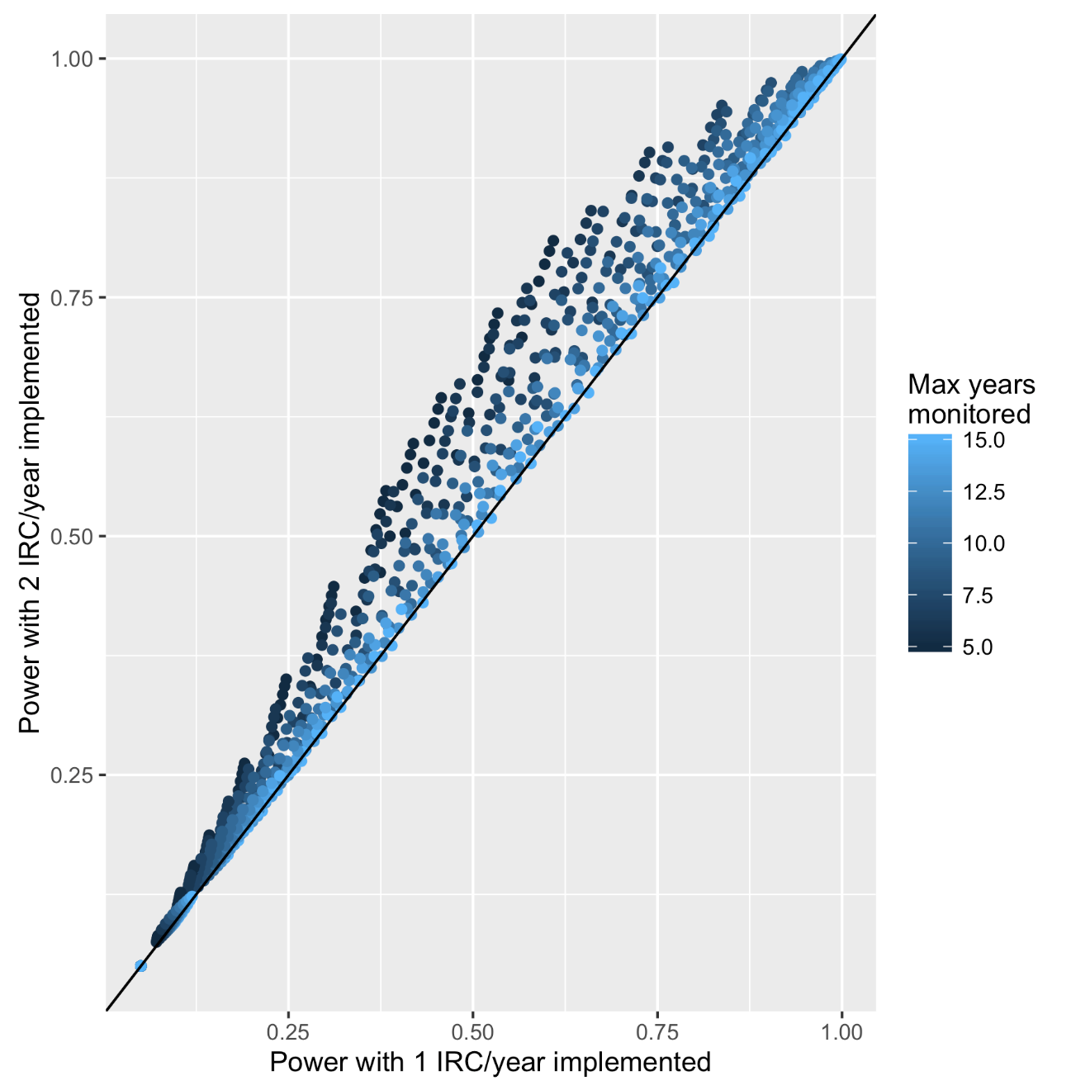

Figure E 5: Impact on power of increasing the number of IRC implemented per year from 1 to 2. Generally speaking the power impact is negligible except in cases where the number of monitoring years is small, and if only one IRC is implemented per year, it is not possible to implement all of the proposed IRC sites. For example, it is not possible to fully implement 6 IRC sites with only 5 years of monitoring unless 2 IRC/year are implemented.

**Sample Data:**

Site Year Treatment Response

1 A 1 C 0.2543600359

2 A 2 C 0.5254238276

3 A 3 C -3.4408767115

4 A 4 C -5.0149562110

5 A 5 C -8.6226452115

6 A 6 C -1.3488555218

7 A 7 C -0.0004504614

8 A 8 C 0.5050409681

9 B 1 C 0.5761786426

10 B 2 T 21.5507582294

11 B 3 T 18.6493742449

12 B 4 T 12.3983730044

13 B 5 T 18.0991001401

14 B 6 T 4.6648869696

etc

* + - 1. Annex 1 – R code for stair case design

Sample data and sample R code to analyze a staircase design. The data need 4 columns corresponding to the site (declared as a factor), the year (declared as a factor), a treatment indicator (declared as a factor), and the numeric response variable. In the portion of the raw data shown, the design is monitored for 8 years. Site A is a control site for all 8 years. Site B is control for year 1, and then has the treatment applied starting in year 2. Additional sites are added as needed.

The *R* code loads the required packages; declares the appropriate factors; and then fits a general linear model with *Site* declared as a random factor. The *lm()* function could also be used with site declared as a fixed factor with identical results in the case of a complete design, but will give different results if the design has missing data. The *lsmeans* package is then used to estimate the treatment effect.

library(lmerTest)

ibrary(lsmeans)

sample$Site <- factor(sample$Site)

sample$Year <- factor(sample$Year)

sample$Treatment <- factor(sample$Treatment)

sample.fit <- lmer(Response ~ Treatment+Year +(1|Site), data=sample)

anova(sample.fit)

sample.fit.lsmo <- lsmeans::lsmeans(sample.fit, ~Treatment)

sample.fit.pairs <- pairs(sample.fit.lsmo, infer=TRUE)

cld(sample.fit.lsmo)

vc <- as.data.frame(VarCorr(sample.fit))

vc

* 1. – Monitoring Plan for Existing SWH Projects

DRAFT/Pre-Decisional/For Discussion Purposes Prepared: May 25, 2016  
By: Todd Gemeinhardt, , Dave Marmorek and Craig Fischenich

* + 1. Introduction
    2. Hypotheses
    3. Approach
       1. Sampling Design
       2. Site Selection
       3. Data Collection Tasks
       4. Data Analysis Tasks
    4. Schedule
    5. References

riefing of unsuccessful contractors and protest procedures - TBD

1. Appendix K. List of Pallid Sturgeon Metrics

**Table K1. Metrics for monitoring status and trend of populations, action effectiveness and ecosystem condition. Some metrics will be measured directly, while others are derived variables (some based on models). Some metrics are used as key performance measures while others are covariates to help explain the observed variability in key performance measures.**

| **Metrics used to monitor Pallid Sturgeon status & trends, action effectiveness, or ecosystem condition** | **Both Upper and Lower Missouri** | | **Upper Missouri** | **Lower Missouri** | | |
| --- | --- | --- | --- | --- | --- | --- |
| **Population / Ecosystem**  **Status and Trends** | **Augmentation (U & L)** | **Intake** | **IRCs** | **Spawning Habitat** | **Spawning Sync Flows** |
| **Hydrology, water quality and geomorphology** |  |  |  |  |  |  |
| Water temperature | X | X | X | X | X | X |
| Water velocity | X | X | X | X | X | X |
| Water depth | X | X | X | X | X | X |
| Discharge | X | X | X | X | X | X |
| Cross-section profile |  |  | X | X | X |  |
| Spawning flow characteristics (timing, magnitude, longitudinal spatial distribution)* |  |  | X |  | X | X |
| Water year conditions (e.g., total inflow, peak flows)* | X | X | X |  | X | X |
| Turbidity | X | X |  |  |  |  |
| Suspended sediment |  |  | X | X | X | X |
| Dissolved oxygen (particularly Lake Sakakawea) | X |  | X | X |  |  |
| Nutrient loads | X |  |  |  |  |  |
| Contaminant loads | X |  |  |  |  |  |
|  | | | | | | |
| **Habitat** |  |  |  |  |  |  |
| Spawning habitat chosen vs. habitat available |  |  | X | X | X | X |
| # and area of spawning sites created with suitable characteristics (depth, velocity, substrate, and derivative hydraulic variables) |  |  |  |  | X | X |
| Fraction of habitat area with suitable habitat characteristics for IRCs; and trends in these attributes |  |  |  | X |  |  |
| Habitat complexity in IRCS (e.g. diversity indices, patch shape, patch connectivity) |  |  |  | X |  |  |
| Production of food / area in IRCs and control sites |  |  |  | X |  |  |
| Effective acreage (acre-days/yr of available IRC habitat) |  |  |  | X |  |  |
|  | | | | | | |
| **Fish Numbers and Survival** |  |  |  |  |  |  |
| Density of free embryos and larvae in IRCs, control areas, navigation channel, etc. | X | X | X | X |  |  |
| Actual survival of hatchery-reared first-feeding pallid sturgeon larvae | X | X | X | X |  |  |
| Number and survival rates (to age-0, age-18F[4], and juvenile stage) for stocked pallid sturgeon by stocked size, hatchery of origin, and condition | X | X | X | X | X | X |
| Numbers of pallid sturgeon free embryos collected | X | X | X | X | X | X |
| Capture of age-0 and older juvenile pallid sturgeon (e.g., present / not present, CPUE) | X | X | X | X | X | X |
| Number of pallid sturgeon by age class and origin (wild vs. hatchery) | X | X |  |  |  |  |
| Survival probabilities for stocked pallid sturgeon by stocked size, age, condition, and hatchery of origin | X | X |  |  |  |  |
| Yearling equivalents (stocking performance based on 3-year running average of annual yearling equivalents) | X | X |  |  |  |  |
| Modelled long-term change in population | X | X | X | X | X | X |
| Population size structure analysis | X | X | X | X | X | X |
|  | | | | | | |
| **Fish Condition and Genetics** |  |  |  |  |  |  |
| Pallid sturgeon condition – length, weight, Kn, health metrics | X | X | X | X | X | X |
| Length frequency distribution of age-0 fish | X | X | X | X |  |  |
| Condition of age-0 fish – % empty/full stomachs, lipid content | X | X | X | X |  |  |
| Genetics | X | X | X | X | X | X |
| Bioenergetic metrics |  |  |  | X |  |  |
| Levels of disease | X | X | X |  | X | X |
|  | | | | | | |
| **Fish Movement and Spawning** |  |  |  |  |  |  |
| Telemetry data showing movement and aggregation of adult fish in reproductive condition |  |  | X |  | X | X |
| Numbers of adult pallid sturgeon passing over/around Intake Dam (moving upstream) | X |  | X |  |  |  |
| Successful passage of pallid sturgeon downstream over Intake Dam |  |  | X |  |  |  |
| Telemetry data on selection for created spawning sites vs. control sites |  |  |  |  | X | X |
| Measures of fish aggregation and spawning behaviors (e.g. optimum male : female ratios in spawning aggregations) |  |  | X |  | X | X |
| Confirmed spawning through telemetry and acoustic video |  |  | X |  | X | X |
| Frequency and location of pallid sturgeon spawning events | X |  | X |  | X | X |
| Site characteristics of pallid sturgeon spawning locations |  |  | X |  | X | X |
| Spawner selection of different spawning substrates |  |  | X |  | X | X |
| Site confirmation that eggs are not buried |  |  | X |  | X | X |
| Hatch rate as a function of habitat availability | X |  | X |  | X | X |
| Capture of eggs and embryos downstream of sites with apparent spawning | X |  | X |  | X | X |
| Confirmed egg release through recapture of female pallid sturgeon |  |  | X |  | X | X |
| Recruitment (field monitoring & model estimation) to age-1,2,3 | X | X | X | X | X | X |
| Estimated improvement in spawning and recruitment due to management action |  | X | X | X | X | X |
|  | | | | | | |
| **Augmentation** |  |  |  |  |  |  |
| Number, size, age, location, habitat and origin of captured pallid sturgeon | X | X |  |  |  |  |
| Pallid sturgeon capture method and intensity |  | X |  |  |  |  |
| Hatchery of origin of released pallid sturgeon |  | X |  |  |  |  |
| Number, size, age, location, hatchery of origin and date of released pallid sturgeon | X | X |  |  |  |  |
| Proportion of pallid sturgeon from different release groups |  | X |  |  |  |  |
| Effective population size, empirical and projected |  | X |  |  |  |  |
| Catch rates of pallid sturgeon/catch efficiency/CPUE |  | X |  |  |  |  |
|  | | | | | | |
| **Ecosystem Condition** |  |  |  |  |  |  |
| Abundance/biomass of direct or indirect competitors | X |  |  |  |  |  |
| Abundance/biomass of predators of pallid sturgeon | X |  |  |  |  |  |
| Abundance/biomass of key food sources for each life history stage of pallid sturgeon | X |  |  |  |  |  |

1. log(x) implies natural logarithms unless otherwise indicated.
2. The method of Stroup (1999) gave identical results to that of Hussey et al (2007) after correcting an error in Hussey et al (2007) power formula.
3. This is analogous to the fact that the variance of the sample mean is found as 
4. Age-0 fish become age-1 fish on January 1st